WCSA

English

Learning Book – Learning Cycle 1

**Year 8**

**Other Cultures Poetry**

**English Language and Literature**

**Name: _______________________________Tutor Group: 8___**

**English Teacher(s): ___________________________________**

**Learning Cycle 1**

|  |  |  |  |  |  |  |
| --- | --- | --- | --- | --- | --- | --- |
| September 2018 | 9 | 10 | 11 | 12 | 13 | Week 1 |
| 16 | 17 | 18 | 19 | 20 | Week 2 |
| 23 | 24 | 25 | 26 | 27 | Week 3 |
| October 2018 | 31 | 1 | 2 | 3 | 4 | Week 4 |
| 7 | 8 | 9 | 10 | 11 | Week 5 |
| 14 | 15 | 16 | 17 | 18 | Week 6 |
| 21 | 22 | 23 | 24 | 25 | Extended Half Term |
| 28 | 29 | 30 | 31 | 1 | Extended Half Term |
| November 2018 | 4 | 5 | 6 | 7 | 8 | Week 7 |
| 11 | 12 | 13 | 14 | 15 | Assessment Week |
| 18 | 19 | 20 | 21 | 22 | Super-Teach Week |

* During the Assessment Week, students will be assessed on the material that they have covered the previous seven weeks.
* Following this, the teacher will re-teach areas of underachievement, as identified during the assessment week, during the Super Teaching week.
* The tasks labelled as “**consolidation tasks**” mean that students should be able to complete them using their knowledge from lessons.
* There are also tasks labelled, “**research tasks**”, where we are asking students to spend 15-20 minutes doing some research.

**Useful Websites**

[***http://news.bbc.co.uk/1/shared/spl/hi/world/06/dharavi_slum/html/dharavi_slum_intro.stm***](http://news.bbc.co.uk/1/shared/spl/hi/world/06/dharavi_slum/html/dharavi_slum_intro.stm)

<http://www.nationalarchives.gov.uk/education/resources/bound-for-britain/>

**Week 1: The slums of India**

**Research**

1. Read the short article from the BBC.
2. Answer the questions underneath the article in FULL sentences.

**Life in a slum**

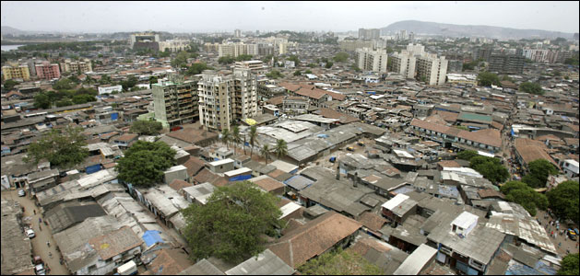 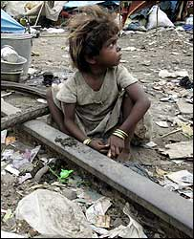

Asia's largest slum, Dharavi, lies on prime property right in the middle of India's financial capital, Mumbai (Bombay).

It is home to more than a million people. Many are second-generation residents, whose parents moved in years ago.

Today's Dharavi bears no resemblance to the fishing village it once was. A city within a city, it is one unending stretch of narrow dirty lanes, open sewers and cramped huts.

In a city where house rents are among the highest in the world, Dharavi provides a cheap and affordable option to those who move to Mumbai to earn their living.

Rents here can be as low as 185 rupees ($4/£2.20) per month. As Dharavi is located between Mumbai's two main suburban rail lines, most people find it convenient for work.

Even in the smallest of rooms, there is usually a cooking gas stove and continuous electricity.

Many residents have a small colour television with a cable connection that ensures they can catch up with their favourite soaps. Some of them even have a video player.

Dharavi also has a large number of thriving small-scale industries that produce embroidered garments, export quality leather goods, pottery and plastic.

Most of these products are made in tiny manufacturing units spread across the slum and are sold in domestic as well as international markets.

[***http://news.bbc.co.uk/1/shared/spl/hi/world/06/dharavi_slum/html/dharavi_slum_intro.stm***](http://news.bbc.co.uk/1/shared/spl/hi/world/06/dharavi_slum/html/dharavi_slum_intro.stm)

Q1. What do you learn about the slum in Dharavi in the first 4 paragraphs? **(4 marks)**

* ………………………………………………………………………………………………………………………….
* ………………………………………………………………………………………………………………………….
* ………………………………………………………………………………………………………………………….
* ………………………………………………………………………………………………………………………….

Q2. What do you think ‘A city within a city’ means? **(1 mark)**

………………………………………………………………………………………………………………………………………………

………………………………………………………………………………………………………………………………………………

Q4. Consider the following line: ‘it is one unending stretch of narrow dirty lanes, open sewers and cramped huts’. What does this make you: **(3 marks)**

Feel? …………………………………………………………………………………………………………………………………..

Imagine? ………………………………………………………………………………………………………………………………

Realise? ……………………………………………………………………………………………………………………………….

Q5. What main reason does the article give for why people choose to move into this area? Use a quotation to support your answer. **(2 marks)**

………………………………………………………………………………………………………………………………………………

………………………………………………………………………………………………………………………………………………

………………………………………………………………………………………………………………………………………………

………………………………………………………………………………………………………………………………………………

**Peer Assess:** Final mark out of 10

What one thing/detail would you add?

**Parent/ carer comments:**

**Week 2: The markets of Jamaica**

**Consolidation**

1. Complete some research on Jamaican market culture.
2. Create a written account of running a Jamaican market stall.

Your task: Imagine you are the woman in the photograph. You sell your fruit and vegetables all day long in the busy, crowded streets. The sun beats down on you. You do not leave until every piece of fresh food is sold or until it becomes very late in the day.

Research what Jamaican markets are like. Then write an account from her perspective.

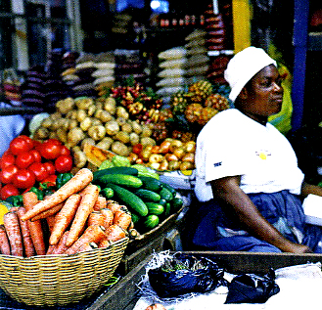

Research:

1. What types of fresh food are sold at a Jamaican market?

………………………………………………………………………………………………………………………………………………

………………………………………………………………………………………………………………………………………………

………………………………………………………………………………………………………………………………………………

………………………………………………………………………………………………………………………………………………

1. What would the atmosphere be like?

………………………………………………………………………………………………………………………………………………

……………………………………………………………………………………………………………………………………………..

………………………………………………………………………………………………………………………………………………

………………………………………………………………………………………………………………………………………………

1. Why would Jamaican’s be proud of their market culture?

…..…………………………………………………………………………………………………………………………………………

………………………………………………………………………………………………………………………………………………

………………………………………………………………………………………………………………………………………………

……………………………………………………………………………………………………………………………………………

**My Market Day**

………………………………………………………………………………………………………………………………………………

………………………………………………………………………………………………………………………………………………

………………………………………………………………………………………………………………………………………………

………………………………………………………………………………………………………………………………………………

………………………………………………………………………………………………………………………………………………

………………………………………………………………………………………………………………………………………………

………………………………………………………………………………………………………………………………………………

………………………………………………………………………………………………………………………………………………

………………………………………………………………………………………………………………………………………………

………………………………………………………………………………………………………………………………………………

………………………………………………………………………………………………………………………………………………

………………………………………………………………………………………………………………………………………………

………………………………………………………………………………………………………………………………………………

………………………………………………………………………………………………………………………………………………

………………………………………………………………………………………………………………………………………………

………………………………………………………………………………………………………………………………………………

**Peer Assess:**

Was research used in the account?

Was the account engaging and believable?

What was your favourite word, phrase or line?

**Parent/ carer comments:**

**Week 3: The Second World War Caribbean immigration**

**Research**

Complete research using the questions to guide you.

You could use the following website to help you answer some of the questions.

<http://www.nationalarchives.gov.uk/education/resources/bound-for-britain/>

**Research: what happened after the Second World War?**

1. Why did Britain open its borders after the Second World War? Give more than just one reason.

……………………………………………………………………………………………………………………………………………..

………………………………………………………………………………………………………………………………………………

………………………………………………………………………………………………………………………………………………

………………………………………………………………………………………………………………………………………………

………………………………………………………………………………………………………………………………………………

1. Why did people from the Caribbean want to leave their home to live in the Britain?

…………………………………………………………………………………………………..…………………………………………

………………………………………………………………………………………………………………………………………………

………………………………………………………………………………………………………………………………………………

………………………………………………………………………………………………………………………………………………

………………………………………………………………………………………………………………………………………………

1. What was the Windrush?

………………………………………………………………………………………………………………………………………………

………………………………………………………………………………………………………………………………………………

………………………………………………………………………………………………………………………………………………

………………………………………………………………………………………………………………………………………………

………………………………………………………………………………………………………………………………………………

1. How were immigrants treated when they arrived in the Britain?

………………………………………………………………………………………………………………………………………………

………………………………………………………………………………………………………………………………………………

………………………………………………………………………………………………………………………………………………

………………………………………………………………………………………………………………………………………………

………………………………………………………………………………………………………………………………………………

………………………………………………………………………………………………………………………………………………

……………………………………………………………………………………………………………………………………………..

1. How might immigrants have struggled to settle in and feel at home?

………………………………………………………………………………………………………………………………………………

………………………………………………………………………………………………………………………………………………

………………………………………………………………………………………………………………………………………………

………………………………………………………………………………………………………………………………………………

………………………………………………………………………………………………………………………………………………

………………………………………………………………………………………………………………………………………………

……………………………………………………………………………………………………………………………………………..

**Peer Assess:** What impressed you/was interesting about this student’s work?

What one thing/detail would you add?

**Parent/ carer comments:**

**Week 4: Race**

**Consolidation**

1. Define key words. 2. Read and respond to the transcript.

**(4 marks)**

Discrimination: …………………………………………………………………………………………………………………………

Prejudice: ……………………………………………………………………………………………………………………………….

Justice: ……………………………………………………………………………………………………………………………………

Destiny: …………………………………………………………………………………………………………………………………...

For the African-American community, that path (towards the future) means embracing the burdens of our past without becoming victims of our past. It means continuing to insist on a full measure of justice in every aspect of American life. But it also means binding our particular grievances – for better health care and better schools and better jobs – to the larger aspirations of all Americans: the white woman struggling to break the glass ceiling, the white man who has been laid off, the immigrant trying to feed his family. And it means taking full responsibility for our own lives – by demanding more from our fathers, and spending more time with our children, and reading to them, and teaching them that while they may face challenges and discrimination in their own lives, they must never succumb to despair or cynicism; they must always believe that they can write their own destiny.

* Transcript taken from Barack Obama’s 2008 speech on race

Summarise the speech. What are Obama’s main points? **(3 marks)**

……………………………………………………………………………………………………………………………………………

………………………………………………………………………………………………………………………………………………

………………………………………………………………………………………………………………………………………………

………………………………………………………………………………………………………………………………………………

Your opinion. Do you think there is still a problem of racism? What do you think needs to be done? **(3 marks)**

……………………………………………………………………………………………………………………………………………

………………………………………………………………………………………………………………………………………………

………………………………………………………………………………………………………………………………………………

**Parent/ carer comments:**

………………………………………………………………………………………………………………………………………………

**Week 5: Segregation in South Africa**

**Research**

1. Read the information about apartheid in South Africa.
2. Answer the questions in FULL sentences.

From 1948–1994 the South African government enforced apartheid (in Afrikaans this means ‘apartness’). This meant that white and black people were forced to live separately, go to different schools and black people could not vote. White people got privileges and ruled the country. But this all came to an end when black people finally got the right to vote and elected Nelson Mandela as president. He had spent 27 years in prison for fighting for black people’s rights.

At birth, children were classified into three races: white, coloured (mixed race) or blacks (bantu).

**Apartheid Law**

•  **The Mixed Marriages Act**: this prohibited marriage between people of different races.

•  **The Group Areas Act**: white governments created separate residential areas by acts of parliament. Black people were obliged to carry passes at all times and were arrested if they could not produce a pass. There were attempts to make towns 'white by night', with a curfew at sunset.

•  **The Reservation of Separate Amenities Act**: residential segregation was reinforced by separate hospitals, beaches, schools, cinemas, trains and buses – even post-office counters. Generally, the only black person a white person ever had any contact with was a domestic worker or other servant.

•  **The Bantu Education Act**: this enforced racially separated educational facilities and students were to follow a curriculum that suited the ‘nature and requirements of the black people’. The law’s aim was to prevent Africans receiving an education that would lead them to aspire to positions they wouldn’t be allowed to hold in society.

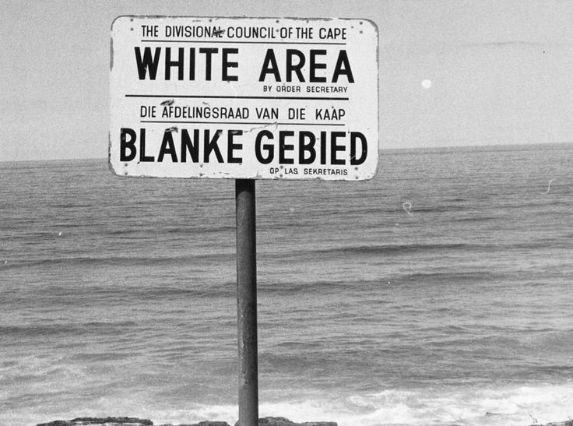

**Questions:**

1. What racial discrimination existed under apartheid law?

………………………………………………………………………………………………………………………………………………

………………………………………………………………………………………………………………………………………………

………………………………………………………………………………………………………………………………………………

1. What does ‘white by night’ mean? Why do you think white men wanted this rule?

………………………………………………………………………………………………………………………………………………

………………………………………………………………………………………………………………………………………………

………………………………………………………………………………………………………………………………………………

1. What rules existed to enforce white and black families to live separately? Why do you think white families wanted this?

………………………………………………………………………………………………………………………………………………

………………………………………………………………………………………………………………………………………………

………………………………………………………………………………………………………………………………………………

1. Look at the images. What do they tell you about life under apartheid rule? How do the images make you feel?

………………………………………………………………………………………………………………………………………………

………………………………………………………………………………………………………………………………………………

………………………………………………………………………………………………………………………………………………

………………………………………………………………………………………………………………………………………………

**Peer Assess:** What impressed you/was interesting about this student’s work?

What one thing/detail would you add?

………………………………………………………………………………………………………………………………………………

**Parent/ carer comments:**

**Week 6: Comprehension task**

**Consolidation**

Complete the questions about the poems you have studied in class this Module.

***Nothing’s Changed* by Tatamkhulu Afrika**

1. Why is Tatamkhulu Afrika’s poem called ‘Nothing’s Changed’?

……………………………………………………………………………………………………………………………………..

……………………………………………………………………………………………………………………………………..

1. What do the following lines mean:

District 6.

No board says it is:

but my feet know,

and my hands

……………………………………………………………………………………………………………………………………..

……………………………………………………………………………………………………………………………………..

……………………………………………………………………………………………………………………………………..

1. What is the main contrasting image in this poem?

……………………………………………………………………………………………………………………………………..

***Island Man* by Grace Nichols**

1. Where does ‘Island Man’ live? ……………………………………………..
2. Where did he used to live? ……………………………………………..
3. What is the reason he ‘heaves’ himself up out bed at the end of the poem

……………………………………………………………………………………………………………………………………..

……………………………………………………………………………………………………………………………………..

***Blessing* by Imtiaz Dharker**

1. What happens to the ‘municipal pipe’ running past the slums?

……………………………………………………………………………………………………………………………………..

……………………………………………………………………………………………………………………………………..

1. Why is the water described as being the ‘voice of a kindly god’?

……………………………………………………………………………………………………………………………………..

……………………………………………………………………………………………………………………………………..

1. Why does she describe the children as having ‘small bones’

……………………………………………………………………………………………………………………………………..

……………………………………………………………………………………………………………………………………..

**Peer Assess.** Mark out of 9: ………….

Were there any misunderstandings? Write the correct answer/s here:

…………………………………………………………………………………………………………………………………….

…………………………………………………………………………………………………………………………………….

…………………………………………………………………………………………………………………………………….

**Parent/ carer comments:**

**Week 7: Revision of key terms**

**Consolidation**

Complete the missing boxes in the table to show your understanding of key poetic terms and techniques.

|  |  |
| --- | --- |
| **Term** | **Definition** |
| Stanza |  |
|  | The continuation of a sentence without a pause beyond the end of a line, couplet, or stanza. |
| Personification |  |
|  | Creating a vivid picture in the reader’s mind |
|  | A comparison in which one thing is said to be another thing (not literally possible) |
| Onomatopoeia |  |
| Alliteration |  |
| Sibilance |  |
| Plosive sounds |  |
| Fricative sounds |  |

Peer assess: ……… /10

**Parent/ carer comments:**