Worle Community School Academy

Geography
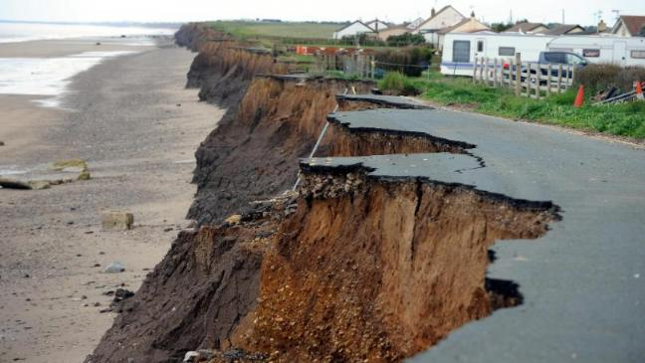
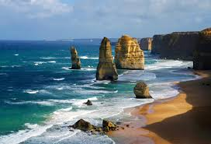
Physical Landscapes: Coasts

Name: ______________________________________
Class: _______________
Teacher: ___________________________________
Yr 9 Homework Cycle 1
Cycle 1 Calendar - Homework
Sep  2018 | 1.1 | 3 | 4 | 5 | 6 | 7
 | 1.1 | 10 | 11 | 12 | 13 | 14
 | 1.2 | 17 | 18 | 19 | 20 | 21
 | 1.3 | 24 | 25 | 26 | 27 | 28
Oct  2018 | 1.4 | 1 | 2 | 3 | 4 | 5
 | 1.5 | 8 | 9 | 10 | 11 | 12
 | 1.6 | 15 | 16 | 17 | 18 | 19
 |  | 22 | 23 | 24 | 25 | 26
 |  | 29 | 30 | 31 | 1 | 2
Nov  2018 | 1.7 | 5 | 6 | 7 | 8 | 9
 | 1.8 | 12 | 13 | 14 | 15 | 16
 | 1.9 | 19 | 20 | 21 | 22 | 23

- During the Assessment Week, students will be assessed on the material that they have covered the previous 7 weeks in Geography.

- Following this, the teacher will re-teach areas of underachievement, as identified during the assessment week, during the Super Teaching week.

- The tasks labelled as “consolidation tasks” mean that students should be able to complete them using their knowledge from lessons.

- There are also tasks labelled, “research tasks”, where we are asking students to spend 15-20 minutes doing some research.

Week | Homework task | Peer / Self | Red | Amber |  | Green
1 | Physical landscape of the UK
2 | UK coastal landscapes
3 | Weathering and erosion
4 | Transportation
5 | Coastal landforms
6 | Coastal deposition
7 | Coastal Management
 | Parent /carer comments
There is a space below in the table for parents/carers to make a comment

HW 1 – consolidation and research
Physical Landscape of the UK

- What does the term ‘relief’ mean? _____________________________________________________________________

- Label the map of the UK showing areas of highland, lowland and rivers. Complete the empty boxes once you have drawn on the rivers and shaded the highland. Use an atlas to help you.
Rivers – Use the number key to identify these rivers in the correct place on the map

- Thames
- Severn
- Wye
- Trent
- Tweed

Areas of Highland – use a brown crayon and shade the highland area lightly. Write their names very small and neatly onto the area of highland. Remember capital letters.
- Northwest Highlands
- Grampian Mtns
- Southern Uplands
- Cumbrian Mtns
- Pennines
- Cambrian Mtns
- Exmoor
- Dartmoor

The boxes around the map should be filled using the information below. Use an atlas to work out which is which.

- The Grampian Mountains are steep, rocky and sparsely populated. Ben Nevis, the highest mountain in the UK is here.
- The largest area of lowland is in East Anglia and around the Fens. The Fens are a marshy area with some areas below sea level.
- The Dorset coast contains bands of hard and soft rock which give features like Durdle Door and Lulworth Cove.
- Flat land of the flood plain of the River Clyde is where Glasgow is built.
- Snowdonia is within the Cambrian Mtns and is a glaciated upland area.
- The SW peninsula contains the upland granite moors of Exmoor and Dartmoor.

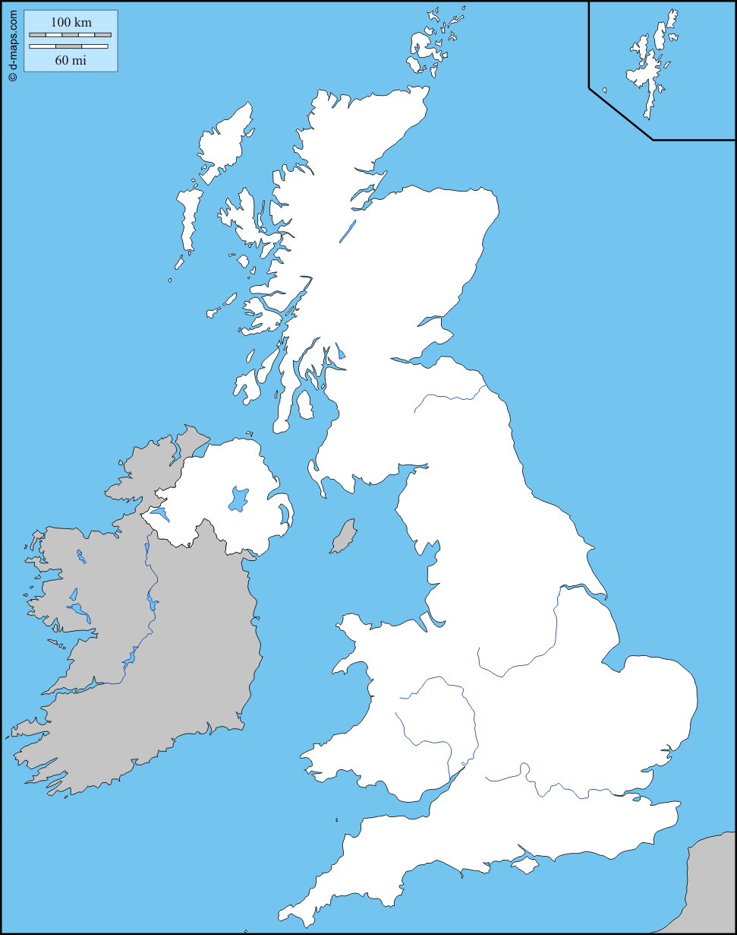

Number Key for Rivers

1. 2.
3. 4.
5.

- Describe the distribution of the UK’s highlands and lowlands –remember to refer to compass directions and nation names. You could also include some mountain names. ________________________________________________________________________________________________________________________________________________________________________________________________________________________________________________________________________________________________________________________________________________________________________________________________________________________________________________________________________________________________________________________________________________________________________________

- What 3 features of a landscape is relief used to describe?
________________________
________________________
________________________

- What is a landscape? ________________________________________________________________________________________________________________________________________________________________________________________________________________________________________________________________________________________

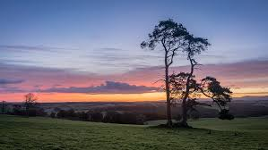
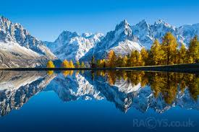

HW 2 - consolidation
UK Coastal Landscapes

1. – How do waves form? (Think about wind, fetch and friction).
___________________________________________________________________________________________________________________________________________________________________________________________________________________________________________________________________________________________________________________________________________________________________________________________________________________________________________________________________________________________________
2. – Compare the characteristics of constructive and destructive waves.

 | Constructive Waves | Destructive Waves
When are they most common? (think seasons).
Distance from each wave.
(far or close)
Height

(high or low)
Frequency

(high or low)
Strength of swash

(strong or weak)
Strength of backwash

(strong or weak)
Effect on the beach

(gain or loss)

TASK 3 – Draw and label a diagram of constructive waves.

TASK 4 – Draw and label a diagram of destructive waves.

TASK 5 – Compare the characteristics between constructive and destructive waves. (Remember to use comparative language).
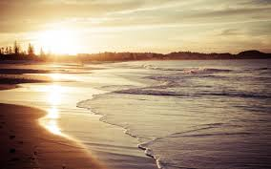
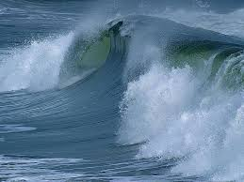
___________________________________________________________________________________________________________________________________________________________________________________________________________________________________________________________________________________________________________________________________________________________________________________________________________________________________________________________________________________ _______________________________

HW 3 – consolidation

Weathering and erosion

- What does the term weathering mean?
____________________________________________________________________________________________________________________________

- Complete the diagram below to describe three different types of weathering

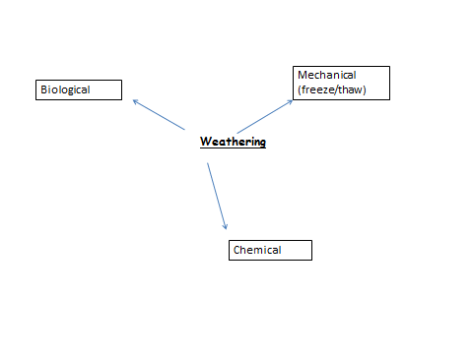

- What is the meaning of mass movement?

__________________________________________________________________________________________________________________________________________________________________________

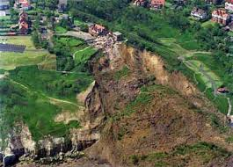
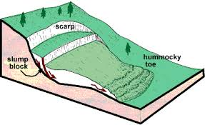

- There are 4 types of mass movement:

L_____________

R_____________

R_____________ S____________

M_____________

- What does erosion mean?

________________________________________________________________________________________________________________________________________

- Complete the table below to describe the 5 processes of erosion, in your own words.

Name of process
Hydraulic Action

Abrasion

Attrition

Corrasion

Solution

- Which type of wave is more likely to cause erosion? Why?

__________________________________________________________________________________________________________________________________________________________________________

HW 4 – consolidation

Transportation

- Describe what each of the 4 types of transportation are in the table below – add a diagram for each one to help you remember them.

Transportation type | Description | Image
TRACTION

SALTATION

SUSPENSION

SOLUTION

- What direction do waves approach the coastline?
__________________________________________________________

- Draw and annotate a diagram to show the process of Longshore Drift

- What is swash and backwash?
____________________________________________________________________________________________________________________________________________________________________________________________________________________________________________

- Explain the process of Longshore Drift
_____________________________________________________________________________________________________________________________________________________________________________________________________________________________________________________________________________________________________________________________________________________________________________________________________________________________

- What does prevailing wind mean?
______________________________________________________________________________________________________________________

- What is the direction of the prevailing wind in the UK?
________________________________________________

HW 5 – consolidation

Coastal landforms

- What factors influence coastal landforms?
____________________________________________________________________________________________________________________________________________________________________________________________________________________________________

- Explain how geological structure influences coastal landforms
____________________________________________________________________________________________________________________________________________________________________________________________________________________________________

- Explain how rock type influences coastal landforms.
____________________________________________________________________________________________________________________________________________________________________________________________________________________________________

- Complete the table below by giving examples of rock types

Hard (more resistant) rocks | Soft (less resistant) rocks

- What are the two types of coastline – draw a simple diagram to help you remember?

i)_______________________

ii)______________________

- Draw and annotate a diagram to show how headlands and bays are formed.

- Give an example of where you can find headlands and bays (not far away)
__________________________________________________________________________________________________________________

- Draw and annotate a diagram to show the formation of caves, arches and stacks.

- Give an example of where this feature occurs.
______________________________________________________

HW 6 - consolidation

Coastal Deposition

- What does deposition mean?
___________________________________________________

- Under what conditions will deposition occur?
_____________________________________________________________________________________________________________________________________________________________________

- Which type of wave will be more likely to deposit? Why?
______________________________________________________________________________________________________________
- What are the differences between sandy beaches and pebble beaches?
____________________________________________________________________________________________________________________________________________________________

- Describe and explain the formation of a spit

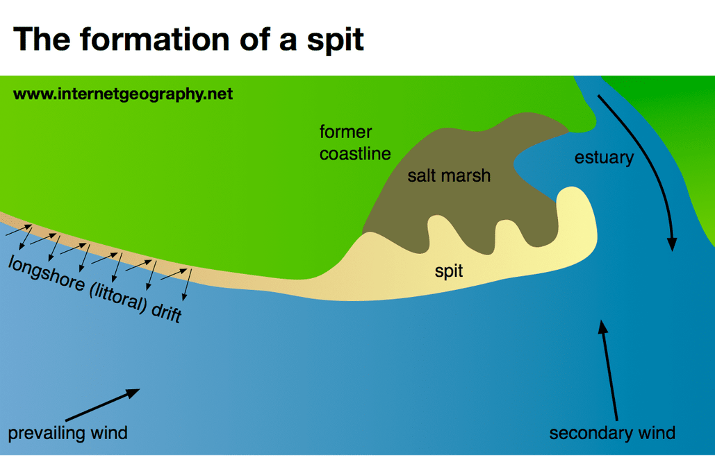

________________________________________________________________________________________________________________________________________________________________________________________________________________________________________________________________________________________________________________________________________________________________________________________________________________________________________________________________________________________________________________________________________________________________________________________________

- Name an example of spit. Where can it be found?

______________________________________________________________________________________________________________

- Name 2 other coastal deposition landforms
___________________________
___________________________

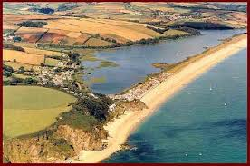
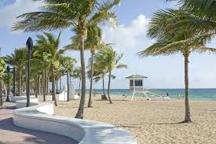

HW 7 – consolidation
Coastal Management
- What is hard engineering – give an example?
________________________________________________________________________________________________________________________

- What is soft engineering – give an example?
________________________________________________________________________________________________________________________

3.Complete the table below on hard engineering strategies
Method | Cost | Advantages – how will it protect the coast | Disadvantages

- Which is the best of these methods and why?
____________________________________________________________________________________________________________________________________________________________________________________________________________________________________________________________________________________________________________

- Complete the table below on soft engineering strategies
Method | Cost | Advantages – how will it help protect the coast | Disadvantages

- Which is the best of these methods and why?
____________________________________________________________________________________________________________________________________________________________________________________________________________________________________________________________________________________________________________

- What does Managed Retreat mean?
____________________________________________________________________________________________________________________________________________________________________________________

