Worle Community School Academy

Geography





**Name: _______________________________________________**

**Class: _______________**

**Teacher(s)_______________________________________________**

Yr 8 Homework Book 1

|  |  |  |  |  |  |  |  |
| --- | --- | --- | --- | --- | --- | --- | --- |
|  |  |  |  |  |  |  |  |
| Cycle 1 Calendar - Homework | | | | | | |  |
|  |
|  |  |  |  |  |  |  |  |
| **Sep 2018** | 1.1 | 3 | 4 | 5 | 6 | 7 |  |
| 1.1 | 10 | 11 | 12 | 13 | 14 | W1 |
| 1.2 | 17 | 18 | 19 | 20 | 21 | W2 |
| 1.3 | 24 | 25 | 26 | 27 | 28 | W3 |
| **Oct 2018** | 1.4 | 1 | 2 | 3 | 4 | 5 | W4 |
| 1.5 | 8 | 9 | 10 | 11 | 12 | W5 |
| 1.6 | 15 | 16 | 17 | 18 | 19 | W6 |
|  | 22 | 23 | 24 | 25 | 26 | 1/2 term |
|  | 29 | 30 | 31 | 1 | 2 | 1/2 term |
| **Nov 2018** | 1.7 | 5 | 6 | 7 | 8 | 9 | W7 |
| 1.8 | 12 | 13 | 14 | 15 | 16 | **Assessment** |
| 1.9 | 19 | 20 | 21 | 22 | 23 | STW |
|  |  |  |  |  |  |  |

* During the Assessment Week, students will be assessed on the material that they have covered the previous 3-4 weeks in Geography.
* Following this, the teacher will re-teach areas of underachievement, as identified during the assessment week, during the Super Teaching week.
* The tasks labelled as “**consolidation tasks**” mean that students should be able to complete them using their knowledge from lessons.
* There are also tasks labelled, “**research tasks**”, where we are asking students to spend 15-20 minutes doing some research.

**Useful Websites to help you with your research**

BBC Bitesize, Wateraid, World food aid, Renewable UK, Trussell Trust

Each week we will mark homework in class. Write in the score you got and how easy you found the homework (RED = really tough, Amber= OK, Green =Easy).

|  |  |  |  |  |  |  |  |  |
| --- | --- | --- | --- | --- | --- | --- | --- | --- |
| Week | Homework task | Complete | | Red | | Amber | | Green |
| **1** | **1. Where can we live?** |  | |  | |  | |  |
|  | Parent /carer comments |  | | | | | | |
| **2** | **Why do some places have more people than others?** |  | |  | |  | |  |
|  | Parent /carer comments |  | | | | | | |
| **3** | **Population density** |  | |  | |  | |  |
|  | Parent /carer comments |  | | | | | | |
| **4** | **Overpopulation solutions** | Peer checked  | |  | |  | |  |
|  | Parent /carer comments |  | | | | | | |
| **5** | **Resources** |  |  | |  | |  | |
|  | Parent /carer comments |  | | | | | | |
| **6.** | **Food security** |  |  | |  | |  | |
|  | Parent /carer comments |  | | | | | | |
| **7.** | **Research task** | Teacher checked |  | |  | |  | |
|  | Parent /carer comments |  | | | | | | |

There is a space below each task in the table for parents/carers to make a comment if they need to.

**Week 1 – Consolidation task**

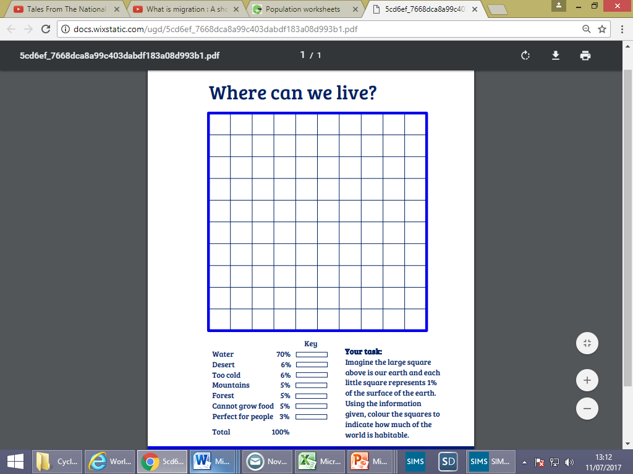

What does the diagram show you? Describe it.

____________________________________________________________________________________________________________________________________________________________________________________________________________________________________________________________

How do you think it affects population?

_________________________________________________________________________________________________________________________________________________________________________________________________________

1. What is the majority of the planet made up of?

________________

1. How much of the planet is perfect for people?

_______________

1. How much of the planet is uninhabitable (not good for people)?

_______________

**Week 2 - Consolidation task**

Why do some places have more people than others?

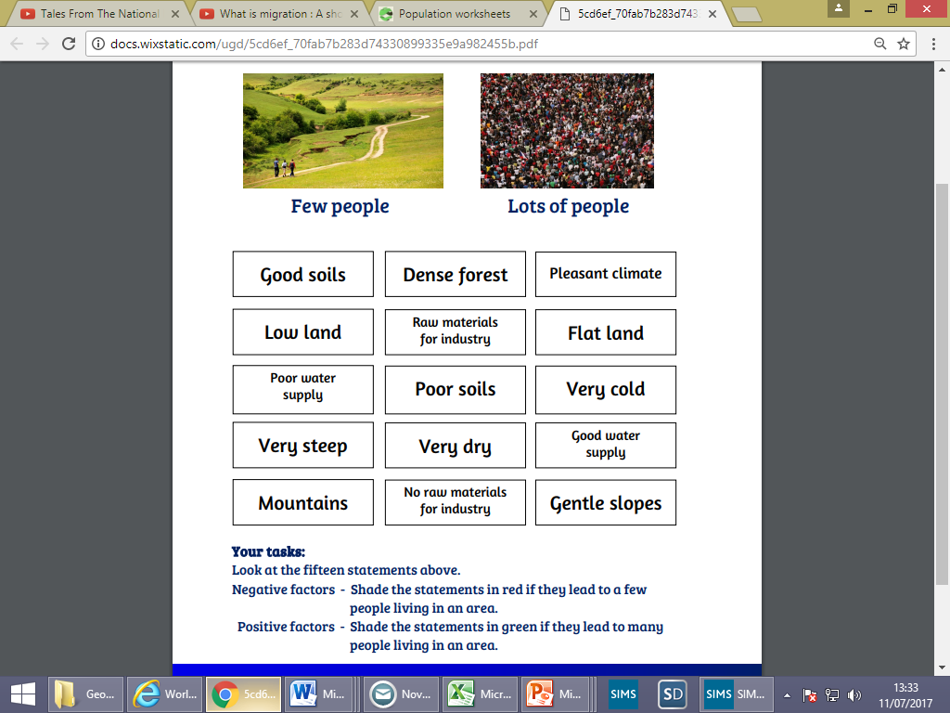

Can you think of a real location with high or low population that is affected by some of these factors?

Location with a high population _________________________

Factor ________________________

Location with a low population ______________________

Factor ________________________

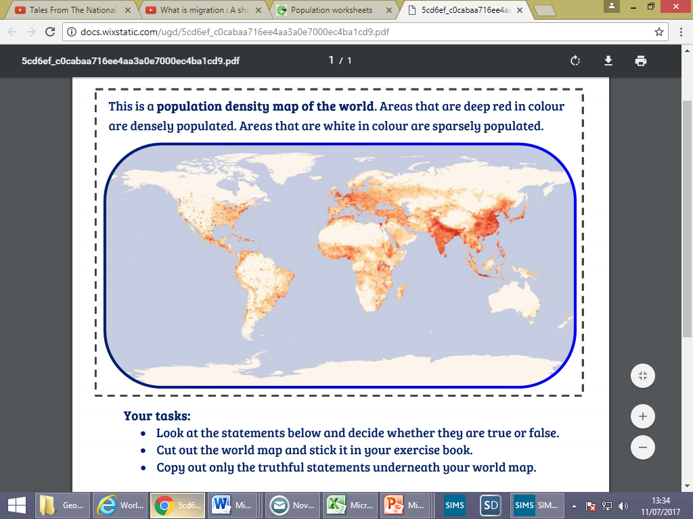**Week 3 – Consolidation task**

This is a population density map of the world. Areas that are a darker colour are densely populated (have lots of people per sq km). Areas that are white are sparsely populated (have fewer people per sq km)

1. Look at the statements below and decide if they are true or false. You may need the map in your planner to help with continents

Circle/shade the true statements

|  |  |  |
| --- | --- | --- |
| Africa is unevenly populated | South America is the most crowed continent | Some places are more crowded than others |
| People are spread out evenly over the world | You can work out the location of the Sahara Desert on this map | Greenland, Australia and northern Canada are all sparsely populated |
| People are spread out evenly over Asia | Asia is the most densely populated continent | Europe is a densely populated continent |

2. Can you write another true statement for the map?

__________________________________________________________________________________________________________________________________________

3. Describe the distribution of people across the world ____________________________ _______________________________________________________________________________________________________________________________________________________________________________________________________________

**Week 4 – Consolidation task**

Overpopulation solutions

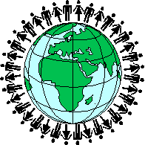Imagine you are the president of a country that is overpopulated. Design a population policy that will reduce the population, making your country more sustainable. Explain why it will work.

**Key word:**

Overpopulation=

Sustainable =

______________________________________________________________________________________________________________________________________________________________________________________________________________________________________________________________________________________________________________________________________________________________________________________________________________________________________________________________________________________________________________________________________________________________________________________________________________________________________________________________________________________________________________________________________________________________________________________________________________________________________________________________________________________________________________________________________________________________________________________________________________________________________________________________________________________________________________________________________________________________________________________________________________________________________________________________________________________________________________________________________________________________________________________________________

**In class** marking: Get your neighbour to read your idea. Do they think it will work? Why?

_________________________________________________________________________________________________________________________________________________________________________________________________________________________________

**Week 5 – Consolidation**

**Resources**

**What resources do people need to survive? List some ideas:**

**What do you think will happen in the future to resources? Think about what we have looked at in lessons to do with population. _____________________________________________________________________________________________________________________________________________________________________________________________________________________________________________________________________________________________________________________________________________________________________________________________________________________________**

**Challenge: what do you think the graph below is showing us?**

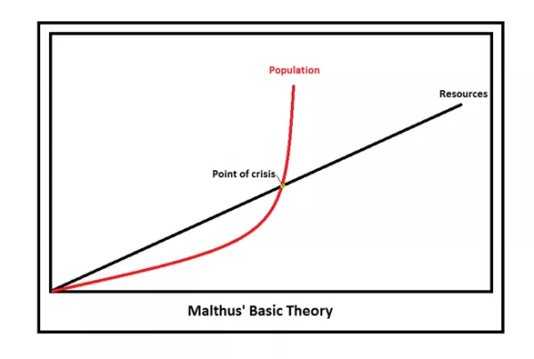

**________________________________________________________________________________________________________________________________________________________________________________________________________**

**Week 6 – Consolidation task**

**Food security**

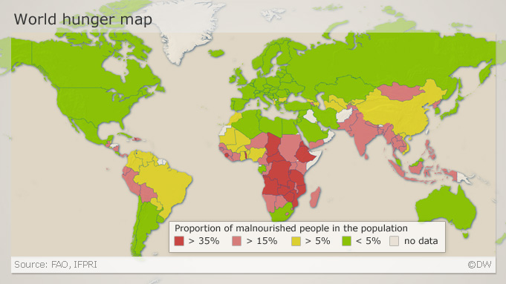

Look at the map above. This shows where in the world people do not have enough food. The darker the colour, the more people are malnourished (not getting enough food).

Describe the locations where people do not have enough food. _________________________________________________________________________________________________________________________________________________________________________________________________________________________________________________________________________________________________________________________________________________________

Why might these locations be malnourished/ not have enough food? What sort of country are they? What might it be like there? _______________________________________________________________________________________________________________________________________________________________________________________________________________________________________________________________________________________________________

**Week 7 – Research task**

**TASK:**

**Research one method used to help with one problem we have looked at to do with FOOD, WATER or ENERGY. Create a fact file about it. Then evaluate how good you think it is.**

**Name of project:_________________________________________**

**Where it is helping:_______________________________________**

**What issue is it dealing with: FOOD/WATER/ENERGY?**

**What does the project do: __________________________________________________________________________________________________________________________________________________________________________________________________________________________________________________________________________________________________________________________________________________________________ ______________________________________________________________________________________________________________________**

**How good do you think this project is? Include pros and cons. _____________________________________________________________________________________________________________________________________________________________________________________________________________________________________________________________________________________________________________________________________________________________________________________________________________________________**

**Teacher comments:**