ICT - Doddle homework
Year you started year 7
Name: ___________________
Class: ___________________
Username: JoeBloggs14
Use capitals for the first letter of your first and last name
Your first name and last name

Password: worle
Learning cycle 1
Week | Homework title | Final % score | Due date | Home signature
1 | Understanding algorithms
2 | Handling data in algorithms
3 | Searching and sorting
4 | Functions and procedures
5 | String and file handling
6 | Python v3 mini quiz 2
7 | Programming Tools
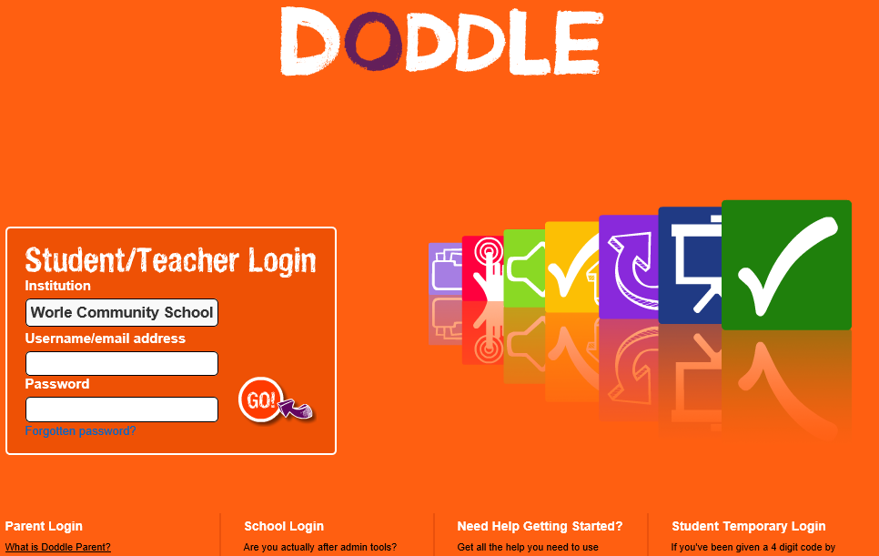
www.doddlelearn.co.uk

Institution = worle community school

