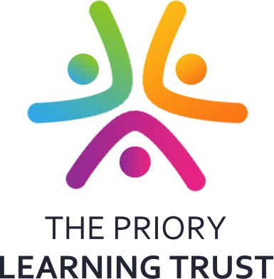

**Year 8 Option Choices**

A student and parent guide to making Year 8 course choices

**2018 - 2021**



**Contents Page**

|  |  |
| --- | --- |
| Content Page | Page 1 |
| Letter to Parents | Page 2 |
| Options Choices Grid | Page 3 |
| Options Specimen Choices Form | Page 4 |
| Useful Websites and Other Useful Information | Page 5 |
| Student Information | Page 6 |
| Thinking about Careers Grid | Page 7 |
| IAG in Key Stage 4 | Page 8 |
|  |  |
| **Core Subjects** | **9** |
| English | Page 10 |
| Maths | Page 11 |
| Combined Science | Page 12 |
| Religious Studies | Page 13 |
| Core PE | Page 14 |
|  |  |
| **Option Subjects Science** | **15** |
| Triple Science | Page 16 |
| **Option Subjects Design and Technology** | **17** |
| Food | Page 18 |
| Graphics | Page 19 |
| Resistant Materials | Page 20 |
| Textiles | Page 21 |
| **Options Subjects Arts** | **22** |
| Art: Fine Art | Page 23 |
| Art: Digital Art | Page 24 |
| Music | Page 25 |
| Music Practitioners | Page 26 |
| Dance | Page 27 |
| Drama | Page 28 |
| **Option Subjects Languages** | **29** |
| French | Page 30 |
| Spanish | Page 31 |
| **Option Subjects Humanities** | **32** |
| History | Page 33 |
| Geography | Page 34 |
| **Option Subjects Social Sciences** | **35** |
| Citizenship | Page 36 |
| Business Studies | Page 37 |
| **Option Subjects Information Technology** | **38** |
| Certificate in Digital Applications | Page 39 |
| Computer Science | Page 40 |
| **Option Subjects Additional Courses** | **41** |
| Cambridge National Child Development | Page 42 |
| OCR National PE | Page 43 |

Dear Parents/Carers & Students

In September 2018 students currently in Year 8 will embark on three options of three year courses, most of which will lead to GCSE qualifications or equivalent. It is hoped that all students will be able to choose courses that meet individual needs and learning styles and prepare students for either further education, an apprenticeship or employment with training. A booklet is designed to support the information and guidance given by subject teachers.

The booklet gives details of both compulsory/core courses and option courses studied during the three Upper School Years. The Options Form within the booklet is a specimen example; a separate form will be issued for you to submit.

**Information & Guidance**

There are a wide variety of ways your child can access information and guidance in choosing their GCSE options.

* During normal lessons individual subject teachers will discuss students’ progress this year and their prospects for GCSE or equivalent course
* Subjects not delivered at Key Stage 3 will be explained by Subject Leaders at Options Evening for your child to consider.
* Students can access additional guidance from Ms Cuthbertson, Careers Coordinator, in the LRC.
* Head of Year 8 and Tutors will also play an important role in advising students on the Options process and appropriate choices. Tutors will dedicate a week of tutor time into explaining and discussing different options for students.
* There are excellent careers websites given in this booklet for you and child to explore, as well as links to related careers/professions alongside subject information.

**Important Dates for diaries**

All parents and students are warmly invited to attend a Choices Information Evening on **Thursday 1st March 2018 at 4.30 – 6.30pm** where you will have the opportunity to meet subject representatives and also be guided through the process of making choices. During the evening there will be presentations on subject options and progression routes. The presentations will take place at 4.30pm and again at 5.45 pm in the Auditorium. Following the presentation, you are welcome to walk around the marketplace in the restaurant and talk to curriculum teachers, who will be available to answer your questions about each course and potential options. During the evening representatives from Weston College and Bridgwater College will provide additional information on Post 16 pathways.

The **deadline** for returning the Options Choices Form is **Friday 16th March 2018.** Choices will then be discussed with students as necessary and subjects need to be viable in terms of numbers for them to run or students may be given their reserve choice of option.

Under current legislation, your child will have to stay in some form of education or training until they turn 18. This can be:

* full-time education, e.g. at a school with sixth form provision or college
* an apprenticeship
* full-time employment (over 20 hours a week) combined with part-time education or training

Students will also continue to study English and Maths if a 5-9 grade is not achieved before starting their post 16 option.

Meanwhile, if you have any questions or require further information please contact us.

Yours faithfully,

Angelos Markoutsas Jacqui Scott

Vice Principal Principal

|  |  |
| --- | --- |
| **All Students do a Core Curriculum which consists of:** | |
| Maths (GCSE) | 4 hours per week |
| English Language and English Literature (2 GCSEs) | 4 hours per week |
| Combined Science (2 GCSEs) | 5 hours per week |
| Religious Studies (GCSE over 3 years) | 2 hours per week |
| Core PE (non-exam based) | 2 hours per week |
| **This equals 6 GCSE qualifications equalling 17 hours per week** | |

**Year 8 Core and Options Subjects for Upper School—23 Subjects**

|  |
| --- |
| **1 or 2 OPTIONS FROM BOX A**  **(COURSES COVERED OVER 3 YEARS, 3 HOURS PER WEEK)** |
| * GCSE History - **EBacc route** * GCSE Geography – **EBacc route** * GCSE French - **EBacc route** * GCSE Spanish - **EBacc route** * GCSE Computer Science |

|  |  |  |
| --- | --- | --- |
| **1 or 2 OPTIONS FROM BOX B**  **(COURSE COVERED OVER 3 YEARS, 2.5 HOURS PER WEEK)** | | |
| **Social Sciences**  • BTEC Business Studies  • GCSE Citizenship    **Design and Technology**  • Level 2: Food  • GCSE DT: Graphics  • GCSE DT: Resistant Materials  • GCSE DT: Textiles | **Arts**  • GCSE Fine Art  • GCSE Digital Art  • GCSE Drama  • GCSE Music  • Music Practitioners (*GCSE Equivalent dependent on units studied)*  • GCSE Dance  **Triple Science**  • Biology/Physics/Chemistry | **Additional Courses**  • Cambridge National Child Development  • OCR National PE    **Information Technology**  • Certificate in Digital Applications (CiDA) |

**Copy**

**Year 8 Options Choices Form:**

Name: ………………………………………………………………………………………………………..

Tutor Group: ……………..

**Make three option choices plus one reserve choice from each box**

Choose **ONE** or **TWO** from Box A

|  |  |
| --- | --- |
| Box A Choices | 🗹 |
| History | 🞎 |
| Geography | 🞎 |
| Computer Science | 🞎 |
| French | 🞎 |
| Spanish | 🞎 |

Reserve from Box A \_\_\_\_\_\_\_\_\_\_\_\_\_\_\_\_\_\_\_\_\_\_\_\_\_\_\_\_\_\_\_

Choose **ONE** or **TWO** subjects from Box B, depending on the number of choices from Box A, and then select **ONE** reserve

*Please note that subjects within the one department e.g. GCSE Textiles and Food are likely to run at the same time*

|  |
| --- |
| Box B Choices |
|  |

|  |  |
| --- | --- |
| Reserve from Box B | |
| Reserve |  |

***I have discussed and agreed these option choices with my child and confirm this selection.***

***I understand that changes to this selection can only be made in exceptional circumstances and within 4 weeks of the start of the new academic year****.*

Signed (Parent/Carer)

Print Parent/Carer Name

**Useful websites for:**

**Year 8 GCSE**

**Careers Guidance and Future Pathways**

<http://icould.com/watch-career-videos/by-job-type/>

[www.careerpilot.org.uk](http://www.careerpilot.org.uk)/

<https://www.plotr.co.uk/>

<https://nationalcareersservice.direct.gov.uk/>

[www.ucas.co.uk](http://www.ucas.co.uk)/

[www.apprenticeships.org.uk](http://www.apprenticeships.org.uk)/











[](http://www.google.co.uk/imgres?imgurl=http://www.smuc.ac.uk/undergraduate/photos/ucas-logo.jpg&imgrefurl=http://www.smuc.ac.uk/undergraduate/ucas-timeline.htm&usg=__wsz4MWK0Pg0rsNm-sknk40Y1dRo=&h=326&w=490&sz=17&hl=en&start=2&zoom=1&tbnid=Q5J2TVCRKoZOyM:&tbnh=86&tbnw=130&ei=PWV-Ua3FD-ng7QazzIH4DA&prev=/search?q=ucas+logo&safe=vss&hl=en-GB&gbv=2&tbm=isch&itbs=1&sa=X&ved=0CC4QrQMwAQ)

**TO YEAR 8 STUDENTS**

**What should you do?**

* Consider which subjects you are **GOOD** at.
* Consider which subjects you **ENJOY.**
* Think about what you would like to do when you leave Worle Community School and find out what subjects are **NEEDED FOR YOUR FUTURE.**
* **READ** the information in this booklet carefully.
* **ASK** if you need further information or help.
* **TRY** to keep open to as many future career options as possible.
* **DON’T** choose a subject because you like a teacher or because a friend has chosen it.
* **Talk** to subject teachers for guidance.

**Who can help you make your Choices?**

* Discuss your choices with your **parents** – they want you to do well.
* Your **Tutor,** whowill be able to advise you.
* Your **Head of Year,** whowill be able to advise you.
* Your **Subject Teachers** can tell you what your strengths and weakness are in their subjects.
* **Ms Cuthbertson can advise you on appropriate pathway options.**
* **Careers websites listed in this booklet**

**Why should i choose a broad and balanced range of subjects?**

* To prepare you for a future you can’t predict.
* Many students do not have firm ideas about future jobs and careers and others change their minds.
* It looks increasingly likely that in the future people will have a variety of jobs during their working lives.

**What should you do next?**

* When you decide on your choices **FILL IN** your Options Choices Form**.**
* **RETURN** your Options Choices Form to the Student Box:

#### 9.00 a.m. Friday 16th March 2018

* **KEEP** a record of your choices on the duplicate form in this booklet.

**Tutors will be able to help you with this during Tutor Time.**

**Thinking about careers: Investigate 3 careers/jobs you may want to do**

|  |  |  |  |
| --- | --- | --- | --- |
|  | Career 1 | Career 2 | Career 3 |
| Qualifications needed/  Length of Training needed |  |  |  |
| Skills needed |  |  |  |
| Examples of current businesses / employers in this field |  |  |  |
| What the career job entails on a day to day basis |  |  |  |
| Pay / Hours/ Working conditions / Location |  |  |  |



**Information, Advice and Guidance (IAG)**

[](http://www.google.co.uk/url?sa=i&rct=j&q=&esrc=s&frm=1&source=images&cd=&cad=rja&uact=8&ved=0ahUKEwieu6bcyKHKAhUKvBQKHYblD0gQjRwIBw&url=http://www.bishopramseyschool.org/page/?pid=448&psig=AFQjCNF7yMmmU34JQ-x9kiypPqxMbZKESw&ust=1452595007139467)Under current Government legislation, your child will be required to remain in further education or training until the age of 18, although funding may be available to remain in further education and training until the academic year in which your child reaches 19. All schools have a statutory obligation to provide impartial IAG to students so that they are not only aware of the options for future education and training but they are encouraged to raise their aspirations. This will help them to know how to overcome barriers to succeed and do what it takes to fulfil their potential.

[](http://www.google.co.uk/url?sa=i&rct=j&q=&esrc=s&frm=1&source=images&cd=&cad=rja&uact=8&ved=0ahUKEwjp1ZC7yaHKAhWKbRQKHaaMCpYQjRwIBw&url=http://www.theferrers.northants.sch.uk/page/?pid=130&psig=AFQjCNF7yMmmU34JQ-x9kiypPqxMbZKESw&ust=1452595007139467)This IAG will consist of impartial information on a range of future Education and Training providers as well as experience in and knowledge of a diverse range of Employment sectors and roles. Working in Partnership with these bodies, we aim to inspire our students by ensuring they benefit from direct, motivating and exciting experiences to inform decisions about their future education and employment. Through this we aim to help every student make an informed choice regarding their progression opportunities.

This will be enhanced by a series of enrichment activities through curriculum enrichment days and 1:1 appointments for impartial careers advice, as well as their Work Experience in Year 10.

**What is the English Baccalaureate?**

The English Baccalaureate (EBacc) is a performance measure for schools, not a qualification for students. It is a measure of success and shows where pupils have secured a grade 5 or above across a core of academic subjects (English, Maths, Science, Geography or History and a Language) at Key Stage 4.

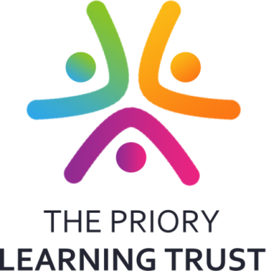

[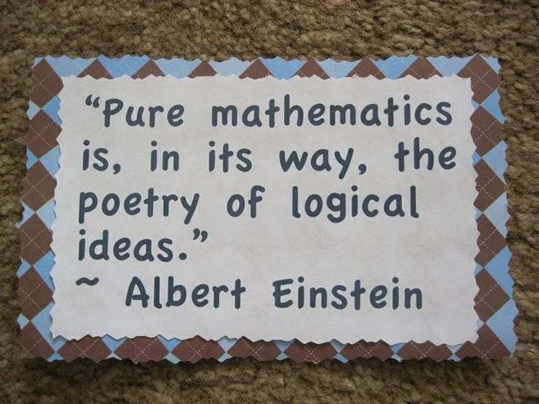](http://www.google.co.uk/url?sa=i&rct=j&q=&esrc=s&source=images&cd=&cad=rja&uact=8&ved=0ahUKEwj4-8qE9vDQAhWpJcAKHRp2B0kQjRwIBw&url=http://quotesgram.com/dear-math-quotes-for-students/&bvm=bv.141320020,d.eWE&psig=AFQjCNEuYqhICP-WdbphNKSuWD9PWB2oSw&ust=1481709929329122)

**Core Subjects**

[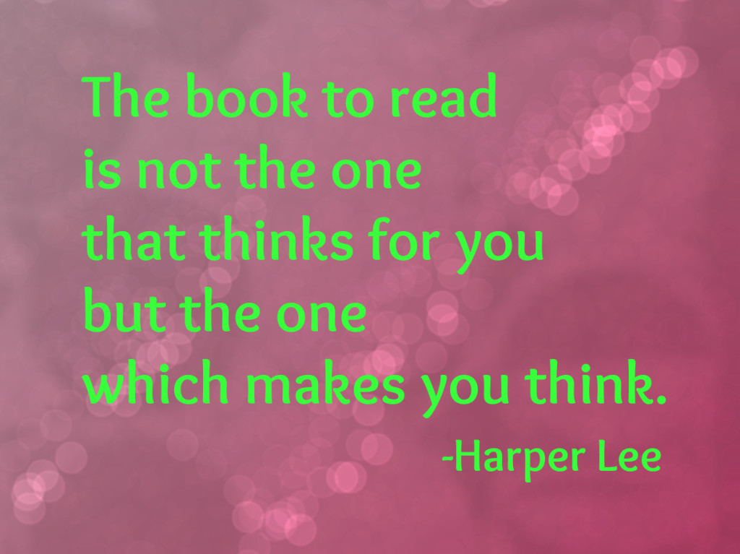](http://www.google.co.uk/url?sa=i&rct=j&q=&esrc=s&source=images&cd=&cad=rja&uact=8&ved=0ahUKEwjTopq1-fDQAhWIAsAKHZtcBVMQjRwIBw&url=http://quotesgram.com/harper-lee-quotes/&bvm=bv.141320020,d.eWE&psig=AFQjCNG0R_NuVEctTIc84Z4ePj1tcxuVeg&ust=1481710882787691)

|  |  |
| --- | --- |
|  | **English** |
| **Qualification Type: GCSE: English Language**  **Examination Board: AQA**  **Qualification Type: GCSE: English Literature**  **Examination Board: AQA**  **Head of Department: Mrs Harris**  **E-mail: gharris@worle-school.org.uk** |

**Description of Course**

All pupils will take two GCSEs: English Language and English Literature. Both courses cover a wide range of opportunities for reading and writing, as well as for speaking and listening, all of which are assessed during the course.

You will read a number of different types of texts, including a Shakespeare play and a post-1914 play, a modern novel and a pre-1914 novel, and a variety of literary poems from different times, as well as looking at different types of non-fiction and media texts. The study of these texts will also help to develop the standard of your writing. In your written tasks, you will learn how to focus on writing with a sense of purpose, audience, format and style of expression.

There is no longer a coursework element to either GCSE, and as a result both courses are completely assessed by end of course examinations.

**How Will You Learn**

English lessons will give you the opportunity for group work, paired work and independent work. There will be a range of reading, writing and speaking and listening activities. There will also be opportunities for you to complete independent research.

You will also be encouraged to continue reading a range of fiction and non-fiction texts, outside of lessons, because the more you read, the better at English you become: it really is as simple as that!

**Method of Assessment**

You will be assessed through:

• Examinations: both English Language and English Literature have two end of course examinations (four in total). You will be required to learn a cluster of fifteen poems, and quotations from Romeo and Juliet, a modern novel and a pre 19th novel.

• Speaking and Listening: you will be assessed on your speaking and listening skills throughout your English Language course. The marks will be reported to the exam board and appear on your exam certificates, although they will not count towards your final grade.

**Pathways after Year 11**

|  |  |
| --- | --- |
| **Training Pathways** | **Career Routes** |
| English is for life, not just for work. The joy of reading and the pleasure that can be found in communicating effectively in speech and writing will always be of use to you.  In work/apprenticeships English is also a vitally important subject: employers, colleges and universities insist you have a qualification in English because it demonstrates to them that you have achieved a satisfactory level of literacy. If you achieve a high grade in English you be able to continue English at A and at degree level. | • Education  • Media  • Publishing  • Advertising  • Marketing  • Journalism/Writing |

|  |  |
| --- | --- |
| MathsLogoV4_NoBackground4 | **Mathematics** |
| **Qualification Type: GCSE**  **Examination Board: Edexcel**  **Specification No: Edexcel GCSE (1MA1)**  **Head of Dept: Mr. Wood**  **E-mail: swood@worle-school.org.uk** |

**Description of Course**

All students follow Mathematics as it is a core subject. There are two levels; Foundation where grades 1-5 are available and Higher where grades 3-9 are available. The course is delivered over 3 years. The topics are Number, Ratio and Proportion, Algebra, Geometry and Measures and Statistics and Probability. Many of the topics will have been studied at a more basic level in years 7 and 8. The amount of content in the new GCSE has increased at both Higher and Foundation level, as has the level of challenge.

**How Will You Learn**

The best way to learn Mathematics is by practice. You will use printed materials, investigations, websites and past papers. Being prepared to attempt problems that at first appear difficult will help you greatly. The new GCSE course has a greater emphasis on problem solving so resilience is vital when faced with difficult questions. This subject will help develop an analytical and logical mind whilst enhancing your numeracy skills.

**Method of Assessment**

|  |
| --- |
| Mathematics is assessed by examinations, all taken at the end of Year 11. There are now 3 papers;  **Paper 1 is a non-calculator paper with a mix of question styles**  **Paper 2 and Paper 3 are calculator papers with a mix of question styles**  The level of demand increases as the students move through the papers and will be designed to test the student’s ability to use a calculator correctly. Each exam is 1 hour 30 minutes long and accounts for 33.3% of the marks awarded. The emphasis on testing has changed and can be seen in the diagrams below;  Half of the marks at foundation tier will be testing Number and Ratio, proportion and change    This is tested less than in the old GCSE  **Pathways after Year 11**  This is tested more than in the old GCSE  This is now a standalone area of content  This is tested less than in the old GCSE  This is now a standalone area of content |

|  |  |
| --- | --- |
| **Training Pathways** | **Career Routes** |
| You will need to study Higher tier if you wish to study A level and beyond. There is a current shortage of people with these skills. | Employers regard mathematics as a key GCSE when they look to appoint people. Mathematics is used in nearly all careers. It is used extensively by architects, engineers, the financial sector, meteorologists, statisticians etc. For further information visit:[**www.mathscareers.org.uk**](http://www.mathscareers.org.uk) |

|  |  |
| --- | --- |
|  | **Combined Science** |
| **Qualification Type: GCSE**  **Examination Board: AQA**  **Specification No: Combined Science: Synergy**  **Useful Web Address: http://www.aqa.org.uk/subjects/science/new-science-gcse-specifications**  **Head of Dept: Mr Davis**  **E-mail: mdavis@worle-school.org.uk** |

**Description of Course**

The Combined Science course includes the three sciences and all students will study this Science course if they are not opting for triple Science.

**Combined Science Modules**

**Biology** – cell biology, organisation, infection and response, bioenergetics, homeostasis and response, inheritance, variation and evolution, and ecology.

**Chemistry** – atomic structure, bonding and the periodic table, quantitative chemistry, energy changes, rates of reaction, chemical analysis, and chemistry of the atmosphere.

**Physics**– forces, energy, waves, electricity and magnetism, matter and atomic structure, and radiation.

**How Will You Learn**

Each topic covers Science that affects our everyday lives and considers Science in the future.

You will build upon the skills and knowledge you have already developed from Years 7 and 8. Your learning will involve a lot of applied practical work and will help you further develop your problem-solving skills. You will look at how Science develops and impacts on our everyday lives and will have the opportunity to develop your communication skills.

**Method of Assessment**

You will sit four written exams for Combined Science worth 25% each and the course is worth two GCSEs. Each is 1 hour and 45 minutes long and consists of 100 marks. The questions are a combination of multiple choice, structured, short and extended writing.

We provide revision resources and support inside and outside of lessons to enable students to make excellent progress in their GCSEs with ample opportunities to practice revision and exam techniques to ensure students are well prepared for their final exams.

**Method of Assessment**

**Pathways after Year 11**

|  |  |
| --- | --- |
| **Training Pathways** | **Career Routes** |
| You could study A-Levels in Science  Other Science-related college courses, e.g. NVQs, BTECs and diplomas.  All post-16 courses look favourably at those who have a Science qualification; for the skills and commitment you have shown in the GCSE. | All employers recognise that studying Science allows you to develop important skills needed in the workplace.  There are many professions that require Double Science qualifications, e.g. Nursing, Medicine, Dentistry, Electronics, Engineering, Business and Management, and Veterinary Science. There are many more where Science is a useful subject to have studied, e.g. Automotive, Mechanics, Beauty, Health and Sports studies. |

**Pathways after Year 11**

|  |  |
| --- | --- |
| Image result for religion | **Religious Studies** |
| **Qualification Type: GCSE**  **Examination Board: AQA**  **Specification No: 8062**  **Useful Web Address: www.aqa.org.uk/subjects/religious-studies/gcse**  **Head of Dept: Ms Reynolds**  **E-mail: mreynolds@worle-school.org.uk** |

**What will I study?**

RS is a subject that looks at belief, philosophy, the meaning of life and the nature of our universe. It is where you can question your beliefs and the beliefs of others. The course introduces students to a wide range of moral and social issues for example environmentalism, abortion, terrorism, the paranormal, justice, homosexuality and divorce to name but a few. Students are encouraged to ask questions, evaluate and be empathetic. The course allows students to be critical, analytical and build their own informed points of view. It aims to enable students to:

• Engage with questions of belief, value, meaning, purpose, truth, and their influence on human life.

• Reflect on and develop their own values, beliefs, and attitudes in the light of what they have learnt and contribute to their preparation for adult life in religiously diverse society and global community.

The course is split into two papers, each containing four topics.

**Paper 1**—Religious Beliefs, Teachings and Practices

**Paper 2**— Themes in Religion: The Existence of God, Marriage and Family, Crime and Punishment and Religion and Life.

**How Will I Learn?**

We encourage students to ask questions, consider both sides of an issue with empathy, but also to be critical and take nothing for granted in order to develop their own balanced and informed point of view. Homework tasks will arise from the content and direction of the lessons and will vary from presentations and research, independent and group work to revision of notes and exam questions.

This course is 100% final exam at the end of Year 11.

Paper 1—1 hour 45 minutes (50%)

Paper 2—1 hour 45 minutes (50%)

There is no controlled assessment.

**What are the pathways for people with an RS GCSE**

|  |  |
| --- | --- |
| **Training Pathways** | **Career Routes** |
| The skills outlined are transferable to, a wide range of situations, subjects and careers in the future. Employers and colleges look favourably upon the subject as demonstrating academic ability and thinking skills.Students can continue with the subject to A Level or use the skills and knowledge learnt to travel down another path way or career. | Any job, which includes contact with people could benefit from GCSE RS. Careers in teaching, law, social work, government, armed forces, police, medical profession and childcare are just a few where RS is highly valued. |



|  |  |
| --- | --- |
| http://t0.gstatic.com/images?q=tbn:ANd9GcSgw4UEg4LBSJpNhpoe_xQ802Gn99Pufb_8HPG7g73sVEddXAPsCQ  **Description of Course** | **Core PE (Non-Examination)** |
| **Qualification Type: n/a**  **Examination Board: n/a**  **Specification No:n/a**  **Useful Web Address:n/a**  **Head of Dept: Mr. Thompson**  **E-mail: cthompson@worle-school.org.uk** |

You will continue to develop and refine your knowledge and understanding of a variety of sports. There will be emphasis placed on your own fitness and understanding about healthy lifestyle. The number of lessons you have will remain as two lessons of PE per week (two hours per week).

You will experience the following:

**Organisation.** You develop the skills and understanding to help organise yourselves and others in a range of sporting activities.

**Teamwork.** You will experience working as a team or for yourselves. You are encouraged to understand the value of full involvement in all activities and to appreciate the role and influence you can have on others.

**Motivation.** You will be given specific challenges and targets which will help motivate you to improve. You will hopefully learn the value of a committed and determined approach to all activities.

**Health and Fitness.** You will be encouraged to take your sport seriously and understand the impact it can have on your future health.

**How Will You Learn**

You will extend your knowledge of activities covered in lower school and wherever possible you are given the opportunity to try out different sports

This is not an examination course

**Method of Assessment**

**Pathways after Year 11**

|  |  |
| --- | --- |
| **Training Pathways** | **Career Routes** |
| Core PE does not have an external examination. However, students are given the opportunity to participate in coaching others, which can lead to leadership qualifications. This qualification is known as Sports Leaders (SL) and it allows students to demonstrate leadership and organisational qualities with young children. | n/a |



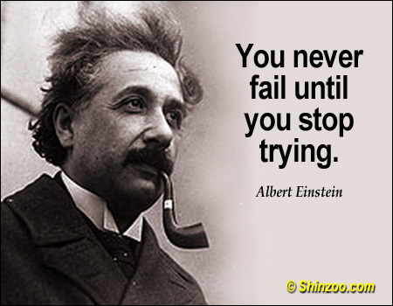

**Option Subjects:**

**Science**

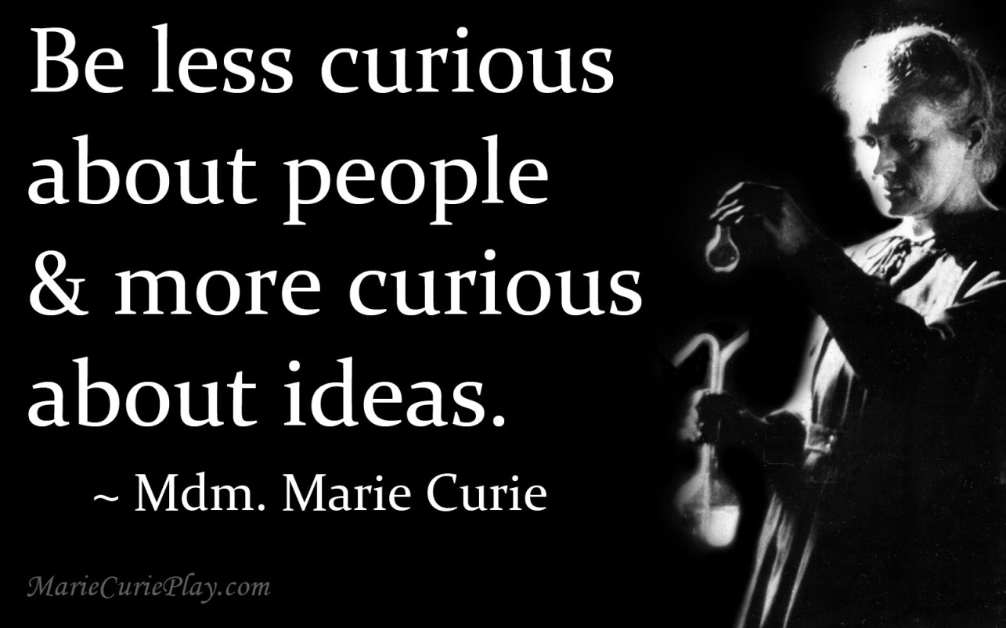

|  |  |
| --- | --- |
| j0305257 | **Triple Science** |
| **Qualification Type: GCSE**  **Examination Board: AQA**  **Specification No: Biology, Chemistry, Physics**  **Useful Web Address: http://www.aqa.org.uk/subjects/science/new-science-gcse-specifications**  **Head of Dept: Mr Davis**  **E-mail: mdavis@worle-school.org.uk** |

The Triple Science course includes the Combined Science (double Science) topics as well as additional triple-only Biology, Chemistry and Physics topics. This option is only available to students achieving higher grades in science and also maths. Students interested in studying this course should speak to either Mr Davis or Mr Muhiddin to discuss their suitability for the course.

This is a highly respected and successful course with a consistent track record of students achieving the top GCSE grades. Many students develop a real passion for the sciences over the two years and go on to study at least one of the sciences post-16, with many pursuing careers linked to science.

All triple Science classes are taught by three subject specialists, who are passionate and experienced at delivering the triple science courses.

Triple Modules

Biology – cell biology, organisation, infection and response, bioenergetics, homeostasis and response, inheritance, variation and evolution, and ecology.

Chemistry – atomic structure, bonding and the periodic table, quantitative chemistry, energy changes, rates of reaction, organic chemistry, chemical analysis, and chemistry of the atmosphere.

Physics – forces, energy, waves, electricity and magnetism, matter and atomic structure, and space.

**Description of Course**

**How Will You Learn**

Each topic covers Science that affects our everyday lives and considers Science in the future.

You will build upon the skills and knowledge you have already developed from Years 7, 8 and 9. Your learning will involve a lot of applied practical work and will help you further develop your problem -solving skills. You will look at how Science develops and impacts on our everyday lives and will have the opportunity to develop your communication skills. You will be expected to work in groups and independently. Your teachers will encourage you to challenge your learning and you must have interest and enthusiasm for Science. If you are someone who has a scientific curiosity about the world around them then this course may be perfect for you.

**Method of Assessment**

You will sit two written exams for each of the three sciences worth 50% of the GCSE each. Both exams are 1 hour and 45 minutes long and consist of 100 marks. The questions are a combination of multiple choice, structured, short and extended writing.

We provide revision resources and support inside and outside of lessons to enable students to make excellent progress in their GCSEs with ample opportunities to practice revision and exam techniques to ensure students are well prepared for their final exams

**Pathways after Year 11**

|  |  |
| --- | --- |
| **Training Pathways** | **Career Routes** |
| A-levels in Science  International Baccalaureate  Degree level Science  Level 3 courses at a college | Careers in Science research.  Medicine, Veterinary Science, Dentistry, Engineering, teaching in a primary school setting and nursing. Popular (but not compulsory) with those wishing to take heavily subscribed University courses, e.g. Law. |

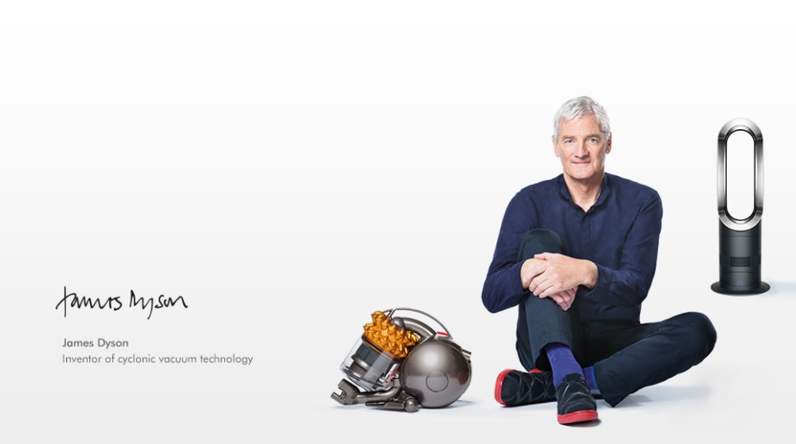

**Option Subjects:**

**Design and Technology**

**Option Subjects:**

**Design and Technology**

[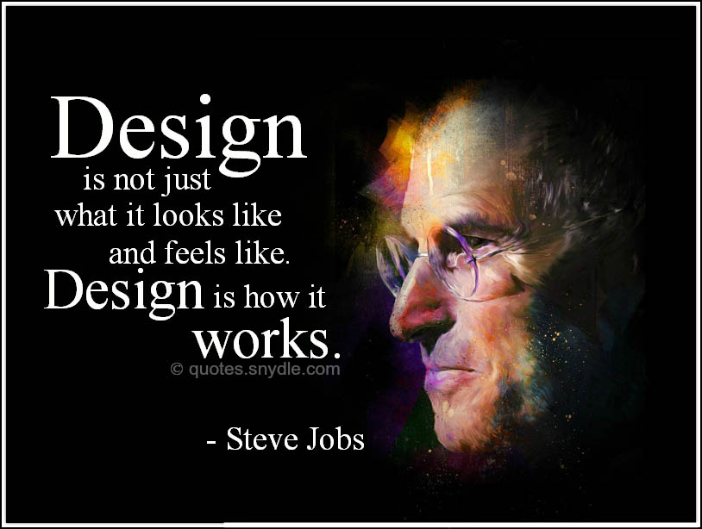](http://www.google.co.uk/url?sa=i&rct=j&q=&esrc=s&source=images&cd=&cad=rja&uact=8&ved=0ahUKEwjr6sm8jPHQAhXDVRoKHdZgC20QjRwIBw&url=http://quotes.snydle.com/steve-jobs-quotes-and-sayings.html&bvm=bv.141320020,d.eWE&psig=AFQjCNEKYEQBnAYtDIeRUAVIdLx9EVhQGg&ust=1481715528585461)

|  |  |
| --- | --- |
| **Description of Course** | **Food** |
| **Qualification Type: Level 1/2 ~Hospitality and Catering**  **Examination Board: Eduqas**  **Specification No: 601/7703/2**  **Useful Web Address: www.eduqas.co.uk**  **Head of Department: Mrs. Burrows**  **E-mail: tburrows@worle-school.org.uk** |

Working in food or cookery requires you to have a passion for food, an interest in and understanding of how it impacts on the body and a wide range of skills depending on your job role and the setting you work in.

Unit 1 Preparing to cook - This unit aims to introduce learners to the safe and hygienic preparation of the cooking environment and ingredients. Learners will understand the importance of how to prepare and store equipment and utensils. Learners will learn to understand and follow recipes to demonstrate their cooking skills to produce a variety of dishes.

Unit 2 Plan and produce dishes in response to a brief - This unit will give learners the opportunity to bring together their learning and skills developed throughout the course to produce a menu in response to a brief. Learners will plan, make and review their completed dishes.

**How Will You Learn**

Studying Eduqas Level 1/2 Hospitality and Catering will help you to develop skills in making, independent learning, researching, analysing and evaluating situations, communicating and modelling ideas and developing decision-making skills through individual and collaborative working.

**Method of Assessment**

The course is assessed in 2 units

Unit 1 (50%) Preparing to Cook – Mandatory Internally Assessed Portfolio of Evidence

Unit 2 (50%) Plan and Produce Dishes in Response to a Brief - Mandatory Internally Assessed Portfolio of Evidence

**There is a one-off payment of £13.25 in Year 9** which will cover some of the basic ingredients needed for some activities over the two years eg salt, pepper, oil, herbs, flavourings, parchment etc

Individual recipe ingredients will not be covered and will need to be brought in from home.

**Failure to bring in ingredients will result in the loss of practical lessons, which are essential for the successful completion of the course.**

Individual recipe ingredients will not be covered and will need to be brought in from home.

**Failure to bring in ingredients will result in the loss of practical lessons, which are essential for the successful completion of the course.**

**Pathways after Year 11**

|  |  |
| --- | --- |
| **Training Pathways** | **Career Routes** |
| By following the Level 1/2 Hospitality and catering course the following level 3 pathways are available:  A Level home economics (food, nutrition and health)  A Level design and technology  Diploma in advanced professional cookery certificate in hospitality and catering principles professional cookery studies | Following successful completion of this course and further studies a number of careers are possible in hospitality and catering with management roles in food establishments and food production. Health and well-being careers in the form of a nutritionist, dietician, environmental health officer and personal trainer. Food development and production roles such as a consumer scientist, food laboratory technician and food retail positions in a bakers, butchers and acting food buyer for larger retail establishments. |

|  |  |
| --- | --- |
| **Description of Course** | **Graphics** |
| **Qualification Type: GCSE**  **Examination Board: Eduqas**  **Specification No: 603/1121/6**  **Useful Web Address: http://www.eduqas.co.uk**  **I/C Graphics: Miss Keogh**  **E-mail: akeogh@worle-school.org.uk** |

The emphasis of the course will be to develop your own creativeness and graphical skills. Underpinning the course are the skills of designing and making, which are taught through the following themes:

* Communication Techniques (colour, logos, typography)
* Presentation Drawings (2D and 3D)
* Design and market influences (product analysis, the environment)
* Materials and Processes (modelling, smart materials, printing, industrial processes)
* Packaging and Pop up Mechanisms ICT/CAD/CAM

**How Will You Learn**

Projects in the first year enable students to learn a wide range of practical & modelling skills to become good graphic designers. Each will involve designing and making to acquire specific skills and knowledge for an extended coursework project in Year 11. Wherever possible, theory work is taught through practical activity but a proportion of the learning is supported by a Text book/Revision guide and an accompanying workbook. Learning about the theory of graphic design and production techniques is important preparation for the written examination in Y11.

**Method of Assessment**

The assessment consists of 2 elements:

1. Written paper - a 2 hour, single tier, 8 question paper which is taken in Year 11 = 50% of GCSE

2. A Controlled assessment: this will be started in September Year 11 and will take place in the classroom in the form of a 9 A3 page folio, a sketchbook and practical piece. This counts for 50% of your final grade.

**There is a one-off payment of £13.25 in Year 9 or 10** **(depending on first year of course)** which will cover everything needed for the course, including a Revision Guide.

**Pathways after Year 11**

|  |  |
| --- | --- |
| **Training Pathways** | **Career Routes** |
| Graphic Products will allow you to develop skills which not only support other/further qualifications in order to follow a subject related career path but are also relevant to adult life.  Should you want to take the qualification further you can study an ‘A’ level at college/sixth form or use the GCSE as one of your grades towards ANY vocational qualification. | Should you decide to pursue Graphics as a career; Universities offer degree courses in a variety of design fields including Graphic Design, Architecture, Web Design, Illustration, Computer Animation, Photography, Product Design and Interior design.  **Graphics is ‘hidden’ in many careers and GCSE Graphic Products is where it all begins** |

|  |  |
| --- | --- |
| j0199727 | **Resistant Materials** |
| **Qualification Type: GCSE**  **Examination Board: Eduqas**  **Specification No: 603/1121/6**  **Useful Web Address: http://www.eduqas.co.uk**  **Deputy Head of D&T & I/C Resistant Materials: Mr. Winstone**  **E-mail: awinstone@worle-school.org.uk** |

This course involves the design and production of artefacts in a range of workshop materials. Production techniques are taught, from computer aided design and manufacturing to traditional workshop skills. Wherever possible, theory work is taught through practical activity but often classroom theory lessons are required. Learning about the theory of material and production techniques is important preparation for the written examination at the end of the course. In the first year, students undertake a number of structured Design and Make projects. Each of these develops specific designing or making skills in preparation for an extended coursework project in Year 11. Coursework is a major part of this course.

**Fact – RMT is not just for boys. Some of our most successful students have been girls.**

**Description of Course**

**How Will You Learn**

Students follow several projects covering a range of materials. Each will involve designing and making to acquire specific skills and knowledge. Projects in Year 9 enable students to learn a wide range of practical & modelling skills to become good designers and manufacturers. This will include working in all resistant materials allowing for individuality to develop. This will include CAD/CAM

The assessment consists of 2 elements:

1. Written paper - a 2 hour, single tier, 8 question paper which is taken in Year 10 = 50% of GCSE

2. A Controlled assessment: this will be started in September Year 10 and will take place in the classroom In the form of a 9 A3 page folio, a sketchbook and practical piece. This counts for 50% of your final grade.

**There is a one-off payment of £13.25 in Year 9 or 10 (depending on first year of course)** which will cover everything needed for the course, including a RevisionGuide.

**Method of Assessment**

**Pathways after Year 11**

|  |  |
| --- | --- |
| **Training Pathways** | **Career Routes** |
| • A Level Product Design — Resistant Materials  • A Level Engineering  • Higher Education Degree courses | • Local industry apprenticeships  • Local employment  • Engineering  • Boat building  • Building  • Architecture  • Construction  • Cabinet making  • Aerospace |

|  |  |
| --- | --- |
|  | **Textiles** |
| **Qualification Type: GCSE**  **Examination Board: Eduqas**  **Specification No: 603/1121/6**  **Useful Web Address: http://www.eduqas.co.uk**  **Head of Department & I/C Textiles: Mrs. Burrows**  **E-mail: tburrows@worle-school.org.uk** |

**Description of Course**

**Designing -** Developing, planning and communicating ideas plus sketching and annotating. Product analysis and evaluation Sustainability and legislative issues **-** ICT and CAM

**Making -** Fabrics and components**,** Basic skills in surface decoration, embellishment, construction & fastenings.

Tools and equipment

Systems and processes including manufacturing and finishing.

**Textiles is a course for EVERYONE with an interest in Design & Technology**

**How Will You Learn**

Studying **GCSE Design and Technology - Textiles** will help you to develop skills in independent thinking and learning, researching, analysing and evaluating situations, communicating and modelling ideas, developing decision-making skills through individual and collaborative working.

A proportion of the learning is supported by a Text book/Revision guide and an accompanying workbook. Practical skills will be gained through demonstrations and personal experience.

The assessment consists of 2 elements:

1. Written paper - a 2 hour, single tier, 8 question paper which is taken in Year 10 = 50% of GCSE

2. A Controlled assessment: this will be started in September Year 10 and will take place in the classroom in the form of a 9 A3 page folio, a sketchbook and practical piece. This counts for 50% of your final grade.

**There is a one-off payment of £13.25 in Year 9 or 10 (depending on first year of course)** which will cover everything needed for the course except the final fabric, including a RevisionGuide.

**Method of Assessment**

**Pathways after Year 11**

|  |  |
| --- | --- |
| **Training Pathways** | **Career Routes** |
| Textiles Technology will allow you to develop skills  which not only support other/further qualifications in order to follow a subject related career path but are also relevant to adult life.  Should you want to take the qualification further you can study an ‘A’ level at college/sixth form or use the GCSE as one of your grades towards ANY vocational qualification | Many Universities offer degree courses in different areas of Textiles which could lead to a career in, for example, Fashion, Car interior design, Home interior design, children’s-wear design, soft toy design &Textile Art.    Whether your interest lies in designing for the cat-walk, working in a team designing the interior of the next Aston Martin or working with a charity to develop and manufacture sustainable and eco-friendly products for the developing world **Textiles** is a step in the right direction.    **Be the next Gok, Westwood, Galliano, Hamilton/Button Maclaren F1 designer, top ‘Diesel‘ designer or work on movie sets…… Textiles Technology is ‘hidden’ in many careers and GCSE Textiles is where it all begins**. |

**Option Subjects:**

**Arts**



**Option Subjects:**

**Arts**

[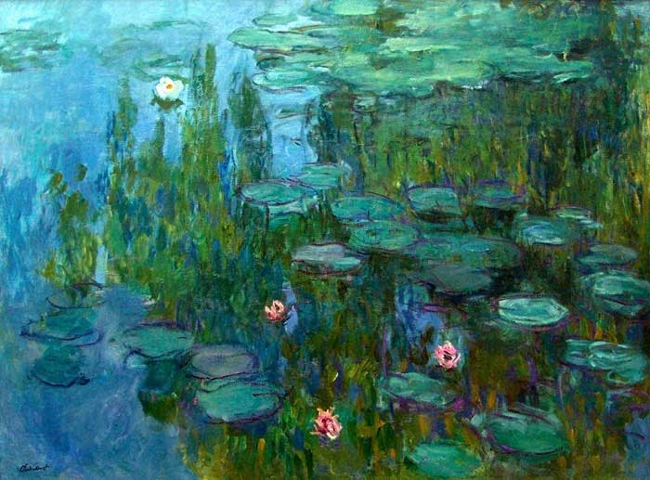](http://www.google.co.uk/url?sa=i&rct=j&q=&esrc=s&source=images&cd=&cad=rja&uact=8&ved=0ahUKEwi4_Nj_gfHQAhXKPBQKHeC-DZcQjRwIBw&url=http://www.dailyartfixx.com/2016/11/14/claude-monet-1840-1926/&bvm=bv.141320020,d.eWE&psig=AFQjCNFDnODT5N6PidR1AEUaPz7FtStyHQ&ust=1481713113402841)

|  |  |
| --- | --- |
| **Description of Course** | **Art: Fine Art** |
| **Qualification Type: GCSE**  **Examination Board: AQA**  **Specification No: Art & Design (Fine Art: 4202)**  **Useful Web Address: www.aqa.org.uk/qualifications**  **Head of Dept: Miss Millar**  **E-mail: jmillar@worle-school.org.uk** |

GCSE Fine Art allows students to develop creatively and practically whilst responding to a project theme. Throughout the projects students are required to explore and develop an idea through research and experimentation, when refining their idea development students will create personal responses. Across the two year course students will develop a range of skills, exploring an range of areas within fine art such as drawing, painting, print making, photography and mixed media. This course expects students to work independently to develop and create ideas. Students will be required to work to strict deadlines in order to complete their project work and be able to write analytically about artists and their work. Project themes include topics such as portraiture, creative landscapes, natural forms and social issues.

The course is made of two components – Coursework (60%) and Exam (40%). The students are required to complete to projects which will be marked as coursework and an externally set assessment which is the exam project.

**How Will You Learn**

Students will be required to respond to a project theme through the use of research, idea development and personal responses. They will develop their artistic ability and practical skills through practice and experimentation with materials and techniques. Teachers will help build students confidence by nurturing the development of their skills in areas such as drawing, painting, written analysis, photography and photoshop.

 Students are required to complete a minimum of one hour home learning per week whilst on this course.

**Method of Assessment**

|  |  |  |  |
| --- | --- | --- | --- |
| **COURSEWORK (60%)**  • Coursework projects run from the start of Year 9 and are completed by January of Year 10.  • Students will be given interim deadlines, with the opportunity to improve their work following feedback.  • Coursework is presented in Sketchbooks and Flip Folders and counts for 60% of the marks. | | **EXAM (40%)**  • The externally set Terminal Exam is taken in April/May of second year of the course and counts for 40% of the marks.  • Students will be given the Exam Paper in January and will complete preparation work in lessons. Preparation work will need to be submitted before the exam.  • The Final Piece of work will be completed under exam conditions over two days (10 hours).  • Both the Preparation Work and the Final Piece are marked as part of the Exam. | |
| During the course each project is marked against the following assessment objectives. Students must be able to demonstrate that they have met each assessment objective. | | | |
| **A01** | **A02** | **AO3** | **AO4** |
| Develop ideas through investigations, demonstrating critical understanding of sources  **Pathways after Year 11** | Refine work by exploring ideas, selecting and experimenting with appropriate media, materials, techniques and processes. | Record ideas, observations and insights relevant to intentions as work progresses. | Present a personal and meaningful response that realises intentions and demonstrates understanding of visual language. |

Training Pathways

Career Routes

Illustration, Animation, Graphic Design, Architecture, Photography, Theatre Design, Scenic Painting, Prop-Making, Teaching, Fashion Design, Art Therapy, Advertising, working in a Museum or gallery.

A’ Levels (Fine Art, Graphic Design,

Photography, Textiles)

BTEC Diploma

Creative & Media Diploma (Higher)

Apprenticeships in the creative field

|  |  |
| --- | --- |
|  | **Art: Digital Art** |
| **Qualification Type: GCSE**  **Examination Board: AQA**  **Specification No: Art & Design (Photography: 4206)**  **Useful Web Address: www.aqa.org.uk/qualifications**  **Head of Dept: Miss Millar**  **E-mail: jmillar@worle-school.org.uk** |

GCSE Digital Art allows students to develop creatively and practicality whilst responding to a project theme. Throughout the projects students are required to explore and develop an idea through research and experimentation, when developing their ideas students will create personal responses. Across the two year course students will develop a range of skills, exploring an range of areas within digital art such as the use of Digital SLRs, studio lighting, photoshop, pixlr and mixed media. This course expects students to work independently to develop and create ideas. Students will be required to work to strict deadlines in order to complete their project work and be able to write analytically about artists and their work. Project themes include topics such as portraiture, creative landscapes, natural forms and social issues.

The course is comprised of two components – Coursework (60%) and Exam (40%). The students are required to complete two projects which will be marked as coursework and an externally set assessment which is the exam project.

**Description of Course**

Students will be required to respond to a project theme through the use of research, idea development and personal responses. They will develop their artistic ability and practical skills through practice and experimentation with materials and techniques. Teachers will help build students confidence by nurturing the development of their skills in areas such as digital editing, composition, written analysis, photography and photoshop.

Students are required to complete a minimum of one hour home learning per week whilst on this course.

**How Will You Learn**

**Method of Assessment**

|  |  |  |  |
| --- | --- | --- | --- |
| **COURSEWORK (60%)**  • Coursework projects run from the start of Year 9 and are completed by January of Year 10.  • Students will be given interim deadlines, with the opportunity to improve their work following feedback.  Coursework is presented in Sketchbooks and Flip Folders and counts for 60% of the marks. | | **EXAM (40%)**  • The externally set Terminal Exam is taken in April/May of 2nd year of the course and counts for 40% of the marks.  • Students will be given the Exam Paper in January and will complete preparation work in lessons. Preparation work will need to be submitted before the exam.  • The Final Piece of work will be completed under exam conditions over two days (10 hours).  Both the Preparation Work and the Final Piece are marked as part of the Exam. | |
| During the course each project is marked against the following assessment objectives. Students must be able to demonstrate that they have met each assessment objective. | | | |
| **A01** | **A02** | **AO3** | **AO4** |
| Develop ideas through investigations, demonstrating critical understanding of sources | Refine work by exploring ideas, selecting and experimenting with appropriate media, materials, techniques and processes. | Record ideas, observations and insights relevant to intentions as work progresses. | Present a personal and meaningful response that realises intentions and demonstrates understanding of visual language. |

Career Routes

Illustration, Animation, Graphic Design, Architecture, Photography, Theatre Design, Teaching, Fashion Design, Art Therapy, Advertising

A’ Levels (Fine Art, Graphic Design,

Photography, Textiles)

BTEC Diploma

Creative & Media Diploma (Higher)

Training Pathways

|  |  |
| --- | --- |
|  | **Music** |
| **Qualification Type: GCSE**  **Examination Board: AQA**  **Specification No: 4270**  **Useful Web Address: www.aqa.org.uk/qual/subjectindex-m.php**  **Head of Dept: Mrs. Burlinson**  **E-mail: eburlinson@worle-school.org.uk** |

**Description of Course**

Component 1: Understanding music

What's assessed - Listening and Contextual understanding

How it's assessed - Exam paper with listening exercises using excerpts of music.

Component 2: Performing music

What's assessed - Music performance

How it's assessed - As an instrumentalist and/or vocalist and/or via technology:

• Performance 1: Solo performance

• Performance 2: Ensemble performance

Component 3: Composing music

What's assessed - Composition

How it's assessed

• Composition 1: Composition to a brief

• Composition 2: Free composition

Practical tasks and theory based learning.

**How Will You Learn**

Performances are marked live in front of an audience.

Compositions are played to the class and them marked by the teacher.

There is a final listening examination.

**Method of Assessment**

Career Routes

Music teaching

Orchestral management

Performer

Composer

Musician for film

Media-based jobs

Radio, TV

Sound production

Recording engineer

Music retail

Performing Artist

Music journalism

Music is a subject that helps us be creative and expressive individuals. It develops your musical awareness and increases your understanding of other cultures and countries. If you already are playing an instrument and perhaps have taken some practical exams then this course is aimed at you. It can give you a good grounding in composition and musical skills ready for the A level route. Many students from Worle have gone on to study music at University or a specialist music college and now perform, teach and make their living through music.

**Pathways after Year 11**

Training Paths

|  |  |
| --- | --- |
|  | **Music Practitioners** |
| **Qualification Type: GCSE Equivalents**  **Examination Board: Rock School**  **Specification No: n/a**  **Useful Web Address: www.accesstomusic.org.uk**  **Head of Dept: Mrs. Burlinson**  **E-mail: eburlinson@worle-school.org.uk** |

**Description of Course**

RSL is aimed at students who are interested in popular music and performing in a band or as a soloist.

The course covers three units: Live Music Performance, Listening to Music and Rehearsal Skills.

You will plan for a live performance and demonstrate, in collaboration with others, the skills to perform a set in a specific live environment to a target audience for 15 minutes. You will reflect on your performance and consider ways to improve future performances.

You will learn to appraise music by analysing its musical elements, emotional responses to it and factors that govern these.

You will learn how to recognise the relationship between the key elements of music and the personal responses they elicit.

The course is very practical and is aimed at students who enjoy performing and making music and have a keen interest in the subject. It allows students to develop skills such as team building, independence and confidence giving them the opportunity to work with other musicians and people who work in the local music industry.

You will develop the skills needed for effective rehearsal so you are fully prepared for a live performance.

Throughout this project you will be expected to

• Devise a rehearsal schedule and individual action plan

• Investigate a variety of rehearsal methods

• Maintain a progress diary

• Work effectively as a team

• Participate in group discussions

• Work with increasing independence from staff

Practical tasks and theory based learning.

**How Will You Learn**

**Method of Assessment**

Performances are marked live in front of an audience. You will put on and be responsible for an event that involves music.

You will complete a series of rehearsal logs that show target setting, progression and independence.

**Pathways after Year 11**

Music teaching

Orchestral management

Performer

Composer

Musician for film

Media-based jobs

Radio, TV

Sound production

Recording engineer

Music retail

Performing Artist

Music journalism

Music is a subject that helps us be creative and expressive individuals. It develops your musical awareness and increases your understanding of other cultures and countries. If you already are playing an instrument and perhaps have taken some practical exams then this course is aimed at you. It can give you a good grounding in composition and musical skills ready for the A level route. Many students from Worle have gone on to study music at University or a specialist music college and now perform, teach and make their living through music.

|  |  |
| --- | --- |
|  | **Dance** |
| **Qualification Type: GCSE**  **Examination Board:AQA**  **Specification No: 600/4786/0**  **Useful Web Address: www.aqa.org.uk**  **Teacher: Ms Butler**  **E-mail: cbutler@worle-school.org.uk** |

**Description of Course**

Dance is a powerful and inspiring qualification that encourages students to develop their creative, physical, emotional and intellectual capacity, whatever their previous experience in the subject. This creative qualification will develop your ability to choreograph, perform and appreciate dances through observing, discussing and actively exploring dance styles. It requires literacy and numeracy skills, awareness of space and musical feeling. Self-reflection, interpersonal skills and teamwork enable your students to develop their creative, artistic, social and physical skills.

As the course is vocational, you will learn through practising and then completing tasks. Classroom learning will be a combination of practical assignments, based on choreography and performance, which is 60% of your GCSE. Furthermore, you will study Dance Appreciation though learning various theories and techniques, which will prepare you for your written examination.

**How Will You Learn**

**Method of Assessment**

**Component 1:Performance and Choreography**

Solo and group performance internally marked and externally moderated, 60% of the GCSE.

**Component 2: Dance Appreciation**

1 hour 30 minutes written examination. The examiner will assess your knowledge and understanding of choreographic processes and performing skills.

**Pathways after Year 11**

|  |  |
| --- | --- |
| **Training Pathways** | **Career Routes** |
| Logical progression to AS and A-level. This course has bridged the gap between AS and A-level and higher education providers, giving you the skills and experience to better prepare for the demands of higher education or the workplace.  Also, Dance GCSE is well received in any creative or performance related qualification for Further or Higher Education. | The course will help progress into a career in the creative or performance related sector.  The course gives learners the opportunity to develop a range of skills and techniques, personal skills and attributes essential for successful performance in working life. |

|  |  |
| --- | --- |
| http://www.intermissionbristol.co.uk/wp-content/uploads/2013/04/drama-singing-classes.jpg  **Description of Course** | **Drama** |
| **Qualification Type: GCSE**  **Examination Board: AQA**  **Specification No: 8261**  **Useful Web Address: http://www.aqa.org.uk/subjects/drama/gcse/drama-**  **Head of Dept: Mrs. Davies**  **E-mail: bdavies@worle-school.org.uk** |

|  |  |  |  |  |
| --- | --- | --- | --- | --- |
| Skills: | Unit | Title | Description | Marks |
| • Confidence and communication  • Imagination and creativity  • Organisation and working to deadlines  • Team work and problem solving  • Interpretative and analytical skills  • Presentation  • Flexibility and adaptability  • Good work ethic and commitment  • Mental versatility  • Evaluation and personal development  • Independent thinking  • Acting, Directing, Design skills (Lighting, Music and Sound, Costume and props)  • Many transferable skills that will help the student in any future career path | 1 | Understanding Drama: written exam | A: Multiple choice questions about theatre role and terminology  B: Four questions on a given extract from the set text *Blood Brothers*  C: One question evaluating live theatre productions that you have seen | 1 hour 45 min    80 marks    (40%) |
| 2 | Devising Drama | Devise from a stimulus: this could be a moment in history, photograph, song, phrase, newspaper article etc. (60 marks)    Write a Devising Log that explains your piece, understanding, influences and evaluation (20 marks) | 80 marks    (40%) |
| 3 | Texts in Practice | Present two extracts from the same play. This unit assesses you on your ability to transform from page to stage with our own dramatic/artistic licence. You will choose the play, extract and design the set, costumes, lighting and sound. | 40 marks    (20%) |

• Through practical lessons and large periods of time to explore your creative ideas

• Develop skills, knowledge and understanding from KS3

• By devising ideas from a range of stimuli, theatre practitioners, performances spaces and audience manipulation

• By being responsible for your own semiotics (lighting, music, costume, set design and props)

• By working collaboratively with your peers, critically evaluating your own work and the work of others

• Through theatre visits: it is an exam requirement that you attend theatre trips, these feature the set texts and performances. Visits are vital in developing your knowledge and understanding and the written exam asks for you to evaluate live theatre.

**How Will You Learn**

**Method of Assessment**

• Practical: commitment to rehearsals, contributions, performance & design elements (lighting, music, sound, costume and props)

• Written: a Devising Log that explains your piece, justified your choices, explains how it developed and evaluates the final product.

• Home learning: might include research, designs, reading/writing/learning scripts, writing draft devising logs or watching video footage of performances. You will be expected to maintain a Drama diary which includes notes on class work, reviews on performances, research, developments in your piece etc. The majority of “home learning” is rehearsal time.

|  |  |
| --- | --- |
| **Why do students typically pick Drama?** | **Why employers and further education highly regard Drama** |
| They intend on pursuing Drama as a career | GCSE Drama is a way of students learning how to present in public |
| As an opportunity to develop their confidence and self esteem | As it requires full commitment to a group and hard work. |
| They love it! They want to pick a GCSE just for their own enjoyment, as escapism from the stress of GCSE’s. | It demonstrates a variety of transferable personal skills that are needed in many situations and any employment. |

**Career Routes**

• **All employers look for the transferable skills that you will gain through Drama**

• Theatre, film or creative industries: Actor, Director, Designer and Stage management

• Teaching, drama therapy and Theatre in education

• Entertainment, events and tourism

• Advertising, Marketing, and Management careers

**Training Pathways**

Drama is a fantastic GCSE in which the skills you learn can be applied to any training pathway

Or if your career choice is in the arts you can develop your skills in an A Level or BTEC in Drama and Theatre studies or Performing Arts.

[](http://www.google.co.uk/url?sa=i&rct=j&q=&esrc=s&source=images&cd=&cad=rja&uact=8&ved=0ahUKEwjch4v-hPHQAhXFPBQKHWtrDp0QjRwIBw&url=http://www.keepcalm-o-matic.co.uk/p/restez-calme-et-parlez-fran%C3%A7ais-159/&bvm=bv.141320020,d.eWE&psig=AFQjCNFzLP4y8C5scWJewnqMspe_F2uPHQ&ust=1481713978465241)[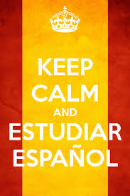](http://www.google.co.uk/url?sa=i&rct=j&q=&esrc=s&source=images&cd=&cad=rja&uact=8&ved=0ahUKEwi-1-TyhfHQAhVDWhoKHXVbBH0QjRwIBw&url=http://www.gostudyspain.es/blog/differences-between-university-and-spanish-school/&bvm=bv.141320020,d.eWE&psig=AFQjCNHMXqPPXGvEyX2xGQ8OWbf97_wWjQ&ust=1481714225346337)[](http://www.google.co.uk/url?sa=i&rct=j&q=&esrc=s&source=images&cd=&cad=rja&uact=8&ved=0ahUKEwiYhOynhfHQAhUCuBQKHYIkC50QjRwIBw&url=http://www.istockphoto.com/illustrations/french-flag&bvm=bv.141320020,d.eWE&psig=AFQjCNHkKCAGYciFLjMFoo2EYsE5vMuqpw&ust=1481714080102740)

**Option Subjects:**

**Languages**

|  |  |
| --- | --- |
| **Description of Course** | **French** |
| **Qualification Type: GCSE**  **Examination Board: AQA**  **Specification No: 8658**  **Useful Web Address: http://www.aqa.org.uk/subjects/languages/gcse/french-8658**  **Head of Dept: Mrs. Venn**  **E-mail: avenn@worle-school.org.uk** |

All four language skills (reading/writing/listening/speaking) are developed and assessed across a range of contemporary, cultural themes. There are three main themes, which are each broken down into topics and sub-topics throughout the course:

• Identity and culture.

• Local, national and global areas of interest.

• Current and future study and employment

You will also study grammar in more depth and be introduced to new linguistic concepts that will enable you to construct more sophisticated language.

**How Will You Learn**

Throughout the course you will hone your foreign language skills in reading, writing, listening and speaking, and will be encouraged by your class teacher to:

• Work in groups, as well as independently, to achieve set goals.

• Use a range of resources, including authentic materials, such as online news articles.

• Think creatively and spontaneously.

• Reflect on key aspects of your work.

• Appreciate other languages and cultures, as well as your own.

You will also be expected to complete regular Home Learning tasks and take ownership of your learning by exposing yourself to as much language as possible outside of the classroom (e.g. internet, TV, films, radio, magazines).

**Method of Assessment**

The overall assessment consists of four elements which take place as final exams (in reading, writing, listening and speaking) at the end, or towards the end, of the course in Year 11. You will be entered at either Foundation or Higher level across the 4 skills (numerical grading system 9-1). The exams are as follows:

• **Reading** – understanding written French in a range of settings, responding to questions, plus French – English translation.

• **Writing** – produce an extended written text on a given topic, plus English – French translation.

• **Listening** – understanding spoken French in a range of settings, responding to questions.

• **Speaking** – role play, questions, conversation in the target language.

**Pathways after Year 11**

**Training Pathways**

**Career Routes**

Common career paths include

Court Interpreter, Customs Officer, Fashion Buyer, Film Maker, Diplomat , Intelligence Specialist , International Banking Officer, Journalist, Media Specialist, National Security Agent, Politician, Professor, Radio/TV Presenter, Teacher, Travel Agent, Translator, Chef

A levels

Higher education

Languages are a demanding but highly enjoyable option which broaden students’ range of knowledge and ultimately teach many transferable skills which are highly prized by employers in an increasingly global and competitive job market. It is also required for entry to some degrees at certain universities.

|  |  |
| --- | --- |
|  | **Spanish** |
| **Qualification Type: GCSE**  **Examination Board: AQA**  **Specification No: 8698**  **Useful Web Address: http://www.aqa.org.uk/subjects/languages/gcse/spanish-8698**  **Head of Dept: Mrs. Venn**  **E-mail: avenn@worle-school.org.uk** |

All four language skills (reading/writing/listening/speaking) are developed and assessed across a range of contemporary, cultural themes. There are three main themes, which are each broken down into topics and sub-topics throughout the course:

• Identity and culture.

• Local, national and global areas of interest.

• Current and future study and employment

You will also study grammar in more depth and be introduced to new linguistic concepts that will enable you to construct more sophisticated language.

Spanish is by necessity intensive and fast moving, and students choosing this course should have a desire to succeed and have demonstrated success in their language learning in lower school. Students should be prepared to invest the necessary time and effort both in school and at home to learn Spanish to this level.

**Description of Course**

**How Will You Learn**

Throughout the course you will hone your foreign language skills in reading, writing, listening and speaking, and will be encouraged by your class teacher to:

• Work in groups, as well as independently, to achieve set goals.

• Use a range of resources, including authentic materials, such as online news articles.

• Think creatively and spontaneously.

• Reflect on key aspects of your work.

• Appreciate other languages and cultures, as well as your own.

You will also be expected to complete regular Home Learning tasks and take ownership of your learning by exposing yourself to as much language as possible outside of the classroom (e.g. internet, TV, films, radio, magazines).

The overall assessment consists of four elements which take place as final exams (in reading, writing, listening and speaking) at the end, or towards the end, of the course in Year 11. You will be entered at either Foundation or Higher level across the 4 skills (numerical grading system 9-1). The exams are as follows:

• **Reading** – understanding written Spanish in a range of settings, responding to questions, plus Spanish – English translation.

• **Writing** – produce an extended written text on a given topic, plus English – Spanish translation.

• **Listening** – understanding spoken Spanish in a range of settings, responding to questions.

• **Speaking** – role play, questions, conversation in the target language.

**Method of Assessment**

**Pathways after Year 11**

**Career Routes**

Court Interpreter, Customs Officer, Fashion Buyer, Film Maker, Diplomat , Intelligence Specialist , International Banking Officer, Journalist, Media Specialist, National Security Agent, Politician, Professor, Radio/TV Presenter, Teacher, Travel Agent, Translator, Chef

Languages are a demanding but highly enjoyable option which broaden students’ range of knowledge and ultimately teach many transferable skills which are highly prized by employers in an increasingly global and competitive job market. It is also required for entry to some degrees at certain universities.

A levels

Higher education

**Training Pathways**

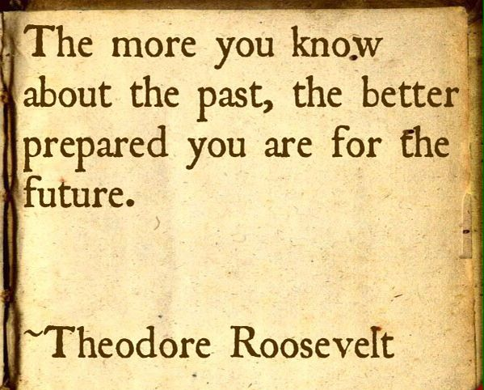

**Option Subjects:**

**Humanities**

|  |  |
| --- | --- |
|  | **History** |
| **Qualification Type: GCSE**  **Examination Board: Edexcel**  **Specification No: B (Schools History Project)**  **Useful Web Address: http://qualifications.pearson.com/en/qualifications/edexcel-gcses/history-2016.coursematerials.html#filterQuery=category:Pearson-UK:Category%2FSpecification-and-sample-assessments**  **Head of Dept: Miss Rand**  **E-mail: mrand@worle-school.org.uk** |

The course is split into 3 units:

**Unit 1: Thematic Study and historic environment**

Medicine in Britain, c1250–present and The British sector of the Western Front, 1914–18: injuries, treatment and the trenches

**Unit 2: Period study and British depth study**

British depth study: Early Elizabethan England, 1558–88.

Period study: Superpower relations and the Cold War, 1941–49

**Unit 3: Modern depth study**

Weimar and Nazi Germany, 1918–39

**Description of Course**

Our aim is to make you independent learners who will be able to use a variety of learning skills which can be applied in further education and beyond.

As a consequence, History lessons will combine a variety of teaching styles to suit different types of learners such as space learning, research tasks, ICT style lessons, role play and much more.

To aid you along the way textbooks, ICT, games, articles, contemporary sources, fiction, images and other such tools will be used to enrich your learning experience.

**How Will You Learn**

**All are written exams which are taken at the end of your course**

**Unit 1 Exam – Summer (30%)**

Section A: in the historic environment you will answer a question that assesses knowledge plus a two-part question based on two provided sources.

Section B: in the thematic study you will answer three questions that assess your knowledge and understanding. The first two questions are compulsory. For the third question, you answer one from a choice of two

**Unit 2 Exam - Summer (40%)**

Section A: This exams to period study and you answer three questions that assess your knowledge and understanding. The first two questions are compulsory. For the third question, you select two out of three parts.

Section B: This is the British depth study and you answer a single three-part question that assesses your knowledge and understanding. The first two parts are compulsory. For the third part, you select one from a choice of two.

**Unit 3 Exam – Summer (30%)**

Section A: you answer a question based on a provided source and a question that assesses your knowledge and understanding.

Section B: you answer a single four-part question, based on two provided sources and two provided interpretations.

**Method of Assessment**

**Career Routes**

Journalism, Law, Museum, Tour Guide, Finance, Civil Service, Human Resources, Librarian, Teaching, Army, Medicine, ICT, Politician, Archaeologist, Architect, Administrators, Police, Market Research, Accountant, Air Force, University Lecturer, Advertising.

**Training Pathways**

Leaves options open for a wide variety of A levels.

Universities value a History GCSE as a good academic qualification regardless of your choice of course

**Pathways after Year 11**

|  |  |
| --- | --- |
|  | **Geography** |
| **Qualification Type: GCSE**  **Examination Board: OCR**  **Specification No: B**  **Useful Web Address: www.ocr.org.uk**  **Head of Dept: Mrs. Tipper**  **E-mail: ktipper@worle-school.org.uk** |

**Description of Course**

The course covers four themes:

1. “People and Society” – features, process and human usage, Settlement and Population—inequalities in the country and diversity of people, Challenges to the Environment – flooding, energy & human’s actions.

2. “Our Natural World” Ecosystems – location, types and impact of human activity, People of the Planet – Rich World vs Poor World: economic development and city life, Environmental Threats – impacts of climate change and extreme weather patterns

3. “Geographical Exploration” Throughout the course you will learn and practise map skills, graphic skills, analyse data and make predictions.

You will also carry out fieldwork: you will design investigations to be carried out in the field, analyse the data gathered, draw conclusions and evaluate your study.

**How Will You Learn**

You will develop & extend your knowledge of places around the World – both the physical features & process AND the social & cultural aspects.

You will understand how people and environments interact – how we are affected by the physical geography & how it affects us.

You will develop research skills, fieldwork skills, mapping & graphic skills and Geographical Information System skills –

you will then be able to apply these through investigations and hypothesis testing.

You will learn how to create evidenced and balanced arguments – using geographical knowledge & enquiry skills Studying GCSE Geography develops all thinking skills – description, explanation, analysis and evaluation – these are transferable to a wide range of situations, subjects, and careers in the future. Students also develop skills in working with others; independent learning and further develops literacy, numeracy, communication and ICT skills.

Homework will be set each week. The types of homework will vary from tasks based on class work, research, projects, group work, independent learning, revision, controlled assessment, exam questions, etc.

**Method of Assessment**

The assessment consists of 3 elements:

1. “People and Society”

Written paper – 30% of total GCSE

2. “Our Natural World”

Written paper – 30% of total GCSE

3. “Geographical Exploration”

Written paper – 40% of total GCSE

**Pathways after Year 11**

**Career Paths**

Students who have studied Geography are highly thought of for having a good combination of knowledge, flexibility, and competence in key skills. There are also clear opportunities for fieldwork, teamwork and independent study. In a recent survey employers regarded Geography as the most valuable GCSE after English, Maths and Science.

**Training Pathways**

A GCSE in Geography provides a huge range of opportunities. Apart from the obvious link to A level Geography and Environmental Science, this subject will be a good backdrop for many other subjects across the curriculum.

[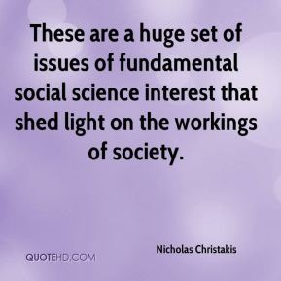](http://www.google.co.uk/url?sa=i&rct=j&q=&esrc=s&source=images&cd=&cad=rja&uact=8&ved=0ahUKEwjo3br2iPHQAhVFcRQKHTIPBKEQjRwIBw&url=http://quotesgram.com/social-science-quotes/&bvm=bv.141320020,d.eWE&psig=AFQjCNF3vHQ-HsFoc-H0QqGrCdf_GqqoPg&ust=1481714917402809)

**Option Subjects:**

**Social Sciences**

|  |  |
| --- | --- |
| Description: http://www.civiceducationva.org/citizenship_wordle.png | **Citizenship** |
| **Qualification Type: GCSE**  **Examination Board: AQA**  **Useful Web Address: www.aqa.org.uk**  **Head of Dept: Mr. Green and Miss Bigge**  **E-mail: mgreen@worle-school.org.uk & abigge@worle-school.org.uk** |

**Description of Course**

Citizenship GCSE prepares you to become an active citizen in our democratic society. Choosing GCSE Citizenship will allow you to apply your learning to real-life scenarios on both a local and global scale.

**Subject content**:

1. Citizenship skills, processes and methods

2. Life in modern Britain

3. Rights and responsibilities

4. Politics and participation

5. Active citizenship

All of the themes require links to be made between local, national, European and global dimensions.

Citizenship Studies provides the opportunity for you to work individually to develop your own knowledge and also encourages you to work with others and take part in group activities to bring about a change. Lessons are planned and delivered to develop key processes such as critical thinking, enquiry, advocacy and representation, taking informed and responsible action. In particular you will have opportunities to explore topical and controversial issues, address issues and problems within communities.

**How Will You Learn**

**Method of Assessment**

The qualification is Linear. Linear means that students will sit all their exams at the end of the two year course.

Paper 1 Section A: Active citizenship. Section B: Politics and participation.

Written exam: 1 hour 45 minutes 80 marks 50% of GCSE.

Paper 2 Section A: Life in modern Britain. Section B: Rights and responsibilities.

Written exam 80 marks 50% of GCSE

**Pathways after Year 11**

**Career Routes**

• Public Services

• Politics

• Teaching

• Law

• Journalism

• Media

**Training Pathways**

GCSE Citizenship gives you an excellent foundation to progress onto any level three course. Specifically it is a good foundation for further studies in Politics, Law, Sociology or Public Services.

|  |  |
| --- | --- |
|  | **Business Studies** |
| **Qualification Type: BTEC (TBC After DFE announcement)**  **Examination Board: Edexcel**  **Specification No: 600/4786/0**  **Useful Web Address: www.edexcel.com**  **Head of Dept: Miss McCorry**  **E-mail: amccorry@worle-school.org.uk** |

**Description of Course**

Choosing to study BTEC Business will provide an engaging and stimulating introduction to the world of business. The qualification builds on learning from Key Stage 3 for those who may wish to explore a vocational route throughout Key Stage 4. The units studied cover the essential knowledge and skills required in the business sector. The first Award in Business encourages personal development of knowledge and skills relevant to business and encourages learners to develop their people, communication, planning and team working skills.

**How Will You Learn**

As the course is vocational, you will learn through researching and then completing tasks. Assignments will be completed out throughout the duration of the course. There are opportunities for presentations and discussions to really help with the communication aspects which a career in Business would need. Links may also be forged with the local Business community to really bring learning to life.

**Method of Assessment**

The course is 75% coursework. There is an interim marking system, whereby feedback will be given on coursework assignments and the student can then use this feedback to improve their work and move forward. The remaining 25% is assessed through an exam which is taken on a computer. There are 2 compulsory units (Enterprise in the Business World and Finance for Business) and 2 optional units which cover a wide range of business areas.

**Career Routes**

The course will help progress into a career in the business sector.

The course gives learners the opportunity to develop a range of skills and techniques, personal skills and attributes essential for successful performance in working life.

**Pathways after Year 11**

**Training Pathways**

Continue to study Business at a higher level at sixth form, college and university. To continue study/training through the vocational/apprentice route.

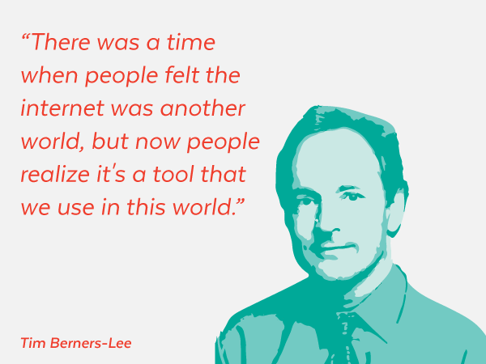[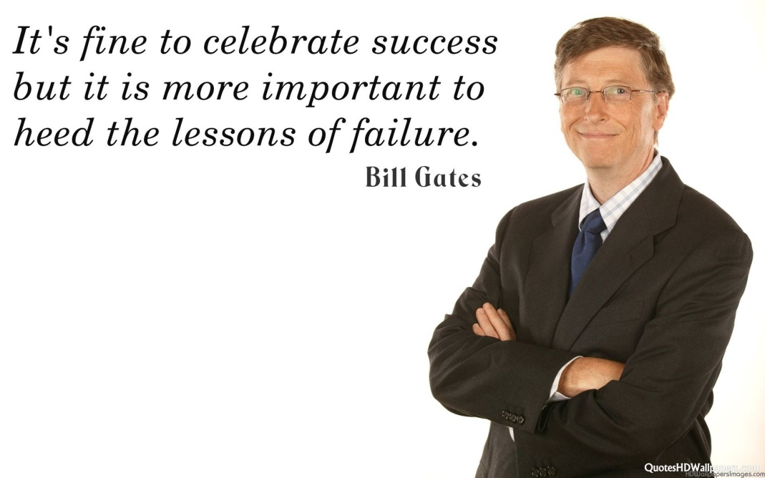](http://www.google.co.uk/url?sa=i&rct=j&q=&esrc=s&source=images&cd=&cad=rja&uact=8&ved=0ahUKEwiK-ae9ivHQAhUFsxQKHSH-B54QjRwIBw&url=http://wallpapercave.com/bill-gates-wallpaper&bvm=bv.141320020,d.eWE&psig=AFQjCNH_XkdmcazwazfoaX3rCEEwYPYeXQ&ust=1481715376957974)

**Option Subjects:**

**Information Technology**

|  |  |
| --- | --- |
|  | **CiDA-(TBC After DFE announcement)** |
| **Qualification Type: CiDA Level 2 in Digital Applications**  **Examination Board: Edexcel**  **Specification No: 600/6627/1**  **Useful Web Address: www.edexcel.com**  **Head of Dept: Miss McCorry**  **E-mail: amccorry@worle-school.org.uk** |

**Description of Course**

The UK is a world leader in the creative digital industries, such as in the creation of visual effects for films and computer games. Its game industry is among the largest in the world, and is set to continue to grow. This qualification has been designed to engage and enthuse young people with an interest in these industries. It appeals to students who want the opportunity to explore and acquire a broad understanding and knowledge of the creative digital industry and the ability to apply that knowledge in practical contexts.

**Unit 1 - Developing Web Products (30 Guided Learning Hours)**

This unit provides students with the knowledge, practical and creative skills they need to use web authoring software, multimedia assets and navigation features to produce web products. Students will learn to design, create, test and evaluate them.

**Unit 2-Creative Multimedia (30 Guided Learning Hours)**

**This unit enables students to investigate different aspects** of products in relation to games and web development in order to understand its success . Students will learn to plan, design, create and evaluate a range of multimedia products.

**Assessment**

**25% Internal exam (Unit 1 Developing Web Products)**

The practical examination for this unit is set and marked by Edexcel. Students will be expected to use web authoring and other software tools to build and test a website based on a scenario set by Edexcel.

**75%-Coursework project (Creative Multimedia**)

Students will be expected to research, design , create test and evaluate a range of creative multimedia based on a scenario provided by exam board.

**Method of Assessment**

**Pathways after Year 11**

**Training Pathways**

The qualification provides a broad and solid foundation for further study of various aspects of creative computing, such as graphic design, web design, computer designs and interactive media. It supports progress to further study including:

• Level 3 BTECs in creative Media production

• Level 3 BTECS in IT

It also enhances young peoples overall digital literacy and gives them a solid foundation for further study and employment.

**Career Routes**

Any chosen career will involve an element of ICT. The CiDA course will give a good grounding for careers involving multimedia such as web design, graphic design or animation.

|  |  |
| --- | --- |
|  | **Computer Science** |
| **Qualification Type: GCSE**  **Examination Board: OCR**  **Specification No: J276**  **Useful Web Address: www.ocr.org.uk/qualifications/gcse-computer-science-j276-from-2016/**  **Head of Dept: Miss McCorry**  **E-mail: amccorry@worle-school.org.uk** |

**Description of Course**

This GCSE course gives students a real, in-depth understanding of how computer technology works. It offers an insight into what goes on ‘behind the scenes’, including computer programming. Through this qualification students can develop an understanding of current and emerging technologies and how they work, look at the use of algorithms in computer programs, become independent and discerning users of IT, acquire and apply creative and technical knowledge and understanding of IT in a range of contexts, develop computer programs to solve problems, evaluate the effectiveness of computer programs and the impact of computer technology in society. It is a great way to develop critical thinking, analysis and problem solving skills, which can be transferred to further learning and everyday life. Computing is a very high level subject so it is vital that students have good mathematical skills and should be working at a level 16-20 in maths at least, by the end of Year 8, as well as a minimum level of 16 in ICT. Please discuss with your ICT teacher if you feel the course is for you but you are not at the required levels.

**How Will You Learn**

There are many different learning methods used for this course. There are, of course, text books and work sheets but there is also a move towards a dynamic learning platform, where lessons, activities and tests are carried out interactively through the computers.

There are 3 units within the course. 80% of the final marks are gained from 2 written exams one is based upon Computational Thinking. Algorithms and programming and one on Computer systems, which covers the body of knowledge about computers. 20% of the final marks are gained from a controlled assessment and will be based upon a programming problem, provided by the exam board.

One exam is based upon IT, algorithms and programming. The other is based upon computer systems

**Method of Assessment**

**Pathways after Year 11**

**Career Routes**

Any chosen career will involve an element of IT and/or computing. Having programming and other technical computer skills will open up many career opportunities for students across a wide variety of industries. All industry sectors need people with programming skills to create applications for them. In particular the video games industry needs more people with programming skills to create the next generation of games in this lucrative industry. As more people depend on their Smartphones on a day to day basis, creating apps for these phones is also likely to be a big growth area requiring programming skills.

**Training Pathways**

Continue to study ICT or Computing at a higher level at sixth form, college and university.

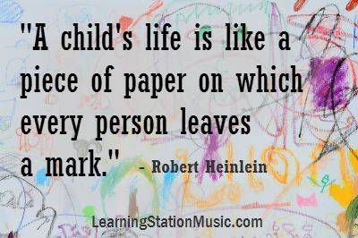

**Option Subjects:**

**Additional Courses**

There are 5 units of work examinable by written exam in Yr 11 (50% of total marks )

• Reproduction / Roles of parents

• Antenatal care and Birth preparation

• Postnatal checks /. Conditions for development

• Managing and preventing childhood illnesses

• Knowing about child safety

Other areas of child development are taught through coursework, (50% of total marks )

|  |  |
| --- | --- |
| cute babies Royalty Free Stock Vector Art Illustration  **Description of Course** | **Child Development** |
| **Qualification Type: Cambridge Nationals Level 1/2**  **Examination Board: OCR**  **Specification No: J818**  **Useful Web Address: www.ocr.org.uk**  **Head of Dept: Mrs. Ley-Morgan**  **E-mail: aleymorgan@worle-school.org.uk** |

Worksheets where you will find out answers and solutions

CDs and films

Using Life choice babies in lessons and taking home for the weekend Practical work such as making bottle feeds and bathing a baby Surveys and questionnaires

Examination practice papers Peer marking of work Discussions

Class presentations

Revision quizzes, puzzles and revision guides

**How Will You Learn**

**Method of Assessment**

Coursework: Child equipment / Feeding solutions (25% final grade)

Coursework: Study of a child (25% final grade)

• End of unit assessments (exam questions)

• Knowledge tests per learning cycle

•  Pre Public Examinations

• Year 11 Exam (50% of f inal grade)

**Pathways after Year 11**

|  |  |
| --- | --- |
| **Training Pathways**  Weston College courses  Diploma in caring for children BTEC Level 2 diploma Apprenticeship in Caring for children  A level, FdA Early years and BA(Hons) Early years education  Midwifery degree at various universities  Medical training | **Career Routes**  Child care worker  Nanny  Pre-school teacher  Social workers  Special education teachers  Children’s nurse  Paediatrician. Neo-natalogist |

|  |  |
| --- | --- |
| http://t2.gstatic.com/images?q=tbn:QpYZjS9_ND9BWM:http://www.torbaysport.com/images/cms/j0438742.jpg | **Physical Education** |
| **Qualification Type: OCR Nationals sports studies**  **Examination Board: OCR**  **Useful Web Address: www.ocr.org.uk**  **Head of Dept: Mr Thompson**  **E-mail: cthompson@worle-school.org.uk** |

The OCR Nationals Sports Studies course has two compulsory units and two coursework units. These include a 1 hour exam on contemporary issues in sport and a practical element of developing sports skills.

Unit titles are:

• Contemporary issues in sport (Exam)

• Practical sport. Team and individual performance

• Sports Leadership

• Sport and Media

it is essential that you enjoy PE, and those who represent the school or an outside club in a sport will benefit tremendously. If you do not take part in competitive sport please do not pick this option.

**Description of Course**

**How Will You Learn**

For the OCR Nationals Sports studies course students will complete a compulsory practical unit of developing sports skills. The knowledge for the exam and coursework assessed units including Sport and the media, sports leadership and working in the sports industry will be taught through theory based lessons.

**Method of Assessment**

The practical component of the course is assessed by your teachers and evidence can be through taught lessons, competitive situations or through external evidence. You will be assessed on your skill level in a range of sports, from which we determine your best two. The theory content is taught in a classroom and will be assessed by a 1 hour written exam.

**Pathways after Year 11**

|  |  |
| --- | --- |
| **Training Pathways** | **Career Routes** |
| BTEC Sports Diplomas  A-level PE  Degree in Sports Science  Degree in Human Movement Studies | Leisure Centre Assistant  Physiotherapist  Sports journalist/photographer  Sports Coach  Personal Fitness Trainer  PE Teacher |

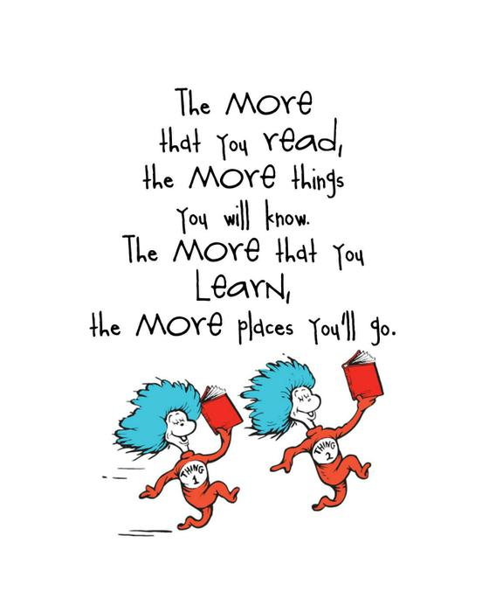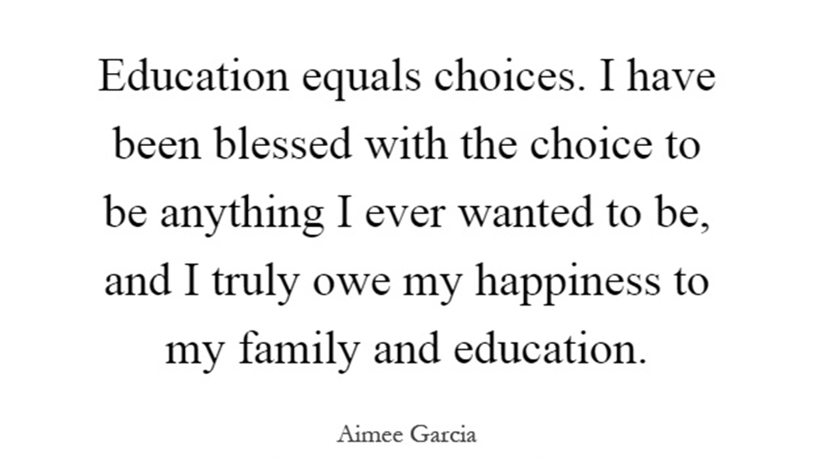

*Dr Seuss*



**Key Dates**

Choices Information Evening -

**Thursday 1st March 2018**

**4.30 - 6.30pm**

Deadline for returning Options Choices Form -

**Friday 16th March 2018**

**Please Meet the Deadlines**

**Students First**

Principal: Miss Jacqui Scott

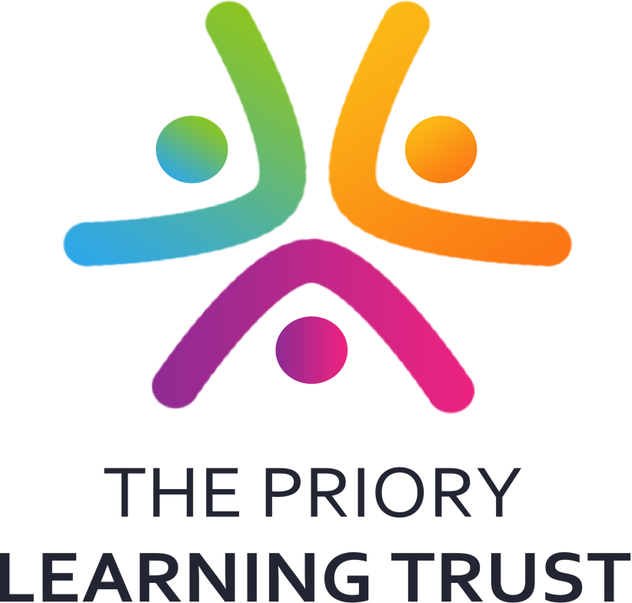

**Students First**