CAREERS ACTIVITIES, EVENTS AND PROMOTION AT WORLE COMMUNITY SCHOOL ACADEMY
2023 – 2024

James Wilmot - Director of Careers Education, Advice and Guidance
Leeza Cuthbertson - Careers Advisor
Sarah Heather - Academy Governors - Careers Link
Victoria Beamish - Enterprise Advisor

OUR CAREER PROGRAMME
- Is written down
- Is approved by the board of governors
- Has the explicit backing of senior leadership
- Has resources allocated to it
- Has systematic monitoring in place
- Has both strategic and operational elements
- Is published on our school website
- Is evaluated for effectiveness at least every 3 years
- Has an identified lead individual with strategic responsibility for overseeing the programme

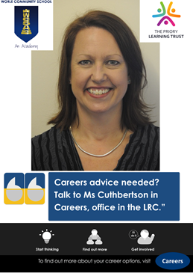

DESTINATIONS
Our students progress to A Levels, Diplomas, Armed Forces, Training and Apprenticeships.
2021-22 Year 11 Progression:
- 85% progressed to a college for A Levels or vocational diplomas (Weston, Bridgwater & Taunton, SGS, Boomsatsuma, Access Creative, Winterstoke Hundred Academy and Bristol Robins Foundation)
- 9% went on to study A Levels at a Sixth Form (The King Alfred School Academy, Churchill Academy and Backwell Academy)
- 2% began an apprenticeship / work based learning
- 2% furthered their education through the Army, traineeships or approved volunteering
- 1% went into employment without training
- 1% NEET

2020-21 Year 11 progression:
- 86% went on to study A Levels or vocational qualifications at a college (Weston, Bridgwater & Taunton, SGS, Boomsatsuma, Access Creative. WHA, City of Bristol and Bath)
- 5% went on to study A Levels at a Sixth Form
- 5% began an apprenticeship / work based learning
- 2% furthered their education through Employment & Training but not an Apprenticeship
- 1% NEET

2019-20 Year 11 progression:
- 78% went on to study A Levels or vocational qualifications at a college (Weston, Bridgwater & Taunton, SGS, Boomsatsuma, Access Creative. WHA, City of Bristol and Bath)
- 10% went on to study A Levels at a Sixth Form
- 11% began an apprenticeship / work based learning
- >1% furthered their education through the Army, traineeships or approved volunteering
- >1% NEET

PRIORITY GROUPS
All students are welcome and encouraged to engage with the careers team, but specific groups of students have a priority:
RONI (Risk of NEET) – All Year Groups - Risk of NEET students are met early in the year for 121 meetings. A clear vision of the student’s career awareness is obtained (family situation, parents in employment, own career aspirations, etc.). Information is passed to Tutors and further actions agreed.
Progression plans – Year 11 - All Year 11 students are met and tracked through their final year to ensure that college applications are complete and the student has a clear vision of their progression route and the appropriate level. A report is sent to North Somerset Council annually to track progress and ensure that full support is provided beyond school.
Children Looked After – All Year Groups - Additional 121 appointments are in place to support with work experience, college applications and general careers support.
Pupil Premium – All Year Groups - Additional time is allocated to engage with pupil premium students to ensure that they have additional support with activities in the potential absence of support at home (packed lunches for trips, help with transport for work experience, early October progression appointments for Year 11s etc.).
Special Educational Needs – All Year groups - The team works closely with the SEND Team to provide additional support for students during their time in school, participation in careers events and to facilitate transition to post 16 studies. Students needing additional support with college transition are given additional support with applications, interviews and exclusive taster days.
Students with academic promise – Year 10 & 11 - Curriculum staff identify students showing academic promise. The careers team meet these students to explore preferred pathways and facilitates University visits, employer guidance, Apprenticeship information etc.
Does it work? Yes! Historically, RONI and PP Students were hard to engage with, but are now strong supporters of the careers offer. WCSAs NEET figure for last academic year (2021) was 1%. This document will be updated to include 2022 NEET figures once this is released after Christmas. Staff capacity now allows for further focus and support for these priority groups, specifically CLA, PP students and students with SEN.

121 INTERVENTIONS
- All students are welcome to meet the careers team at any time.
- All priority group students have multiple 121s.
- All Year 10 students have 121s on a weekly basis during the work experience planning period until their placement is confirmed.
- All Year 11 students have progression 121s on their own and/or with their family until progression plans have been agreed. Action plans are created and made available for families to view.
- All Year 7 students have a 121 as part of their interview challenge.
- All Year 9 students are encouraged to have a 121 to discuss their Options. This offer is also open to families.
Does it work? Yes! The careers office has great footfall. Pre-booked appointments are well attended as students are generally taken out of class for appointments. Work experience participation was at 100% in 2023. Student progression is 100% robust and all students have at least one Post 16 destination available to them. A central spreadsheet of IAG interactions is kept to give an accurate picture of the service provided. All PP Year 11 students are seen in term 1 to assist with focus and drive in the lead up to exams. Information from these is passed to year heads to ensure a collaborative approach.

REFERRALS
- Careers welcome referrals from anyone within the school including Tutors, Teachers, Leadership Team, Student Services, parents and self-referral from students.
- Careers can request attendance from students at any point during the day and teaching staff agree to students leaving class. Assessment weeks are avoided.
Does it work? Yes! Student attendance for 121 appointments is very high. Teachers are open to students visiting the careers office during teaching time as they are confident that it is time well spent.

VENUE
- Careers is fortunate to have a dedicated meeting space full of resources, inspirational quotes, free of clutter and an open door policy. Students are welcome to drop in any time of the day - with no need to knock!
- The Careers office is largely paperless and an events and activities calendar is kept up to date allowing plenty of time for prior planning to achieve successful outcomes.
- Worle Community School Academy is also one of the few schools in the region who have employed dedicated careers staff to provide the best possible service to its students. The Careers Team shares resources and best practice across The Priory Learning Trust.

Does it work? Yes! The Careers office has moved to a new venue. It is now at the end of the LRC used by all year groups, with large areas of wall space available for careers promotion. The Careers office is accessible to all students during social times and is shared with our brilliant Jill Dando journalists who publish positive student stories for the Trust newspaper. Many staff have already commented on its positive environment. The paperless systems that have been implemented reduce waste, supports data protection and the risk of mislaying information. Dedicated staff can focus on student engagement, activities and events and deliver successful outcomes without distraction or split responsibilities.

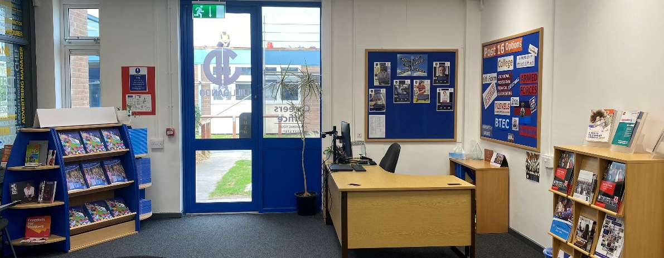

STUDENT ENGAGEMENT
- The majority of student engagement is on a 121 basis.
- The Careers team also passes on important information and can field enquiries in assemblies, via social media, school website, a monthly careers bulletin as well as parent text and emails. Out of hours appointments with parents are also available.
- Other engagement is on a group basis, for example attendance at careers events, guest speaker drop ins, workshops, trips etc.
- PM tutor time – is additional time available for Careers to deliver messages, engage students with alumni, employers and post 16 providers in person and via zoom within PSHE.

Does it work? Yes! Students feel comfortable engaging with The Careers team. Tutors also appreciate our short and snappy interventions in assemblies and tutor time. Out of hours appointments are gratefully received by parents who work longer hours than traditional school opening times and would like to meet with the Careers team directly. Parents can also access the service for their own career development. WCSA has launched a second tutor time at the end of the school day; additional time for information to be delivered.
EARLY INTERVENTION
- As part of our commitment to engage with students as early as possible to help them make the most from school, our Year 7 students are encouraged to participate in both on and offsite careers events and activities.
- Prior to this, Year 5 students from our primary schools within TPLT are mock interviewed and Year 6 students are invited in to school during National Careers Week to meet visiting employers, colleges and universities. These activities aid transition to WCSA and raise aspirations from an early age.
- Year 7 participate in the annual ‘Interview Challenge’ where they produce a CV, practice interview skills and apply for their dream job! The careers team and WCSAs Enterprise Advisor interview the year group, helping them explore their existing skills, identify skills to develop and reinforce the message of kindness, bravery and curiosity as winning attributes for life.
Does it work? Yes! Attendance at careers events is very high and feedback is very positive. The interview challenge was a great success and the students thoroughly enjoyed the experience. Parent feedback was outstanding. It will be very interesting to see how these aspirations change (or not) over the students’ time at WCSA.

EMPLOYER ENGAGEMENT
- The Careers team are very connected and proactive with creating and growing a team of employers covering as many industry sectors as possible to provide our students with a real insight into working life in the real world.
- Recruitment of employers includes the TPLT Careers team attending networking events, forming good working relationships with local businesses, utilising the school’s Enterprise Advisor and LinkedIn marketing.
- Employer participation with students includes employer visits to school and their own premises, engagement with subject area classes, work experience opportunities, assemblies, support with mock interviews and more.

Does it work? Yes! Employer engagement is at an all-time high. Over 200 employers supported the Year 10 WEX programme in 2023. All Year 10 students have at least 1 week of WEX. 45 employers supported the WCSA Year 10 Mock Interview Day in 2023. Alumni also visit the students to talk about their own education and career choices. Feedback from students, staff and parents is extremely positive regarding the contributions that our local employers make.
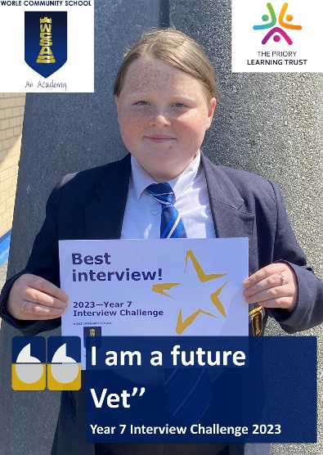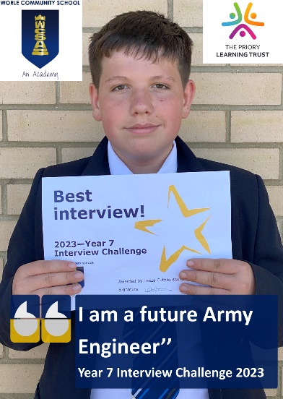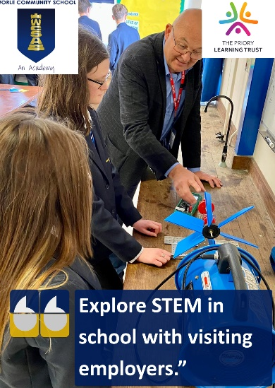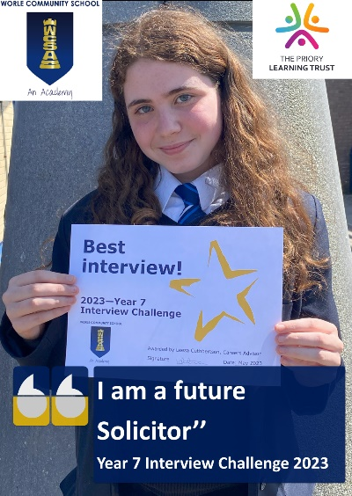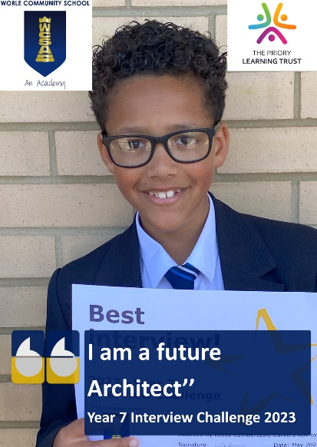

FURTHER EDUCATION
- We have a completely impartial relationship with the local colleges, 6th Forms and Apprenticeship providers.
- All Year 10 students attend college taster days to explore study options and learn more about labour market information led career pathways.
- All students receive at least two FE focussed assemblies per year promoting A Levels, T Levels, Diplomas and Apprenticeships. A parent information evening is also held covering these topics for Year 11 students.
- College summer school and half term activities are promoted to students and their families through various means.
- College and 6th Form open evenings are promoted to students and their families through various means.
- We communicate with colleges on a regular basis to review and develop the range of activities and events.
- Spring 2023 we ran an Apprenticeship Academy for the Year 11 students considering apprenticeships as their Post 16 option. With support from Ask Apprenticeships we offered CV workshops and advice and guidance as to how to secure an employer.

Does it work? Yes! Student attendance at offsite college events is higher than our neighbouring schools. Colleges, 6th Forms and Training Providers attended the 2023 Careers Convention, greatly attended by PLT students and their families.

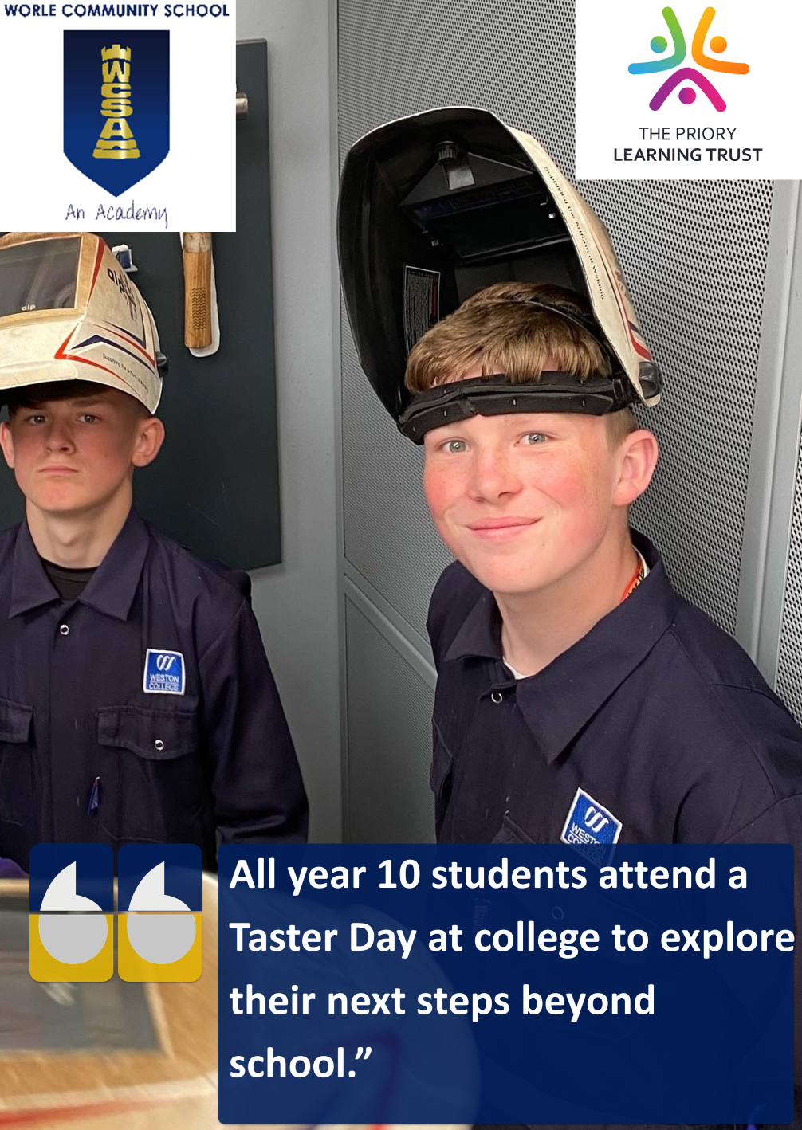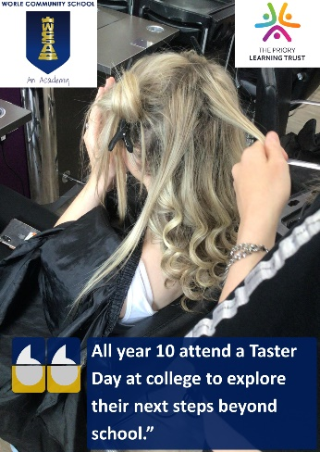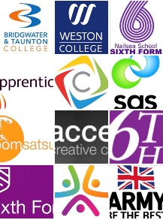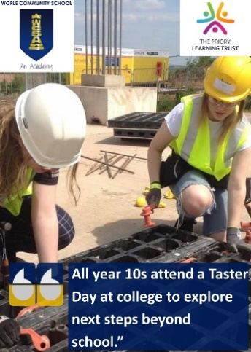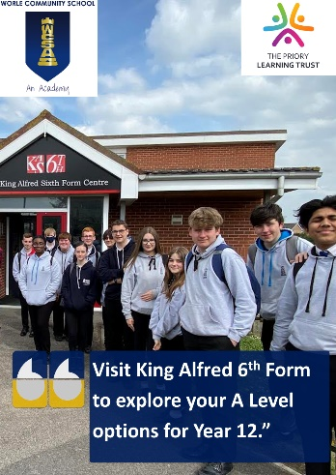

HIGHER EDUCATION
- University outreach has a strong presence at our annual careers convention.
- All Students receive at least one university focussed assembly per year.
- Guest speakers from Russell Group Universities including Oxford and Cambridge visit the PLT. Talks are held in the early evening to encourage parent attendance.
- Visits to local universities are encouraged for all students and their families. Open days and events are promoted in the monthly careers bulletin.
- Student visits to universities are arranged for specific students in specific faculties/groups. An annual Y10 trip to Exeter College, Oxford University always runs in Term 2 and last year Careers accompanied WCSA Brilliant Club (Year 8 & 9), to both Southampton University and Bristol University.

Does it work? Yes! During a recent visit to a leading university, 2 of 14 students voiced an intention to apply. On the return trip all 14 had raised their aspirations sufficiently to want to apply. We are fortunate to also have a number of local universities who are happy to engage with our students and promote degree level education not just from 18 years but later in life too.
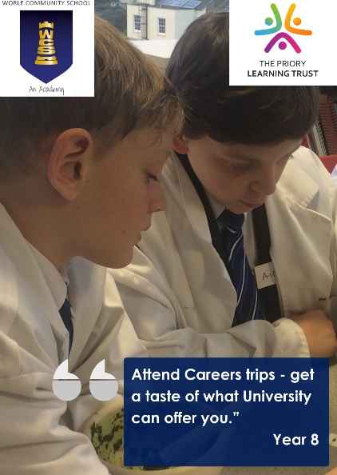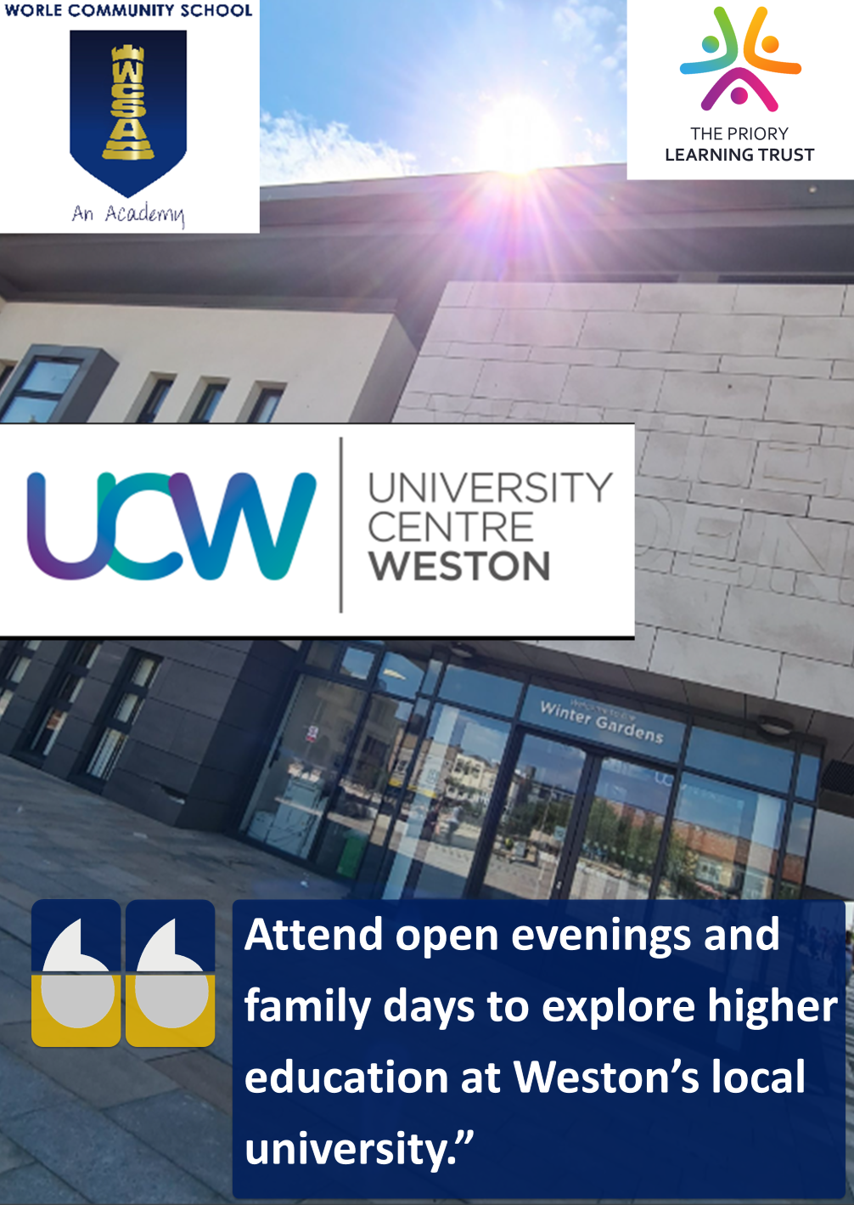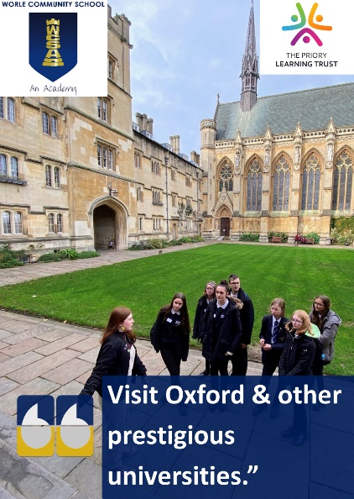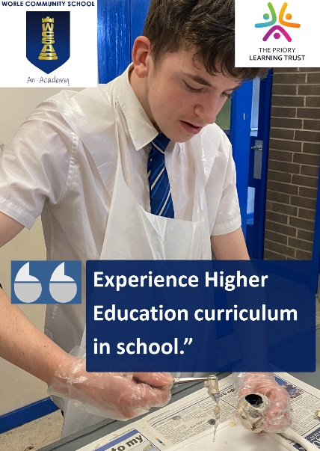
NOT JUST JOBS, JOBS, JOBS…………….
- A happy and healthy life is not solely down to career choice and education pathway. The Careers team offers a wide range of activities and opportunities for students to participate in to build confidence, self-esteem and friendships.
- Students are encouraged to engage with local youth councils and local charity organisations.
- The North Somerset NEET team make themselves available to provide further support to students at risk of NEET.
- The National Careers Service offer is also included in the monthly bulletin.
- Students with social anxiety and at risk of bullying are welcome to spend time in the careers office as a safe space.
- Annual Hero Awards and prizes in conjunction with The Grand Pier are awarded to students for acts of kindness at school, home and the community. Parents are invited to a breakfast event showcasing their child’s kindness.
- The National Citizenship Service engage with Year 11 students and offer a summer residential programme after their GCSE exams.
- The school links with Big Worle community centre and The Stable to promote their events and activities.

Does it work? Yes! Our students have a strong reputation in the town for their community mindedness. The Careers office is a frequent space for students to visit for quiet time. The hero awards run annually with great nominations.

CURRICULUM
  - Embedded daily classroom based activities have an additional focus on ‘soft skills’.
  - Weekly brief is sent to all staff; careers updates are added so everyone is aware of our activities and events.
  - Financial awareness and money management is also built into curriculum and tutor time.
  - Curriculum careers posters and alumni posters are present in and around school faculties.
  - Central Leaders have access to a suite of careers in curriculum resources created by the Careers team.
  - ‘Job of the Week’ are short videos that contain information about a specific job, sent out by Careers to students and families every week.
  - Pre-recorded interviews with alumni and employers for teachers to play in relevant curriculum areas.
  - Annual training for teaching staff and trainee teachers to emphasise the importance of careers in the curriculum.

Does it work? Yes! During day 1 of the new year, several students from different year groups visited the careers office looking for more resources and information.

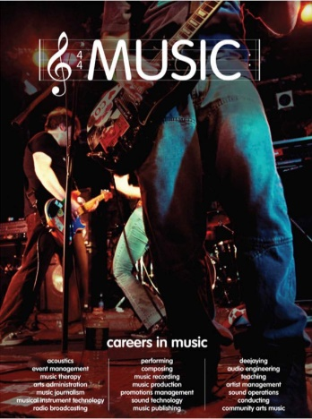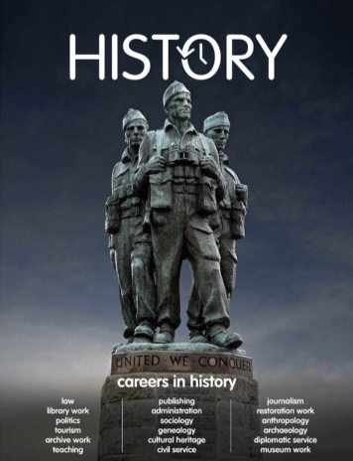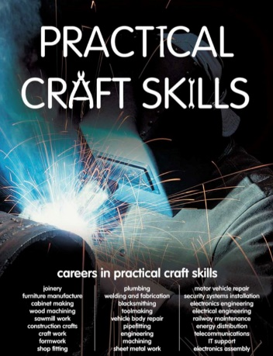

EMPLOYABILITY
- Mock interviews by employers are held for Year 10 students annually. Year 7 students are also mock interviewed by the Careers team and more recently, year 5s!
- CV and interview skills are taught in tutor time in Year 7 and Year 10 in the run up to the Interview Challenge and Mock Interview Day. For Y11 students looking to go on to do an Apprenticeship, ASK Apprenticeships come in to run CV workshops after school.
- 1 week block work experience for Year 10 students is held annually.
- Student Priority Groups are given additional time and support to prepare for these key activities.
- All of these events and activities are in place to build employability skills and to help students learn to use labour market information to help guide their aspirations and plans.

Does it work? Yes! Many students leaving Worle had identified Year 10 Mock Interview Day as the most important day of their school life. Feedback from employers and students was outstanding. Year 5 and 7 Interview Challenge’s ensure early engagement with the Careers team and buy in for later activities. 100% of Year 10 students participated in Work Experience week in 2022 & 2023. The range of Work Experience placements has increased significantly and students and parents fully understand it’s importance. Many have progressed to part time work with the same employers and even Apprenticeships. Each year an award is given to the ‘Work Experience Student of the Year’.
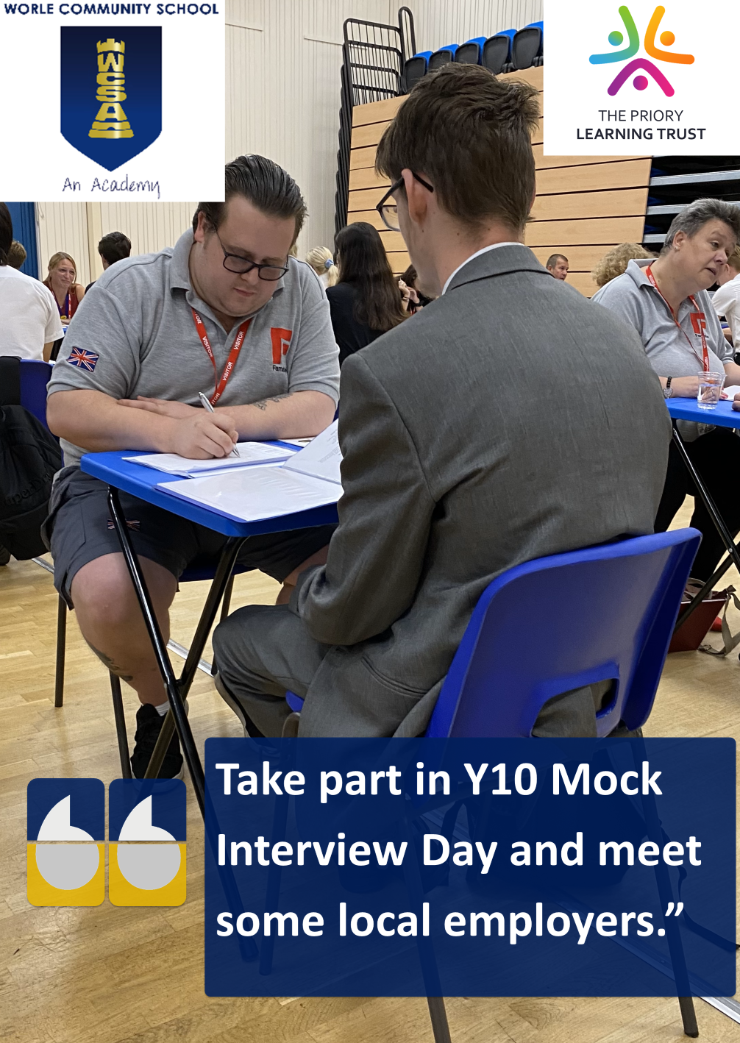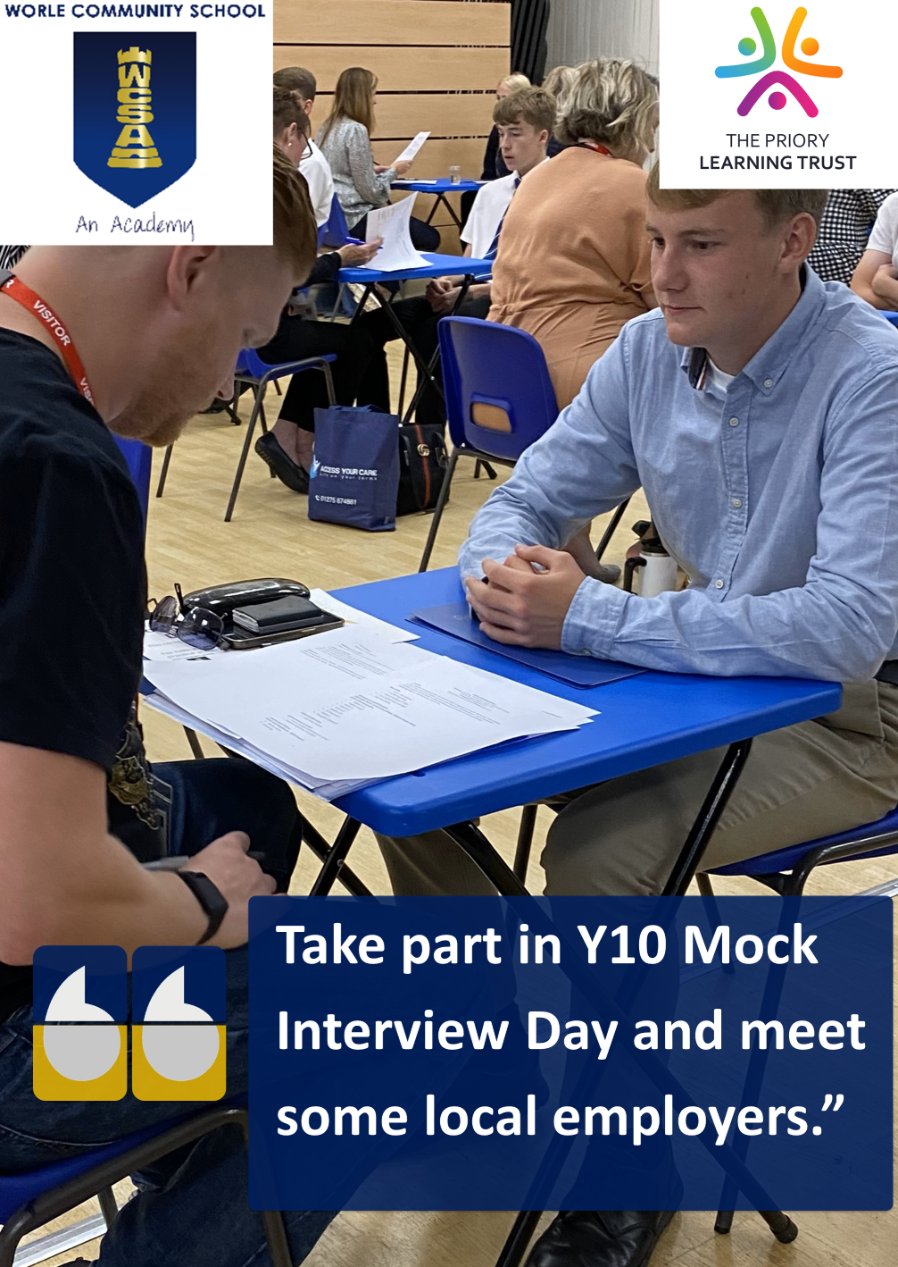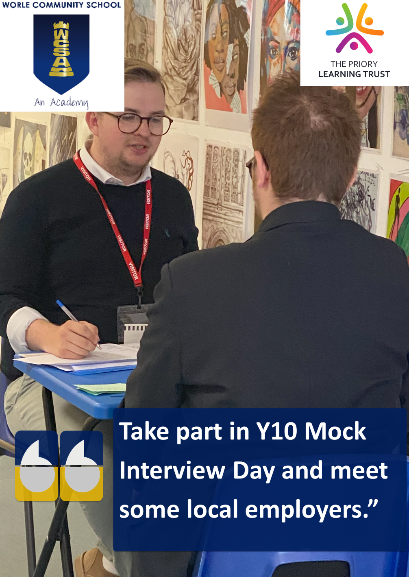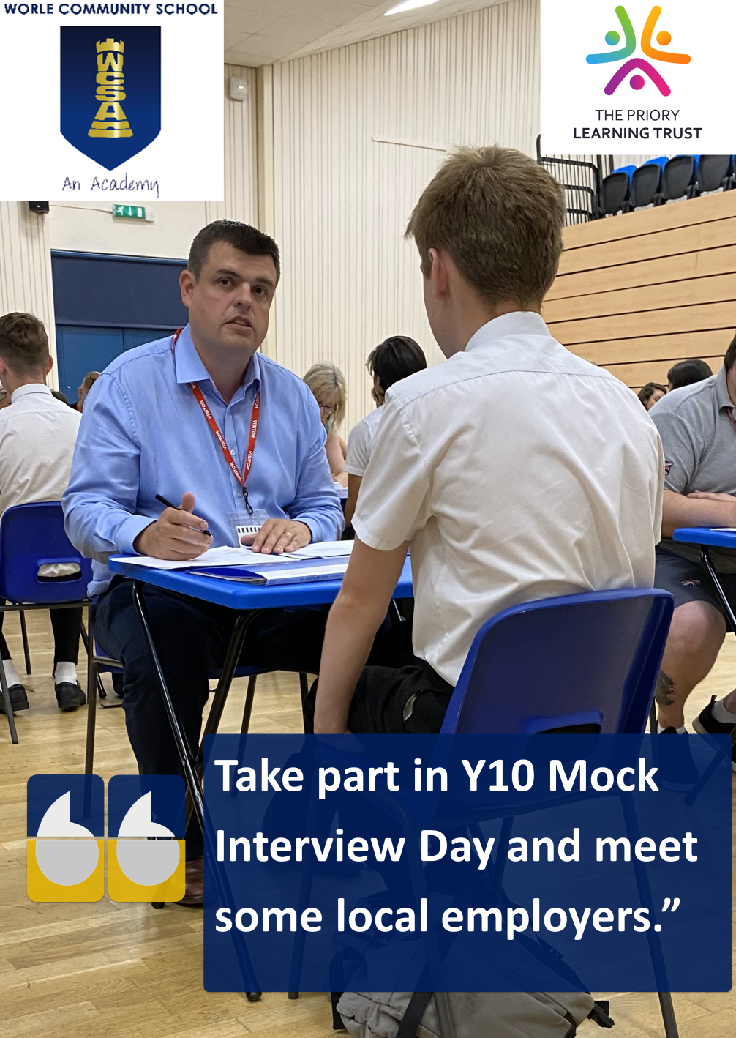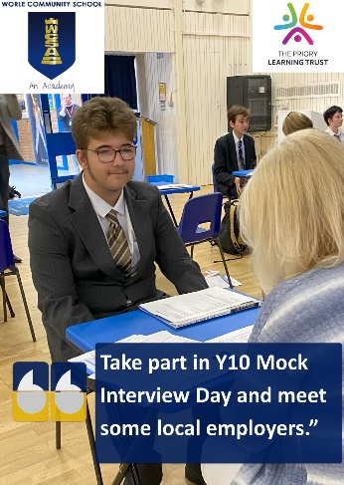

PARENTS

- A monthly careers activity bulletin is created, emailed to parents & tutors and uploaded onto the WCSA website and Facebook page. This bulletin highlights relevant activities at school, colleges and the community suitable for all year groups.
- Following 121 appointments, action plans are created, agreed with students and fed back to parents.
- Online parent progression information evenings for Year 11 students annually. All progression routes are explained.
- Website resources are updated on a regular basis and a dedicated careers page has been created with links and useful information for students and their families.
- Social media is used professionally and is used to promote specific events, activities and successes.
- Careers information is also passed to parents in regular newsletters and press releases.
- The careers offer is also open to parents to help develop their own career.
- Parents are welcome to attend family 121 sessions with their child.

Does it work? Yes! Parental ‘buy in’ to the careers offer is at an all-time high and the feedback indicates that they value the information that is being sent home to them. Parents often contact the Careers Team for further guidance or to arrange an appointment.

FEEDBACK

- Feedback is recorded and acted upon with improvements in place. Complaints are dealt with immediately.
- First and foremost, the students must enjoy engaging with The Careers Team and find our activities and events relevant, interesting and productive. Feedback is vital to help us achieve this.
- We use a google form to collect feedback from all students and parents regarding the careers offer as a whole and the events and activities they take part in.

Does it work? Yes! Student feedback has helped us provide a more relevant service to our students’ needs. Employer and stakeholder feedback has helped us run more effective activities and events. Feedback helps the service move forward to make improvements and also positively reinforce the existing activities which have been praised.

THE CAREERS TEAM

• The Careers Team is impartial at all times. A balanced relationship with local colleges is assured. They are non-disciplinary and encourage students to speak openly without fear of judgement.
• The Careers Team market themselves to students and their families as providers of opportunities and choices.
• The Careers office door is always open and students should never knock…it is their space.
• Parents are always welcome to contact us with questions and this is promoted in the monthly bulletin.
• The Careers Team remain trained, Level 6 qualified, expert, impartial, enthusiastic and participate in reflective practice.

Does it work? Yes! The quality and effectiveness of our career activities and events is of a higher level of quality than many of our neighbouring schools who do not have the same staff resources or level of experience. Feedback from students, staff and parents has been extremely positive. Employers and stakeholders also value the fact that a central point of contact is always available without split responsibilities and the events that they participate in will be well organised, effective and a good use of their time.

POLICY & PRACTICE

• Our activities are Gatsby compliant and we have been externally moderated with 100% compliance.
• Risk assessments are produced for activities on and offsite.
• Staff are appropriately trained.
• Visiting staff are DBS checked or supervised by staff at all times.
• The Director of Careers liaises with the Careers and Enterprise Company on a regular basis to access policy updates.
• The provider policy access document is visible on all Priory Learning Trust websites.
• WCSA works closely with an allocated Enterprise Advisor.
• WCSA is considered to be a centre of excellence and best practice is shared with visiting staff from other schools.

CONCLUSION

All Students leave WCSA with –

• Work experience.
• A CV and interview practice.
• A successful application for a relevant progression route.
• A clear vision of their career plan and the confidence to make good career choices.
• An awareness of soft skills and their importance in the world of work.
• A strong sense of self-worth and opportunity.
• A knowledge of where they can find further support and guidance beyond school.

FURTHER PLANS

• We will continue to review events and activities and make ongoing improvements.
• We will continue to recruit a wider range of employers to work in partnership with and maintain stakeholder relationships.
• We will continue to reach out and engage with parents to ensure that the careers message is also promoted at home.

CONTACT: leeza.cuthbertson@wcsa.theplt.org.uk

OUR PLEDGE TO STUDENTS
When you complete your time with a TPLT Primary School, you will have:
Created your first CV and attended your mock interview challenge with The Careers Team.

When you complete Year 7, you will have:
- Met your Careers Advisor, created a CV and attended your mock interview challenge with the Careers Team
- Had at least 4 encounters to learn about college, apprenticeships and university
- Met multiple employers and previous students
- Had the opportunity to visit a college or 6th form for an open evening
- Had the opportunity to visit our careers fair in person and our online careers convention
- Had the opportunity to call into the careers office any time

When you complete Year 8, you will have:
- Had at least 4 encounters to learn about college, apprenticeships and university
- Met multiple encounters with employers and previous students
- Had the opportunity to visit a college or 6th form for an open evening
- Had the opportunity to visit our careers fair in person and our online careers convention
- Had the opportunity to take part in careers related trips to college, university or an employer
- Had the opportunity to call into the careers office any time

When you complete Year 9, you will have:
- Had at least 4 encounters to learn about college, apprenticeships and university
- Met multiple encounters with employers and previous students
- Had the opportunity to visit a college or 6th form for an open evening
- Had the opportunity to visit our careers fair in person and our online careers convention
- Had the opportunity to take part in careers related trips to college, university or an employer
- Had the opportunity to call into the careers office any time to discuss your options

When you complete Year 10, you should have:
- Attended at least two college or sixth form open evenings
- Had at least 4 encounters to learn about college, apprenticeships and university
- Had multiple 1:1s with the Careers Team to discuss work experience and progression beyond school
- Completed a week of work experience
- Finished your CV and attended mock interview day
- Attended a College Taster Day trip with school
- Visited our careers fair in person and our online careers convention
- Had the opportunity to take part in careers related trips to college, university or an employer

When you complete Year 11, you should have:
- Visited the Careers Office for a progression meeting
- Completed college, 6th form and / or apprenticeship applications for your next step beyond school
- Attended application interviews at colleges and/or sixth forms with places offered
- A general plan of your career pathway
- Attended or had the opportunity to attend further college and 6th form taster activities on weekends or half term
- Attended at least two college or sixth form open evenings
- Had at least 4 encounters to learn about college, apprenticeships and university
- Attended a College Taster Day trip with school
- Visited our careers fair in person and our online careers convention
- Had the opportunity to call into the careers office any time to discuss your options beyond school
- Had the opportunity to access further help and support with your transition beyond school if you need it

