Worle Community School Academy

Geography
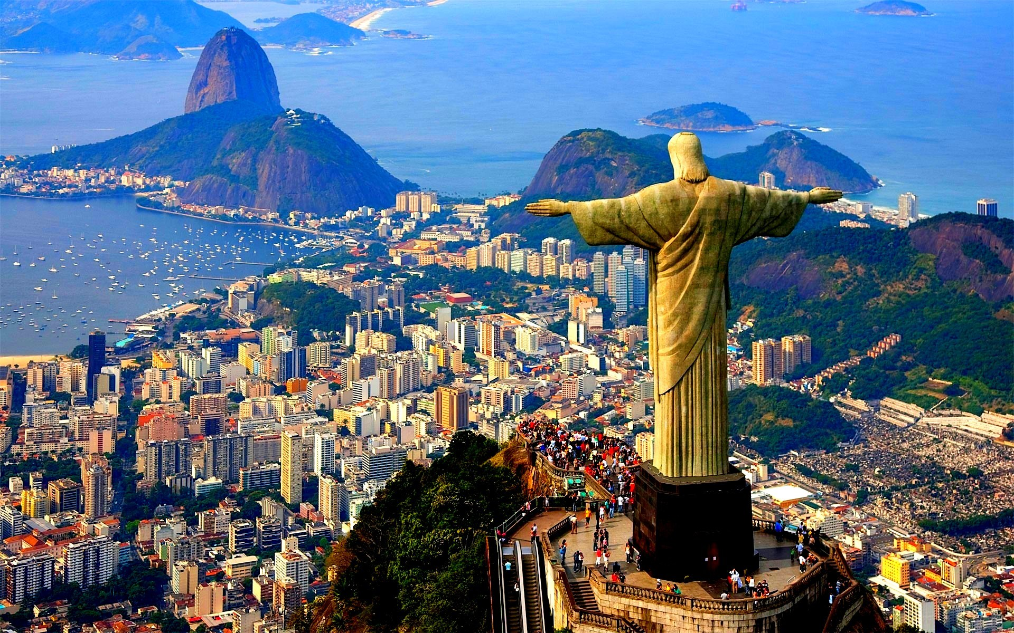

Name: ______________________________________
Class: _______________
Teacher: ___________________________________
Yr 9 Homework Cycle 2
Cycle 2 Calendar
Nov
2018
 | 2.1 | 26 | 27 | 28 | 29 | 30 | Week 1
Dec  2018 | 2.2 | 3 | 4 | 5 | 6 | 7 | Week 2
 | 2.3 | 10 | 11 | 12 | 13 | 14 | Week 3
 | 2.4 | 17 | 18 | 19 | 20 | 21 | Week 4
 |  | 24 | 25 | 26 | 27 | 28 | Christmas
 |  | 31 | 1 | 2 | 3 | 4 | Christmas
Jan  2019 | 2.5 | 7 | 8 | 9 | 10 | 11 | Week 5
 | 2.6 | 14 | 15 | 16 | 17 | 18 | Week 6
 | 2.7 | 21 | 22 | 23 | 24 | 25 | Week 7
 | 2.8 | 28 | 29 | 30 | 31 | 1 | Assessment
Feb  2019 | 2.9 | 4 | 5 | 6 | 7 | 8 | STW

- During the Assessment Week, students will be assessed on the material that they have covered the previous 7 weeks in Geography.

- Following this, the teacher will re-teach areas of underachievement, as identified during the assessment week, during the Super Teaching week.

- The tasks labelled as “consolidation tasks” mean that students should be able to complete them using their knowledge from lessons.

- There are also tasks labelled, “research tasks”, where we are asking students to spend 15-20 minutes doing some research.
Useful Websites to help you with your research
BBC Bitesize

Each week we will mark homework in class. Tick how easy you found the homework (RED = really tough, Amber= OK, Green =Easy).
Week | Homework task | Peer / Self | Red | Amber |  | Green
1 | Map skills recap
2 | Urbanisation
3 | Mega cities
4 | Urban Growth
5 | Impacts of Urbanisation
6 | Richer areas of Rio
7 | Improving Rio’s favelas
 | Parent /carer comments
There is a space below in the table for parents/carers to make a comment if they need to.

Week 1 – Consolidation task
Map skills recap

1. Work out the for figure grid reference for
Caravan Site ______________________

Public Phone ______________________

Parking Space_____________________

Picnic Area ________________________

- Place a circle at grid 0070

- Give the 6 figure grid reference for the following
- Bridge _____________________
- Viewpoint __________________
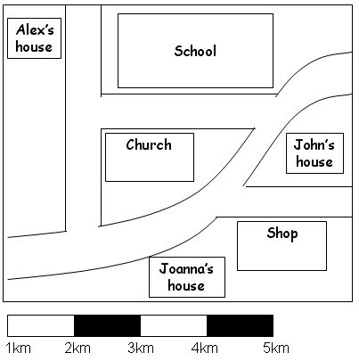

- Using the map and scale on the following page, provide the accurate distances from:
- Alex’s house to John’s house by road ________________
- Alex’s house to Church by road ______________
- John’s house to Joanna’s house by road _______________
- Alex’s house to the shop by the road, if he goes past John’s house on his way __________________

- In geography, what does the term “relief” mean?
__________________________________________________________________________________________________________________________________________

- On an Ordinance Survey map, what are Contours?
__________________________________________________________________________________________________________________________________________

Week 2 – Consolidation task
Urbanisation
- What does rural mean?

- What does urban mean?

3. What does HIC mean? Give an example

- What does NEE mean? Give an example.
________________________________________________________________

- What does LIC mean? Give an example

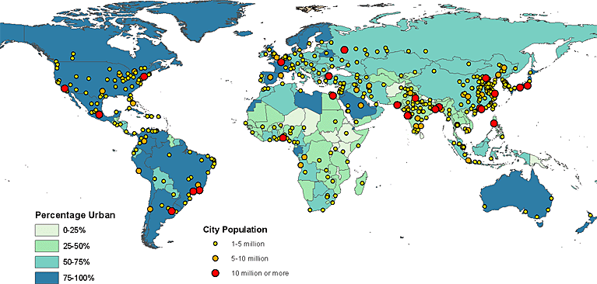
- Name a country which has an urban population over 75%

6. Name a city with more than 10 million people
_________________

Week 3 – Consolidation task
Megacities
- What is a megacity?

2. Below is a map showing how megacities will grow over the next few years.

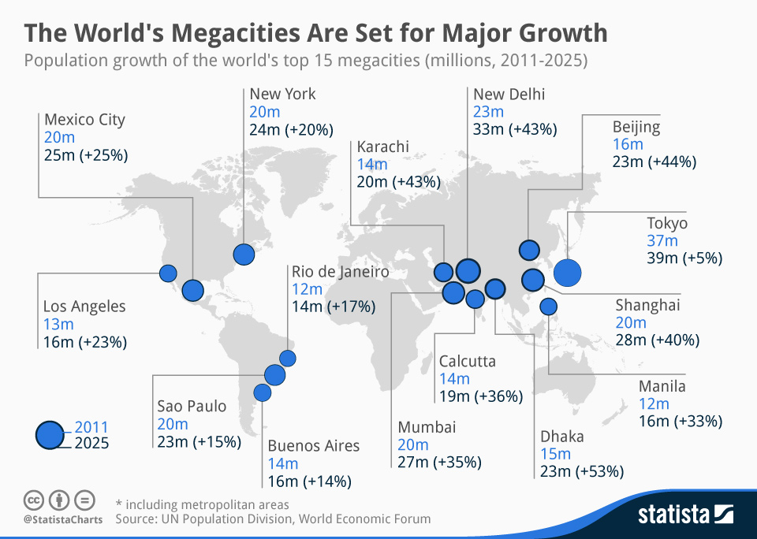

How many of these megacities are currently in HICs? Which cities are they?

- What is a World city?

- London is a World City but not a megacity? Explain what this means.
________________________________________________________________________________________________________________________________________________________________________________________________

Week 4- Consolidation task
Urban Growth

- During which time period did UK cities see a major growth? Why was this?
________________________________________________________________________________________________________________________________________________________________________________________________________________________________________________________________________

- What type of countries are we seeing massive urban growth now ? _______________________________________________________________

- One reason for this growth is rural to urban migration. What does this mean?
________________________________________________________________

- There are 2 sets of reasons for rural to urban migration. What does each set of factors mean and give 3 examples of each.
- PUSH FACTORS:
____________________________________________________________
_______________________________________________________________
_______________________________________________________________
_______________________________________________________________
- PULL FACTORS:
____________________________________________________________________________________________________________________________________________________________________________________________________________________________________________________

- The other reason for growth in LIC cities is because birth rate is higher than death rate.
Birth rate = ______________________________________________________________________________________________________________________________

Death rate = ______________________________________________________________________________________________________________________________

Explain why birth rates are high in LIC’s ___________________________________________________________________________________________________________________________________________________________________________________________________________________________________________________________________________________________________________________________

Explain why death rates are falling in some LIC’s _________________________________________________________________________________________________________________________________________________________________________________________________________________________________________________________________________________________________________________________________________________________________________________________________________________________________________________________

6. What is the impact of rapidly increasing cities in LIC’s?: ____________________________________________________________________________________________________________________________________________________________________________________________________________________________________________________________________________________

Week 5 – Consolidation task
Impacts of Urbanisation
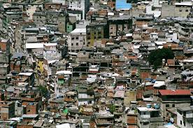

- Above is an image of slums in Rio de Janeiro. Describe conditions for people who live here.

Housing________________________________________________________________
__________________________________________________________________
__________________________________________________________________
__________________________________________________________________
________________________________________________________________
__________________________________________________________________
__________________________________________________________________
______________________________________________________________________Transport_____________________________________________________________________________________________________________________________________________________________________________________________________________________________________________________________________________________________________________________________________________________________________________________________________________________________Health_____________________________________________________________________________________________________________________________________________________________________________________________________________________________________________________________________________________________________________________________________________________________________________________________________________________________________________________________________________________________________Education_____________________________________________________________________________________________________________________________________________________________________________________________________________________________________________________________________________________________________________________________________________________________________________________________________________________________Environment ____________________________________________________________________________________________________________________________________________________________________________________________________________________________________________________________________________________________________________________________________________________________________________________________________________________________________

Week 6 Consolidation task
Richer areas of Rio

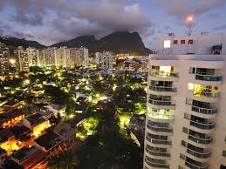

- Above is another area of Rio. Describe conditions for people in this part of the city
__________________________________________________________________________________________________________________________________________________________________________________________________________________________________________________________________________________________________________________________________________________________________________________________________________________________________________________________________________________________________________________________________________________________________________________________________________________________________________________________________________________________________________________________________________________________________________________________________________________________________________________________________________________________________________________________________________________________________________________________________________________________________________________________________________________________

Week 7 Consolidation task

Improving Rio’s favelas
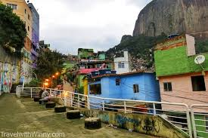
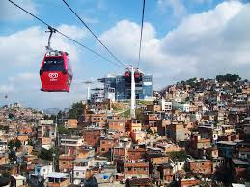

Describe how life in Rio’s favelas could be improved. Think about housing, amenities, jobs, healthcare, education , etc.
Housing____________________________________________________________________________________________________________________________________________________________________________________________________________________________________________________________________________________________________________________________________________________________________________________________________________________________________________________________________________________________________Jobs_______________________________________________________________________________________________________________________________________________________________________________________________________________________________________________________________________________________________________________________________________________________________________________________________________________________________________________________________________________________________________Healthcare______________________________________________________________
______________________________________________________________________________________________________________________________________________________________________________________________________________________________________________________________________________________________________________________________________________________________Education___________________________________________________________________________________________________________________________________________________________________________________________________________________________________________________________________________________________________________________________________________________________________________________________________________________________________________________________________________________________________Amenities___________________________________________________________________________________________________________________________________________________________________________________________________________
________________________________________________________________________________________________________________________________________________________________________________________________________________________________________________________________________________________Environment_________________________________________________________________________________________________________________________________________________________________________________________________________________________________________________________________________________________________________________________________________________________________________________________________________________________________________________________________________________________________________________________________________________________________________________________________________________________________________________________________________________________________________________________________________________________________________________________

