WCSA
English
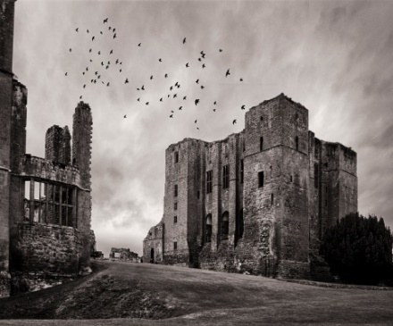
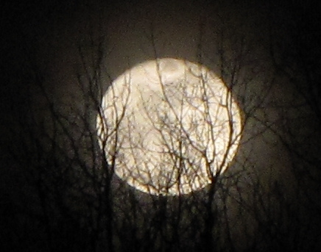

Home Learning Book –
Learning Cycle 2

Year 9
Gothic Literature

English Language and Literature

Name: __________________________Tutor Group: 9___

English Teacher(s): ______________________________

Learning Cycle 2

November 2018 | 26 | 27 | 28 | 29 | 30 | Teaching week 1
December 2018 | 3 | 4 | 5 | 6 | 7 | Teaching week 2
 | 10 | 11 | 12 | 13 | 14 | Teaching week 3
 | 17 | 18 | 19 | 20 | 21 | Teaching week 4
 | 24 | 25 | 26 | 27 | 28 | Christmas Holiday
January 2019 | 31 | 1 | 2 | 3 | 4 | Christmas Holiday
 | 7 | 8 | 9 | 10 | 11 | Teaching week 5
 | 14 | 15 | 16 | 17 | 18 | Teaching week 6
 | 21 | 22 | 23 | 24 | 25 | Teaching week 7
 | 28 | 29 | 30 | 31 | 1 | Assessment week
February 2019 | 4 | 5 | 6 | 7 | 8 | Super Teaching week

- During the Assessment Week, students will be assessed on the material that they have covered the previous seven weeks.

- Following this, the teacher will re-teach areas of underachievement, as identified during the assessment week, during the Super Teaching week.

- The tasks labelled as “consolidation tasks” mean that students should be able to complete them using their knowledge from lessons.

- There are also tasks labelled, “research tasks”, where we are asking students to spend 15-20 minutes doing some research.

Useful Websites to help you with your research
https://en.oxforddictionaries.com/grammar/word-classes-or-parts-of-speech
http://www.thesaurus.com/
http://literary-devices.com/
https://www.thoughtco.com/what-is-gothic-literature-739030
https://www.bl.uk/romantics-and-victorians/themes/the-gothic

Week 1 – Page 3 - Key Words
Research
Research and write the definitions for the following key terms.

Gothic - __________________________________________________________________________________________________________________________________________________________________
Genre –
__________________________________________________________________________________________________________________________________________________________________
Noun __________________________________________________________________________________________________________________________________________________________________
Adjective –
__________________________________________________________________________________________________________________________________________________________________
Verb –
__________________________________________________________________________________________________________________________________________________________________
Adverb - __________________________________________________________________________________________________________________________________________________________________
Character –
__________________________________________________________________________________________________________________________________________________________________
Simile –
__________________________________________________________________________________________________________________________________________________________________
Metaphor –
__________________________________________________________________________________________________________________________________________________________________

Parent/carer comments:
Week 2 – Page 4 - Synonyms
Research
Task 1:
Write a definition for the term synonym:
__________________________________________________________________________________________________________________________________________________________________

Task 2:
Write a selection of appropriate synonyms for the following Gothic terms:
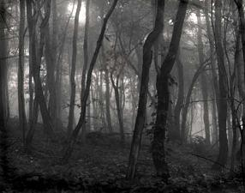
Dark:

Cold:

Silent:

Anger:

Sad:

Scream:
Parent/carer comments:
Week 3 – Page 5 & 6 – Language Skills
Consolidation

Read the extract from the opening chapters of ‘The Canterville Ghost’ by Oscar Wilde and complete the tasks that follow

Chapter I

When the American, Mr Otis, bought Canterville Castle, everyone told him that this was very foolish, as the place was haunted. But Mr Otis answered, “I come from a modern country, where we have everything that money can buy. And if there were such a thing as a ghost in Europe, we would have it at home in one of our museums.”
A few weeks later, on a lovely July evening, Mr Otis, his wife and their children, Washington, Virginia and the twins, went down to their new home. When they entered the avenue of Canterville Castle, the sky suddenly became dark and a spooky stillness was in the air.
Mrs Umney, the housekeeper, led them into the library of the castle, where they sat down and began to look around. Suddenly, Mrs Otis saw a red stain on the floor just by the fireplace and said to Mrs Umney, “I am afraid something has been spilt there.”
“Yes, madam,” said the old housekeeper in a low voice, “blood has been spilt on that spot.”
“How terrible,” said Mrs Otis; “I don't want any blood-stains in my sitting-room. It must be removed at once.”
The old woman smiled and answered, “It is the blood of Lady Eleanore de Canterville, who was murdered on that spot by her husband, Sir Simon de Canterville, in 1575. Sir Simon disappeared seven years later. His body has never been found, but his ghost still haunts the Castle. The blood-stain is a tourist attraction now and it cannot be removed.”
“That is all nonsense,” said Washington, the eldest son of the Otis family, “stain remover will clean it up in no time,” and he took a bottle of stain remover out of his pocket and cleaned the spot. But as soon as the blood-stain had disappeared, a terrible flash of lightning lit up the room and a fearful peal of thunder made the whole building shake.

Chapter II

There was a horrible storm that night, but apart from that nothing scary happened. The next morning, however, when the family came down to breakfast, they found the terrible stain of blood once again on the floor. Washington cleaned it a second time, but the second morning it appeared again. The third morning it was there, too, although the library had been locked up at night by Mr Otis himself.
The following night, all doubts about the existence of the ghost were finally removed forever. At eleven o'clock the family went to bed and sometime after, Mr Otis was awakened by a strange noise in the corridor, outside his room. It sounded like the clank of metal, and it came nearer every moment. Mr Otis got up and looked at the time. It was exactly one o'clock. So Mr Otis put on his slippers, went to the door and opened it. There, right in front of him, stood the ghost - his eyes were as red as burning coals; long grey hair fell over his shoulders and from his wrists and ankles hung heavy chains.
“My dear Sir,” said Mr Otis, “you must oil those chains. It's impossible to sleep with such a noise going on outside the bedrooms. I have therefore brought you this bottle of lubricator, and I will be happy to supply you with more if you require it.” With these words Mr Otis laid the bottle down, closed his door and went back to bed.
Shocked, the Canterville ghost stood quite motionless for a moment, but then he growled angrily. Just at this moment, the twins appeared on the corridor and threw a large pillow at him! The ghost hastily escaped through the wall, and the house became quiet again.
When the ghost reached his small secret chamber, he took a deep breath. No ghosts in history had ever been treated in this manner!

Task 1.
Read through the following statements and identify the FOUR correct ones.
1 – Mr Otis is not frightened by the ghost. He’s an American and doesn’t believe in them.
2 – The blood stain disappears after being cleaned.
3 – Mrs Umney owns the house.
4 – Washington is the eldest son in the Otis family.
5 – The house was destroyed in the storm.
6 – The Canterville ghost cannot believe how he is being treated by the family.
7 –Around his wrists and ankles, the Canterville ghost wears chains.
8 – Sir Simon de Canterville was murdered by his wife.

Task 2. – Highlight any words and phrases which make this story part of the Gothic tradition.
Parent/carer comments:
Week 4 – Page 7 & 8 - Text Analysis and Comprehension.
Consolidation
Read the opening of ‘The Monkey’s Paw’ by W. W. Jacobs and answer the questions that follow.
Without, the night was cold and wet, but in the small parlour of Laburnum villa the blinds were drawn and the fire burned brightly. Father and son were at chess; the former, who possessed ideas about the game involving radical chances, putting his king into such sharp and unnecessary perils that it even provoked comment from the white-haired old lady knitting placidly by the fire.
"Hark at the wind," said Mr. White, who, having seen a fatal mistake after it was too late, was amiably desirous of preventing his son from seeing it.
"I'm listening," said the latter grimly surveying the board as he stretched out his hand. "Check."
"I should hardly think that he's come tonight,” said his father, with his hand poised over the board. "Mate," replied the son.
"That's the worst of living so far out," balled Mr. White with sudden and unlooked-for violence; "Of all the beastly, slushy, out of the way places to live in, this is the worst. Path's a bog, and the road's a torrent. I don't know what people are thinking about. I suppose because only two houses in the road are let, they think it doesn't matter."
"Never mind, dear," said his wife soothingly; "perhaps you'll win the next one."
Mr. White looked up sharply, just in time to intercept a knowing glance between mother and son. The words died away on his lips, and he hid a guilty grin in his thin grey beard.
"There he is," said Herbert White as the gate banged to loudly and heavy footsteps came toward the door.
The old man rose with hospitable haste and opening the door, was heard condoling with the new arrival. The new arrival also condoled with himself, so that Mrs. White said, "Tut, tut!" and coughed gently as her husband entered the room followed by a tall, burly man, beady of eye and rubicund of visage.
"Sergeant-Major Morris,” he said, introducing him.
The Sergeant-Major took hands and taking the proffered seat by the fire, watched contentedly as his host got out whiskey and tumblers and stood a small copper kettle on the fire.
At the third glass his eyes got brighter, and he began to talk, the little family circle regarding with eager interest this visitor from distant parts, as he squared his broad shoulders in the chair and spoke of wild scenes and doughty deeds; of wars and plagues and strange peoples.
"Twenty-one years of it," said Mr. White, nodding at his wife and son. "When he went away he was a slip of a youth in the warehouse. Now look at him."
"He don't look to have taken much harm." said Mrs. White politely.
"I'd like to go to India myself," said the old man, just to look around a bit, you know."
"Better where you are," said the Sergeant-Major, shaking his head. He put down the empty glass and sighing softly, shook it again.
"I should like to see those old temples and fakirs and jugglers," said the old man. "what was that that you started telling me the other day about a monkey's paw or something, Morris?"
"Nothing." said the soldier hastily. "Leastways, nothing worth hearing."

- List four things that we learn about the parlour and its inhabitants from the opening paragraph:
- ________________________________________________________________
- ________________________________________________________________
- ________________________________________________________________
- ________________________________________________________________

- List four things that we learn about the outside setting of the story.
- ________________________________________________________________
- ________________________________________________________________
- ________________________________________________________________
- ________________________________________________________________

- Look at the second half of the text. List four things that we learn about the “new arrival”.
- ________________________________________________________________
- ________________________________________________________________
- ________________________________________________________________
- ________________________________________________________________

- List four features from the extract which conform to the Gothic tradition.
- ________________________________________________________________
- ________________________________________________________________
- ________________________________________________________________
- ________________________________________________________________
Parent/carer comments:
Week 5 – Page 9 - Key Words
Research
Research and write the definitions for the following key terms.

Folklore - __________________________________________________________________________________________________________________________________________________________________

Mood –
__________________________________________________________________________________________________________________________________________________________________

Atmosphere __________________________________________________________________________________________________________________________________________________________________

Synonyms –
__________________________________________________________________________________________________________________________________________________________________

Tension –
__________________________________________________________________________________________________________________________________________________________________

Antonyms - __________________________________________________________________________________________________________________________________________________________________

Context –
__________________________________________________________________________________________________________________________________________________________________

Syntax –
__________________________________________________________________________________________________________________________________________________________________
Parent/carer comments:
Week 6 – Gothic Words
Consolidation
Task 1.
Label the following image with as many gothic elements as you can. One has been done for you.
Ruined Buildings

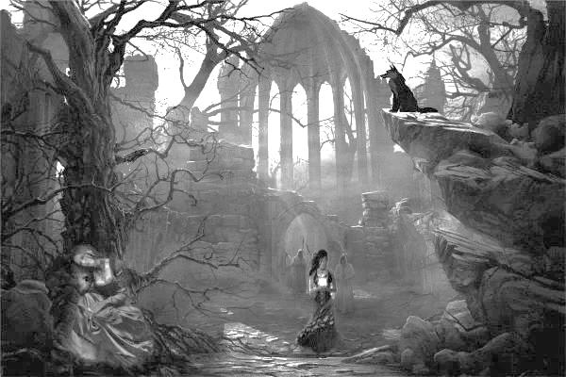

Task 2.
Write a paragraph describing this setting, using at least 5 of the methods listed below.

Metaphor | Simile | Personification | Alliteration | Pathetic Fallacy
Onomatopoeia | Gothic lexis | Hyperbole | Repetition | Symbolism

____________________________________________________________________________________________________________________________________________________________________________________________________________________________________________________________________________________________________________________________________________________________________________________________________________________________________________________________________________________________________________________________________________________________________________________________________________________________________________________________________________________________________________________________________________________________________________________________________________________________________________________________________________________________________________________________________________________________________________________________________________________________________________________________________________________________________________________________________________________________________________________________________________________________________________________________________________________________________________________________________________________

Task 3.
Annotate your descriptions, identifying the methods used and explaining how ideas created link to the Gothic genre.

Parent/carer comments:

Week 7 –
Research
Research and write the definitions for the following key terms.

Exposition - __________________________________________________________________________________________________________________________________________________________________

Complication –
__________________________________________________________________________________________________________________________________________________________________

Climax –
__________________________________________________________________________________________________________________________________________________________________

Resolution –
__________________________________________________________________________________________________________________________________________________________________

Pathetic fallacy -
__________________________________________________________________________________________________________________________________________________________________

Connotation –
__________________________________________________________________________________________________________________________________________________________________

Setting –
__________________________________________________________________________________________________________________________________________________________________

Imagery –__________________________________________________________________________________________________________________________________________________________________
Parent/carer comments:

