WCSA


Home Learning Book – Learning Cycle 2

Year 9
Design & Technology
Resistant Materials Focus

Name: _______________________________Tutor Group: ___

Teacher(s): ___________________________________

Why is regular home learning important?

- It can improve a student’s thinking and memory skills. This is vital for the new content heavy GCSEs.

- It helps students to develop positive study skills and habits that will serve them well throughout life.

- Home learning encourages students to use time wisely and efficiently.

- It teaches students to work independently.

- Home learning teaches students to take responsibility for their own work.

- It allows students to review and practice what has been covered in class and consolidate their knowledge and skills.

- Equally important, it helps students to get ready for the next day’s class.

- It helps students learn to use resources, such as libraries, reference materials, and computer Web sites to find information.

- It encourages students to explore subjects more fully than classroom time permits.

- It allows students to extend their learning by applying skills to new situations.

- Home learning helps parents learn more about what their children learning in school.

- It allows parents to communicate with teachers about learning in order to support their children efficiently.

Week 1

Homework 1: Research
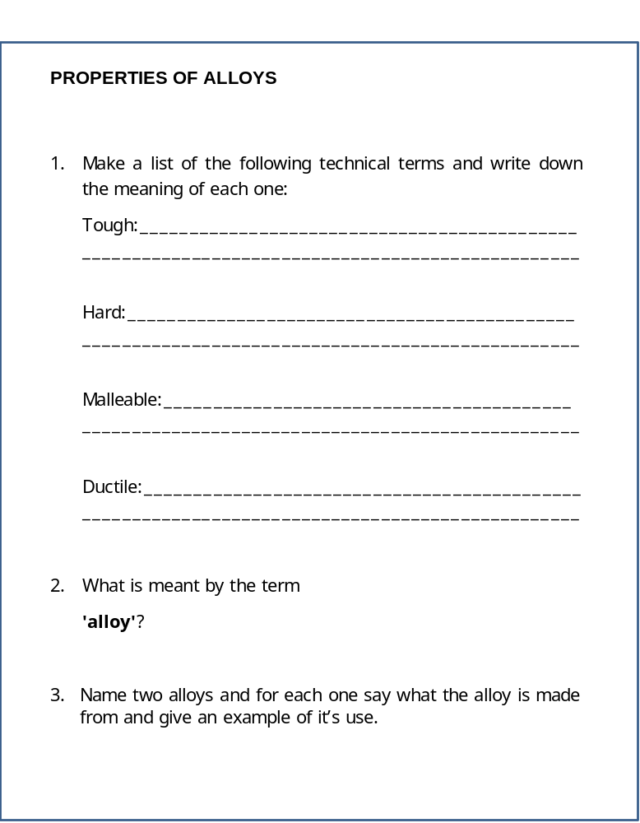

Week 2

Homework 2: Key words

Research and explain the definitions of the following key words giving examples where appropriate:

Key Word | Definition
Research
Jig
J.I.T.
Evaluation
Week 3

Homework 3: Research

List below the 6 R’s of sustainability and give an explanation for each.

1

2

3

4

5

6

Week 4

Homework 4: Key words

Research and explain the definitions of the following key words giving examples where appropriate:

Key Word | Definition
Cam
Scale of Production
Bevel
Abrasive Paper

Week 5

Homework 5: Research

Research (internet, encyclopaedias, or reference books) the Injection moulding process and Vacuum forming process as two methods that plastic materials can be shaped and formed. Explain in your own words, or sketch the processes in the boxes below.

Injection Moulding

Vacuum forming

Week 6

Homework 6: Key words

Research and explain the definitions of the following key words giving examples where appropriate:

Key Word | Definition
Casting
Development
Chuck
C.N.C

Week 7

Homework 7: Research


