Cycle 1 Homework

September 2019

Subject: ICT

Year 7

This cycle you will be learning: The purpose and content of pre-production documents.

What you will learn | Week
Introduction to the network and Google class room | 1
Personal information | 2
Social networking | 3
Cyber bullying | 4
Sexting | 5
Digital footprint | 6
Consolidation of taught knowledge and skills | 7
Assessment week | 8
Super teach week | 9
Expectations:

• Complete homework tasks each week.
• Your homework will be marked each week and your teacher will allocate the specific lesson /
day.
• It must be completed by the due date.
• Use Knowledge organiser to help with your homework.

Calendar Cycle 1

September | 2 | 3 | 4 | 5 | 6
 | 9 | 10 | 11 | 12 | 13 | Teaching week 1
 | 16 | 17 | 18 | 19 | 20 | Teaching week 2
 | 23 | 24 | 25 | 26 | 27 | Teaching week 3
October | 30 | 1 | 2 | 3 | 4 | Teaching week 4
 | 7 | 8 | 9 | 10 | 11 | Teaching week 5
 | 14 | 15 | 16 | 17 | 18 | Teaching week 6
 | 21 | 22 | 23 | 24 | 25 | Inset/Half term
 | 28 | 29 | 30 | 31 | 1 | Half term
November | 4 | 5 | 6 | 7 | 8 | Teaching week 7
 | 11 | 12 | 13 | 14 | 15 | Teaching week 8
 | 18 | 19 | 20 | 21 | 22 | Teaching week 9

Name:

Teacher: Group:
•

Task 1: Week 1 Key terms

Due Week 1, Date:

Success Criteria: Define all key terms correctly

Task:

In the table below, there is a list of some key terms that you will learn during cycle 1. Your challenge is to write the definition for each of the work in the allocated box. You can research the definitions in the knowledge organiser or using the internet, but it must be written in your own words.

Key Term | Definition
Username
Network
password
Strong password
Network login
E-mail Address
Google Sign- in
Acceptable use
policy

Score out of 10:

Task 2: Week 2 Recognising Google apps

Due Week 2, Date:

Success Criteria: Explain what each Google app does

Task:

In the table below provide all content for each pre-production document. To help with the task the first letter of the words have been included. You can research using the knowledge organisers or the internet to help find the content of each document.

Explanation

Task 3: Strong passwords

Due Week 3, Date:

Success Criteria: To understand the importance of strong passwords

Task: In your own words below write down three rules you must think of when creating strong passwords.

Task 4: Cyberbullying

Due Week 4, Date:

Success Criteria: To understand what Cyber bulling is and how to report it

Explain in your own words what Cyberbullying is:
Explain in your own words the actions you should take if you are being Cyber bullied:

Task 5: Sexting

Due Week 5, Date:

Success Criteria: To understand what Sexing is and how to report it.

Explain in your own words what Sexting is:
Explain in your own words the actions you should take if you were a victim of
Sexting:

Task 6: Poster task

Due Week 6, Date:

Success Criteria: To provide the examples for file formats for each file type.

Task: Create a poster below for Year 6 students in order to inform on your knowledge of “E-Safety” this cycle.

Task 7: Consolidation of learning

Due Week 7, Date:

Success Criteria: Be able to write down a minimum of 5 rules for staying safe online

1.

2.

3.

4.

5.

Cycle 1 in Computer Science will focus on being safe online, using the Internet for research and learning to use
Google applications to help support your studies.

Topic 1
Key words and definitions
Username | The name you use to log into the school  network and Google, usually the year you started, your last name and first letter of your first name, e.g. 2019SmithB for Bob Smith who started in September 2019.
Network  Password | Used with your username to log into the  network. Make sure your password is a strong one.
Strong Password | Use a combination of lowercase and upper case letters and symbols to make it hard to guess (e.g. Pa55WorD! rather than password)
Network login | A secure way to access your files and folders and to access the internet. Uses your username and password.
E-Mail Address | Your school email address is:  <your user name>@tkasa.org.uk  (e.g. 2019SmithB@tkasa.org.uk)
Google Sign-in | Use your school E-Mail address and your network password to sign-in to Google
Acceptable Use  Policy | When you log into the School network, you  agree to a set of rules on how you use the computer and how you use the Internet.

Google
Apps

Google Apps:
Learning Objectives: To understand how to use Google Apps including, Sheets, Slides Google Classroom, and Gmail.

To be able to work collaboratively using the share function on Google software.

Computer Science

It is important that you use strong passwords where ever you have to log into a network or website. Check how long it would take to guess your password using this website: https://howsecureismypassword.net/
Google Chrome – preferred web browser for
accessing the Internet and Google Apps.
Waffle Icon – appears in the top right hand corner of the web browser once you have signed into Google. Used to access Google Apps
Google Docs – a word processor which auto-
saves your work to Google Drive. Used for writing letters, reports, assignments
Google Sheets – an application for creating spreadsheets. Used for calculations, producing graphs and modelling data
Google Slides – an application for creating presentations. Used for presenting information to an audience.
Google Classroom – an application used in class
to organise activities, provide resources and to set assignments and assessments
Gmail – an application for sending and receiving
email. Used for communicating with other people, such as your teachers and friends.
Google Drive – Used to save and organise your
Google files and folders

Topic 2

E-Safety
Learning Objectives: To understand how use the Internet for research, how to stay safe online, and be able to identify good and bad practices when using social media.

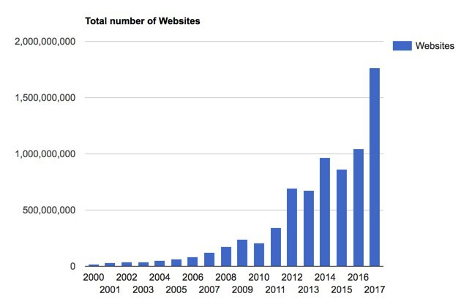
Computer Science

Social Media Applications:
Key words and definitions
Web browser | An application for viewing and interacting with  webpages from the World Wide Web, which is part of the Internet
URL | Uniform Resource Locator – this is the unique  address of the website you type into the browser (e.g. www.bbc.co.uk)
Search Engine | A database on the World Wide Web that enables you to use search terms or key words  to find relevant web pages or websites. E.g. Google, Bing, Yahoo
Keywors | The terms used in a webpage that would be used to match the search term a user enters  into a search engine.
http and https | These are the protocols (set of rules) used to  send and receive web pages over the Internet. The ‘s’ in https means that the connection is secure (e.g. used with online banking sites).
Advanced  search | Using Google’s advanced search to have  greater control over your search terms.  https://www.google.co.uk/advanced_search
Cyber bullying | The use of electronic communication to bully a person by sending messages of an  intimidating or threatening nature.
Sexting | The sending or receiving of inappropriate  images, videos or texts.

Rules for using social media:

1. Don’t upload pictures that you wouldn’t want anyone else to see.
2. Make sure your user settings are kept private.
3. Make sure you know who is on your friends list.
4. Report abuse – tell a trusted adult, or use the CEOP
website: https://www.ceop.police.uk

