WCSA
Completion dates;
Week 1 Week 5
Week 2 Week 6
Week 3 Week 7
Week 4

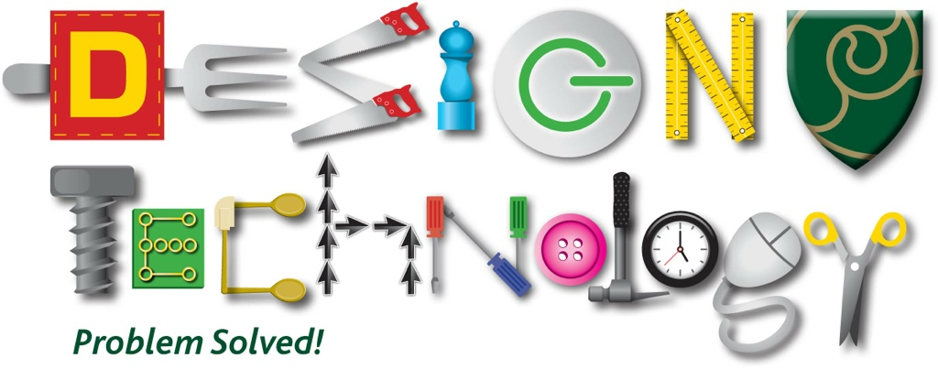
Home Learning Book – Learning Cycle 2

Year 9
Design & Technology
Resistant Materials Focus

Name: _______________________________Tutor Group: ___

Teacher(s): ___________________________________

Why is regular home learning important?

- It can improve a student’s thinking and memory skills. This is vital for the new content heavy GCSEs.

- It helps students to develop positive study skills and habits that will serve them well throughout life.

- Home learning encourages students to use time wisely and efficiently.

- It teaches students to work independently.

- Home learning teaches students to take responsibility for their own work.

- It allows students to review and practice what has been covered in class and consolidate their knowledge and skills.

- Equally important, it helps students to get ready for the next day’s class.

- It helps students learn to use resources, such as libraries, reference materials, and computer Web sites to find information.

- It encourages students to explore subjects more fully than classroom time permits.

- It allows students to extend their learning by applying skills to new situations.

- Home learning helps parents learn more about what their children learning in school.

- It allows parents to communicate with teachers about learning in order to support their children efficiently.

Week 1

Homework 1: Research
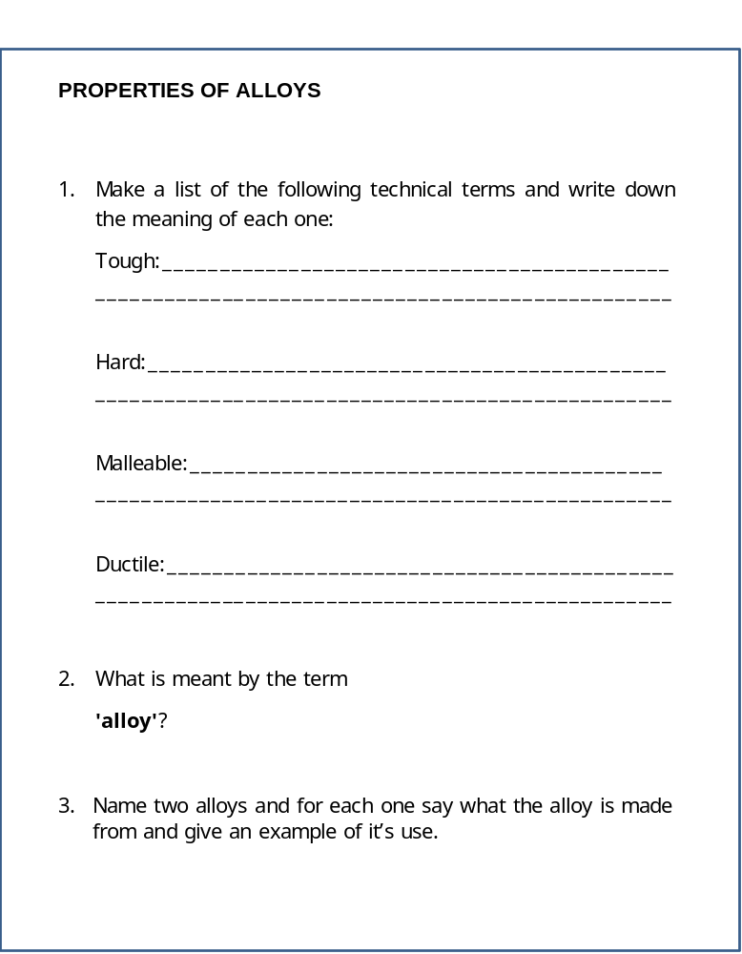

Week 2

Homework 2: Key words

Research and explain the definitions of the following key words giving examples where appropriate:

Key Word | Definition
Clamp
Coping saw
Dip coating
Enamel
Ferrous

Week 3

Homework 3: Research

List below the 6 R’s of sustainability and give an explanation for each.

1

2

3

4

5

6

Week 4

Homework 4: Key words

Research and explain the definitions of the following key words giving examples where appropriate:

Key Word | Definition
Forge
Grain
Green Timber
Hacksaw
Hardwood

Week 5

Homework 5: Research

Research (internet or reference books) the Injection moulding process and Vacuum forming process as two methods that plastic materials can be shaped and formed. Explain in your own words, or sketch the processes in the boxes below.

Injection Moulding

Vacuum forming

Week 6

Homework 6: Key words

Research and explain the definitions of the following key words giving examples where appropriate:

Key Word | Definition
Casting
Development
Chuck
C.N.C

Week 7

Homework 7: Research
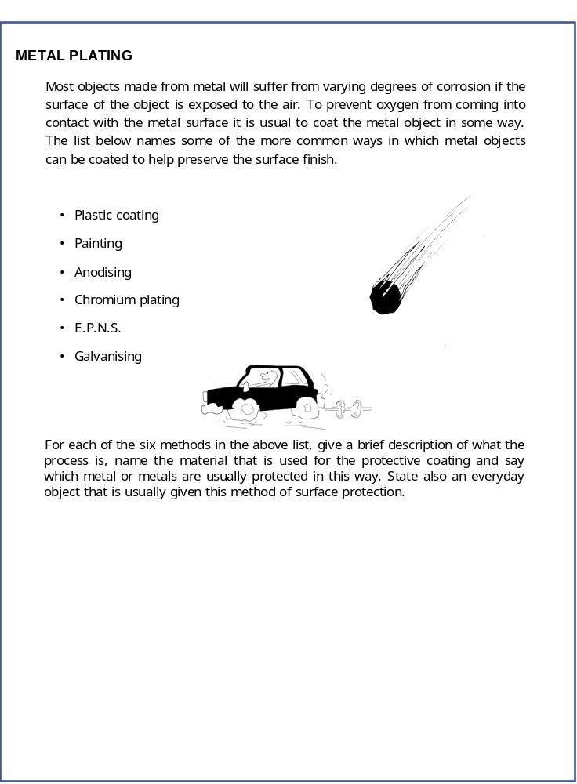

WCSA
Completion dates;
Week 1 Week 5
Week 2 Week 6
Week 3 Week 7
Week 4

Home Learning Book – Learning Cycle 3

Year 9
Design & Technology
Resistant Materials Focus

Why is regular home learning important?

- It can improve a student’s thinking and memory skills. This is vital for the new content heavy GCSEs.

- It helps students to develop positive study skills and habits that will serve them well throughout life.

- Home learning encourages students to use time wisely and efficiently.

- It teaches students to work independently.

- Home learning teaches students to take responsibility for their own work.

- It allows students to review and practice what has been covered in class and consolidate their knowledge and skills.

- Equally important, it helps students to get ready for the next day’s class.

- It helps students learn to use resources, such as libraries, reference materials, and computer Web sites to find information.

- It encourages students to explore subjects more fully than classroom time permits.

- It allows students to extend their learning by applying skills to new situations.

- Home learning helps parents learn more about what their children learning in school.

- It allows parents to communicate with teachers about learning in order to support their children efficiently.

Week 1

Homework 1: Research

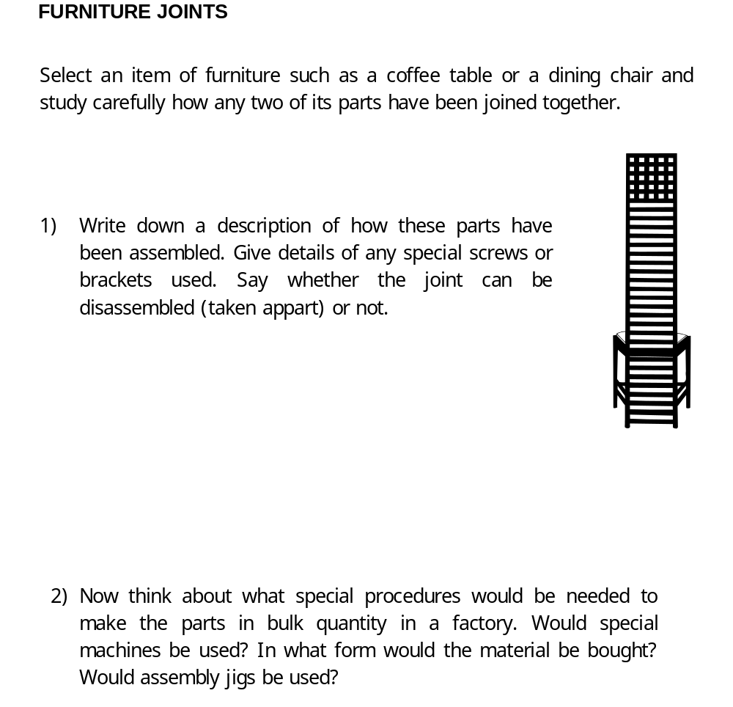

Week 2

Homework 2: Key words

Research and explain the definitions of the following key words giving examples where appropriate:

Key Word | Definition
Jig
Joint
Knot
Laminate
Lathe

Week 3

Homework 3: Research

Homework 5: Research

Draw, label and render a wood working lathe.
This work must be finished to a high standard.

Week 4

Homework 4: Key words

Research and explain the definitions of the following key words giving examples where appropriate:

Key Word | Definition
Manufactured
Board
Mild steel
Ore
Plane
Plywood

Week 5

Homework 5: Key words

Research and explain the definitions of the following key words giving examples where appropriate:

Key Word | Definition
Anodise
Corrosion
Durable
Analysis

Week 6

Homework 6: Key words

Research and explain the definitions of the following key words giving examples where appropriate:

Key Word | Definition
Flux
Brazing
Welding
Soldering

Week 7

Homework 7: Keywords

Research and explain the definitions of the following key words giving examples where appropriate:

Key Word | Definition
Centre Punch
Coping Saw
Dividers
Wet & Dry Paper

WCSA

Home Learning Book – Learning Cycle 4

Year 9
Design & Technology
Resistant Materials Focus

Completion dates;
Week 1 Week 5
Week 2 Week 6
Week 3 Week 7
Week 4

Why is regular home learning important?

- It can improve a student’s thinking and memory skills. This is vital for the new content heavy GCSEs.

- It helps students to develop positive study skills and habits that will serve them well throughout life.

- Home learning encourages students to use time wisely and efficiently.

- It teaches students to work independently.

- Home learning teaches students to take responsibility for their own work.

- It allows students to review and practice what has been covered in class and consolidate their knowledge and skills.

- Equally important, it helps students to get ready for the next day’s class.

- It helps students learn to use resources, such as libraries, reference materials, and computer Web sites to find information.

- It encourages students to explore subjects more fully than classroom time permits.

- It allows students to extend their learning by applying skills to new situations.

- Home learning helps parents learn more about what their children learning in school.

- It allows parents to communicate with teachers about learning in order to support their children efficiently.

Week 1

Homework 1: Polymers

- Explain the difference between Thermoforming Polymers and Thermosetting Polymers?

- Explain and draw the difference in the structure of the above 2 polymers?

- Explain why some children’s toys are made from HIPS?

- What is a Biopol polymers?

Week 2

Homework 2: Key words

Research and explain the definitions of the following key words giving examples where appropriate:

Key Word | Definition
Quench
Primer
Rivet
Smart material
Softwood

Week 3

Homework 2: Key words

Research and explain the definitions of the following key words giving examples where appropriate:

Key Word | Definition
Stock size
Thermoplastic
Thermoset
Veneer
Weld

Week 4

Homework 4: Ethical

- Identify 10 companies that use the Fairtrade Foundation Mark

1.

2.

3.

4.

5.

6.

7.

8.

9.

10.

- What types of item can be identified as Fairtrade?

Week 5

Homework 5: Metals

- Explain the difference between Ferrous and Non Ferrous metals?

- Name the element that is added to iron to make mild Steel?

- Summarise what makes a metal an alloy. Identify 2 other alloys and explain why the ’new’ metal is suited to a particular application?

Week 6

Homework 6: Textiles

- Explain where natural and synthetics fibres come from and give 3 examples of each?

- Describe the advantages and disadvantages of cotton?

Week 7

Homework 7: Smart materials

- Explain what is meant by the terms Smart and Modern Materials?

- Find 4 examples of Smart / Modern Materials and explain how each of them work and what they are used for?

- Explain one disadvantage of conductive inks?

