WCSA
Completion dates;
Week 1 Week 5
Week 2 Week 6
Week 3 Week 7
Week 4


Home Learning Book – Learning Cycle 2

Year 9
Design & Technology
Graphics Focus

Name: _______________________________Tutor Group: ___

Teacher(s): ___________________________________

Why is regular home learning important?

- It can improve a student’s thinking and memory skills. This is vital for the new content heavy GCSEs.

- It helps students to develop positive study skills and habits that will serve them well throughout life.

- Home learning encourages students to use time wisely and efficiently.

- It teaches students to work independently.

- Home learning teaches students to take responsibility for their own work.

- It allows students to review and practice what has been covered in class and consolidate their knowledge and skills.

- Equally important, it helps students to get ready for the next day’s class.

- It helps students learn to use resources, such as libraries, reference materials, and computer Web sites to find information.

- It encourages students to explore subjects more fully than classroom time permits.

- It allows students to extend their learning by applying skills to new situations.

- Home learning helps parents learn more about what their children learning in school.

- It allows parents to communicate with teachers about learning in order to support their children efficiently.

Week 1

Homework 1: Technical drawing

Figure 5 shows an orthographic drawing of one of the pieces of the mechanical toy

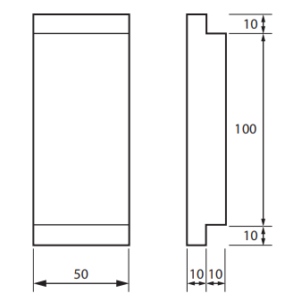

Not to scale. All dimensions in mm

Figure 5 Draw an accurate full-sized view of the piece shown in Figure 5. Use the grid provided on the opposite page.
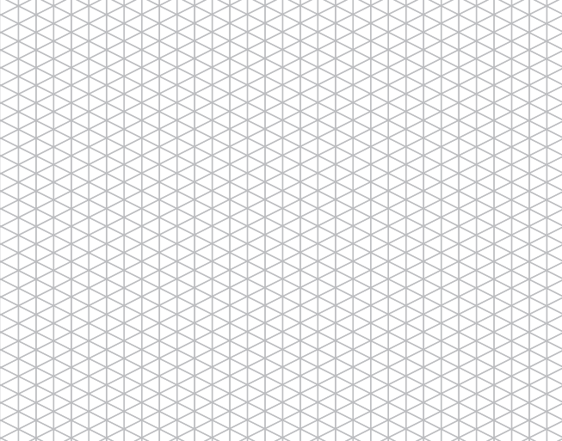

Week 2

Homework 2: Key words - Drawing

Research and explain the definitions of the following key words giving examples where appropriate:

Key Word | Definition
Isometric
Planometric
One point perspective
Oblique
Orthographic projection

Week 3

Homework 3: Orthographic/Isometric

Use drawing instruments to complete an isometric drawing of the shape below, in the space provided.

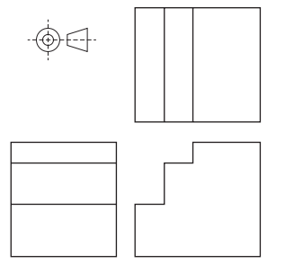
Sizes are approximate and should be estimated
Draw what you think the shape looks like here first. It can be a rough sketch

Week 4

Homework 4: Key words

Research and explain the definitions of the following key words giving examples where appropriate:

Key Word | Definition
Orthogonal lines
Horizon line
Protractor
Vanishing points
Parallel lines

Week 5

Homework 5: Drawing interpretations

The following net is to be used as a charity box
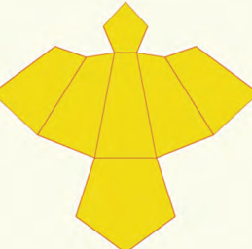

In the space provided, make a 3D drawing of the shape that the net will create

Week 6

Homework 6: Finishes

Here are pictures of types of finishes. You need to look at them closely and explain the process in detail. You MUST google them please.

Finish | Explanation of how it is done
UV Varnish

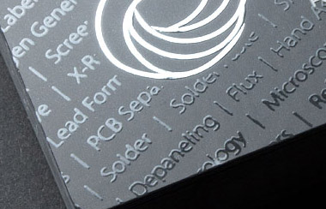

Foil blocking
Embossing

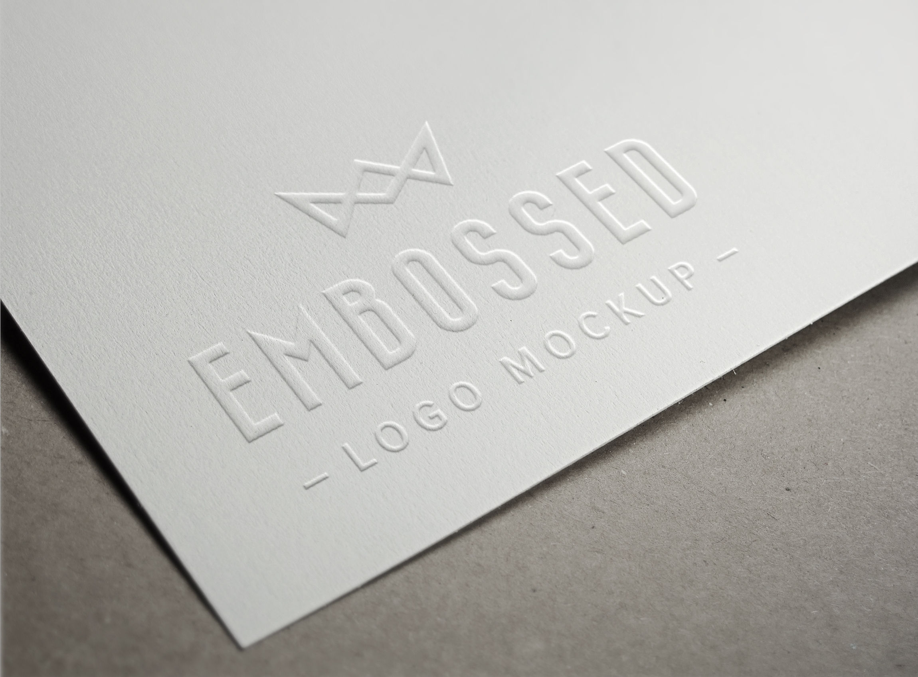
Debossing



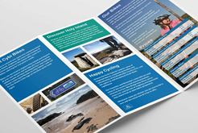
Week 7

Homework 7: Planning

The statements listed show the different stages in the production of the leaflet shown below. Complete the flowchart by placing the stages into the correct order

Stages
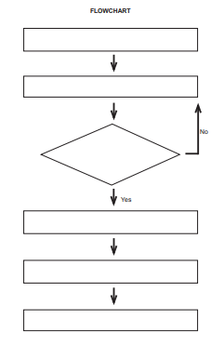
- Does the document look as expected?

- Load printer with correct paper and click print.

- Create the document with correct fold lines and imposition.

- Score document and fold.

- Save document as a PDF (make any alterations).

- Cut out document safely.

WCSA

Home Learning Book – Learning Cycle 3

Year 9
Design & Technology
Graphics Focus

Completion dates;
Week 1 Week 5
Week 2 Week 6
Week 3 Week 7
Week 4

Week 1

Homework 1: Research

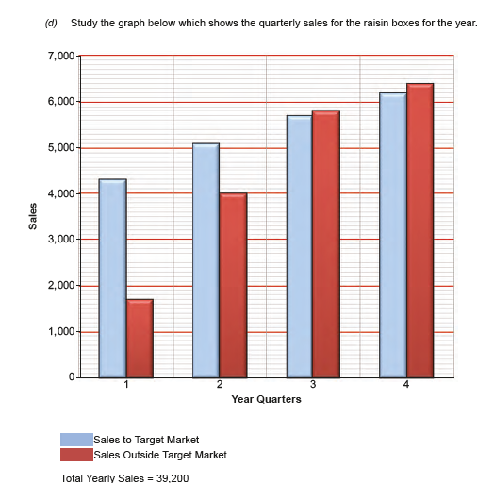

(d) Study the graph below which shows the quarterly sales for the raisin boxes for the year.
Sales Outside Target Market
(i) State how many boxes of raisins were sold in the first quarter of the year. [1]
(ii) Calculate as a percentage how many raisin boxes were sold in the last quarter of
the year. (Show all your workings.) [2]

- State how many boxes of raisins were sold in the first quarter of the year.

- Calculate as a percentage how many raisin boxes were sold in the last quarter of the year. (Show all your workings.)

Week 2

The advert below shows the company’s special offer that attempts to attract potential
customers into purchasing their product. The questions that follow are about the advert.
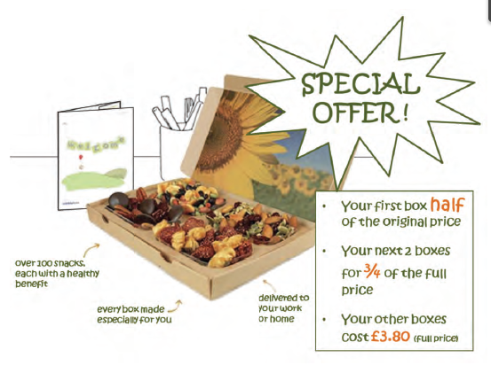

- State how much the first box would cost?

- Calculate the total cost of 7 boxes-

Week 3

The graph below shows the percentage sales of the drinks cartons by six leading supermarkets. 5000 litres were sold over a 2 day period. Study the graph and answer the questions that follow.

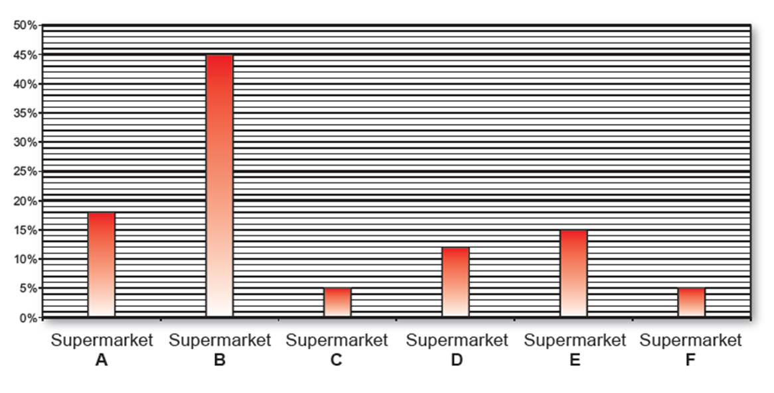

- State which three supermarkets’ sales combined equal the sales of the highest selling supermarket?

- Calculate how many more litres Supermarket B sold than Supermarket. (Show all your workings.)

Week 4

Homework 4:

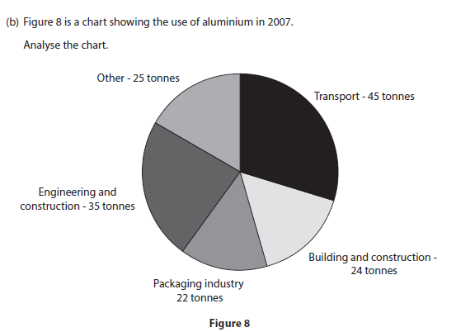

The aluminium used was sourced from recycled and new aluminium in the ratio of 18:38

Calculate how much recycled aluminium was used in the packaging industry.

Give your answer to two decimal places.

Answer _____________________ Tonnes

Week 5

Homework 5: Key words

Research and explain the definitions of the following key words giving examples where appropriate:

Key Word | Definition
Smart materials
Photochromic material
Thermo chromic material
Micro encapsulation

Week 6

Homework 6: Key words

Research and explain the definitions of the following key words giving examples where appropriate:

Key Word | Definition
Harmonious colours
Contrasting colours
Tints and shades
Monochrome

Week 7

Homework 7: Keywords

Research and explain the definitions of the following key words giving examples where appropriate:

Key Word | Definition
Typography
Kerning
Serif
Sans serif

WCSA

Home Learning Book – Learning Cycle 4

Year 9
Design & Technology
Graphics Focus

Completion dates;
Week 1 Week 5
Week 2 Week 6
Week 3 Week 7
Week 4

Week 1

Homework 1: Equipment
Example  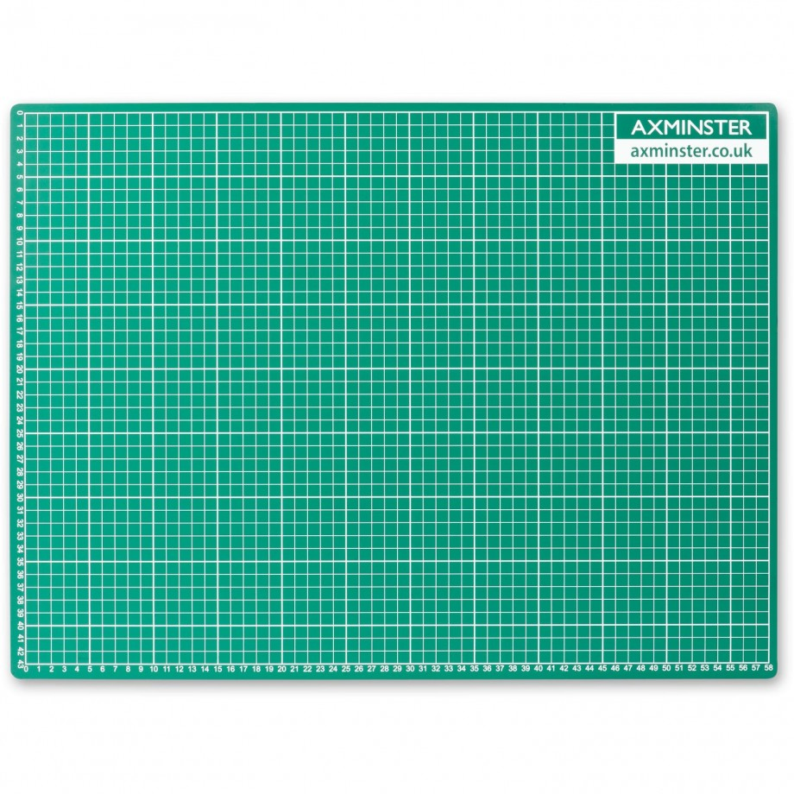 | Name – Cutting mat  Use – Used to lean on when cutting card or paper out to ensure the card doesn’t slip and to protect the table
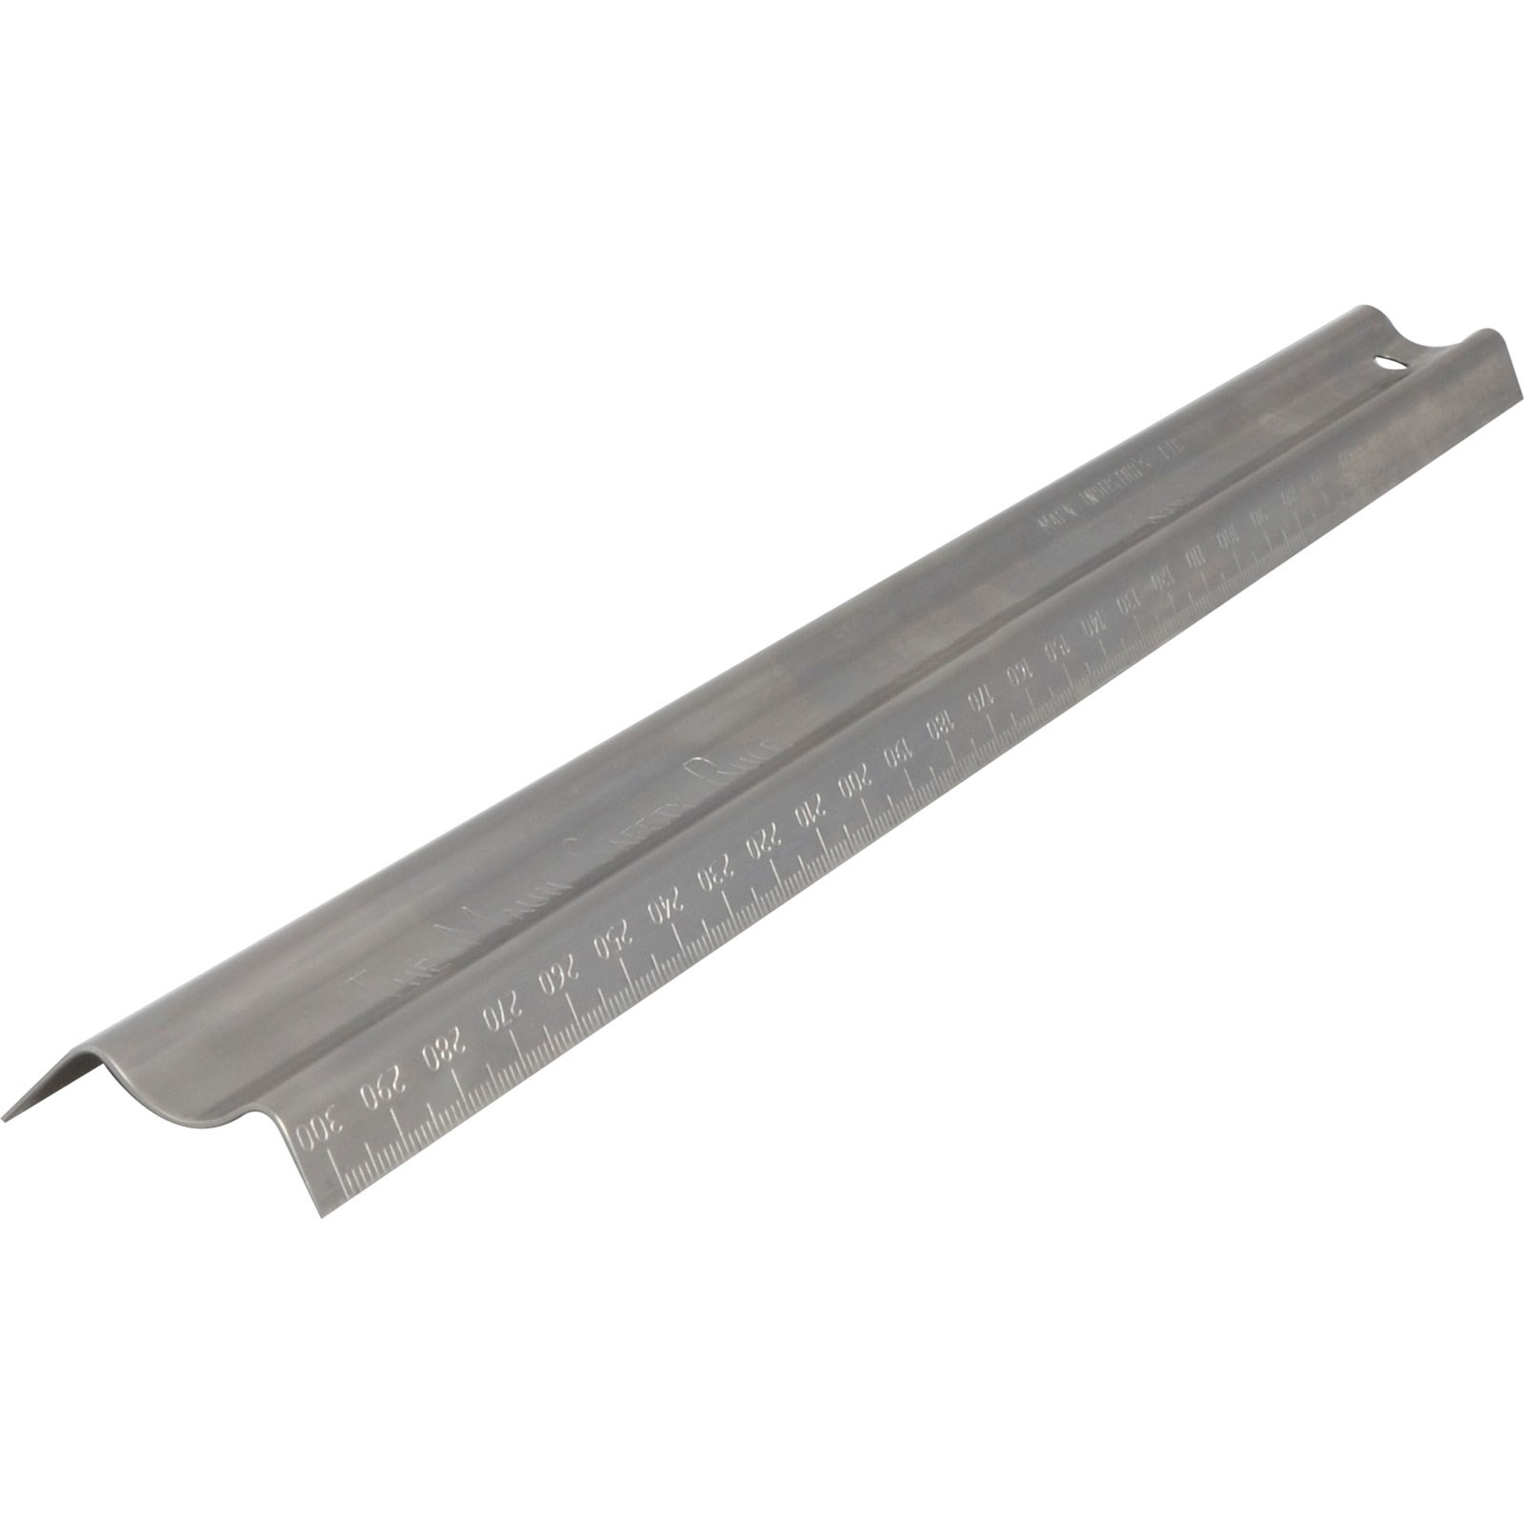

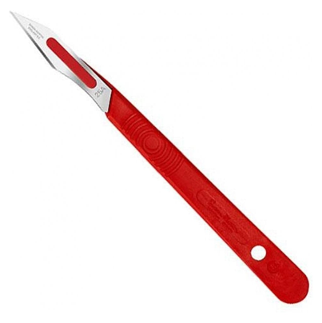

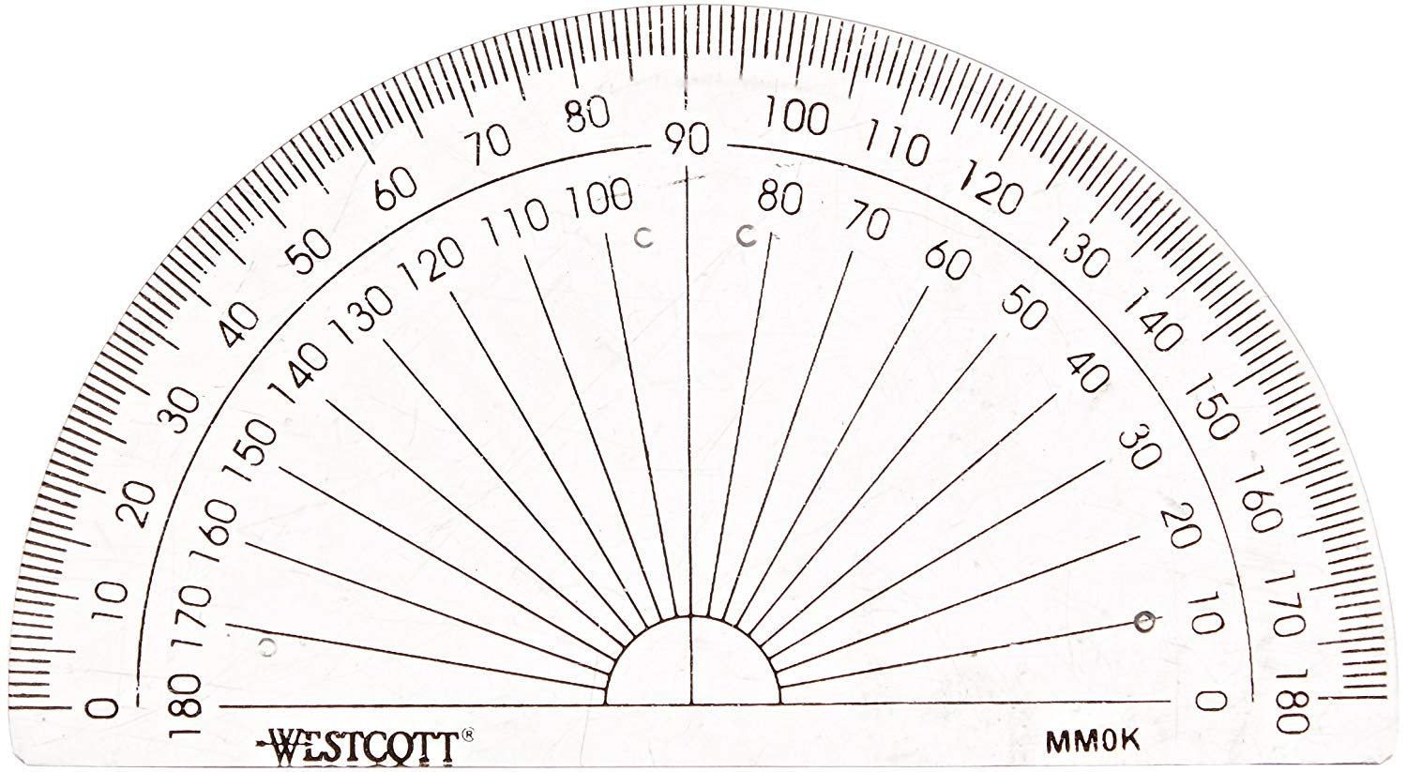

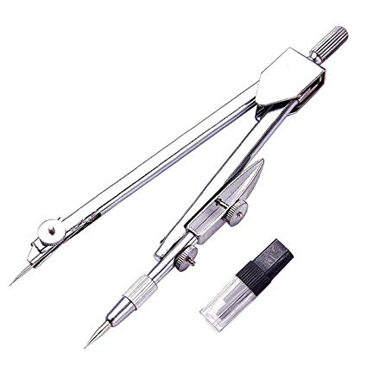

Week 2

Homework 2: Key words

Research and explain the definitions of the following key words giving examples where appropriate:

Key Word | Definition
Score
Adhesive
Template
Cardboard net
Prototype

Week 3

Homework 2: Key words

Research and explain the definitions of the following key words giving examples where appropriate:

Key Word | Definition
Mass production
Batch production
One off
Continuous flow
Bespoke

Week 4

Homework 4: Ethics

- Identify 10 companies that use the Fairtrade Foundation Mark

1.

2.

3.

4.

5.

6.

7.

8.

9.

10.

- What types of item can be identified as Fairtrade?

Week 5

Homework 5: Metals

- Explain the difference between Ferrous and Non Ferrous metals?

- Name the element that is added to iron to make mild Steel?

- Summarise what makes a metal an alloy. Identify 2 other alloys and explain why the ’new’ metal is suited to a particular application?

Week 6

Homework 6: Textiles

- Explain where natural and synthetics fibres come from and give 3 examples of each -

- Describe two advantages and disadvantages of cotton-

Week 7

Homework 7: Smart materials

- Explain what is meant by the terms Smart and Modern Materials?

- Find 4 examples of Smart / Modern Materials and explain how each of them work and what they are used for?

- Explain one disadvantage of conductive inks?

