Cycle 1 Homework
September 2019
Subject:
Creative iMedia - R081

Year 10

This cycle you will be learning: The purpose and content of pre-production documents.
What you will learn | Week
Purpose of Pre-Production Documents | 1
Content of Pre-Production | 2
Client Requirements | 3
Target Audience | 4
Primary and Secondary Resources | 5
Work Plan | 6
Hardware and Software | 7
Assessment | 8
Super Teaching Week | 9
Expectations:
- Complete homework tasks each week.
- Your homework will be marked each week and your teacher will allocate the specific lesson / day.
- It must be completed by the due date.
- Use Knowledge organiser to help with your homework.
Calendar Cycle 1
September | 2 | 3 | 4 | 5 | 6
 | 9 | 10 | 11 | 12 | 13 | Teaching week 1
 | 16 | 17 | 18 | 19 | 20 | Teaching week 2
 | 23 | 24 | 25 | 26 | 27 | Teaching week 3
October | 30 | 1 | 2 | 3 | 4 | Teaching week 4
 | 7 | 8 | 9 | 10 | 11 | Teaching week 5
 | 14 | 15 | 16 | 17 | 18 | Teaching week 6
 | 21 | 22 | 23 | 24 | 25 | Inset/Half term
 | 28 | 29 | 30 | 31 | 1 | Half term
November | 4 | 5 | 6 | 7 | 8 | Teaching week 7
 | 11 | 12 | 13 | 14 | 15 | Teaching week 8
 | 18 | 19 | 20 | 21 | 22 | Teaching week 9
Name:
Teacher: Group:
Task 1: Week 1 Key terms
Due Week 1, Date:______________
Success Criteria: Define all key terms correctly
Task:
In the table below, there is a list of some key terms that you will learn during cycle 1. Your challenge is to write the definition for each of the work in the allocated box. You can research the definitions in the knowledge organiser or using the internet, but it must be written in your own words.
Key Term | Definition
Storyboard

Mind Map

Moodboard

Script

Visualisation Diagram
Hardware

Software

Primary Source

Secondary Source
Client Requirements

Score out of 10:

Task 2: Week 2 Content of Pre-Production Documents
Due Week 2, Date:______________
Success Criteria: To provide the content of all pre-production documents
Task:
In the table below provide all content for each pre-production document. To help with the task the first letter of the words have been included. You can research using the knowledge organisers or the internet to help find the content of each document.
Moodboard | - I  - T S  - F  - L  - Digital Mood board – S or V
Mind Map | - T  - I  - B  Or  - A  - N
Visualisation Diagram | - I  - G  - L  - T  - A
Script | - L of S  - D  - S T  - Camera M  - S  - C  - D  - Layout / formatting
Storyboard | - N of S  - S C  - T  - Camera S  - Camera A  - Camera M  - Camera T  - L  - S  - L

Task 3: Understand Primary and Secondary Resources
Due Week 3, Date:______________
Success Criteria: To provide the content of all pre-production documents
Task:
In the table below provide examples of the primary and secondary resources and include advantages and disadvantages for using these types of resources. You can use the knowledge organisers or the internet for help but please provide the answers in your own words.
Primary Sources | Secondary Sources
Provide 3 examples  1.  2.  3. | Provide 3 examples  1.  2.  3.
Provide 1 advantage for using Primary Sources:  1. | Provide 1 advantage for using Secondary Sources:  1.
Provide 1 disadvantage for using Primary Sources:  1. | Provide 1 disadvantage for using Secondary Sources:  1.

Task 4: File Formats
Due Week 4, Date:______________
Success Criteria: To provide the examples for file formats for each file type.
Task:
In the table below provide examples of formats for each file type. You can use the knowledge organisers or the internet for help.
Name 3 file formats for each file type:
Video
1.
2.
3.
Audio
1.
2.
3.
Image
1.
2.
3.
Animation
1.
2.
3.

Task 5: Exam Questions - Moodboard
Due Week 5, Date:______________
Success Criteria: To provide the examples for file formats for each file type.
Task:
Complete the Exam Question Below. You can use the knowledge organiser for help.
Exam Question – Moodboard
Three Oaks, a supermarket chain, is launching a Summer Bank Holiday Sale. In the sale it will be offering discounts on its summer sun products including sun cream, barbecues and ice cream. You have been asked to develop the pre–production documents for the advertising campaign for this sale.
One of the main methods of advertising will be the use of printed adverts in magazines. Three Oaks has asked that you produce a mood board for the magazine adverts.
[3]

Task 6: Exam Questions – Script / Storyboard
Due Week 6, Date:______________
Success Criteria: To provide the examples for file formats for each file type.
Task:
Complete the Exam Question Below. You can use the knowledge organiser for help.
Exam Question – Script / Storyboard

Task 7: Exam Questions
Due Week 7, Date:______________
Success Criteria: To provide the examples for file formats for each file type.
Task:
Complete the Exam Question Below. You can use the knowledge organiser for help.

Name: Group: Teacher:

Creative iMedia

Knowledge Organiser
R081- Exam

Storyboard

Pre-Production Documents

- Mind Map
- Moodboard
- Visualisation Diagram
- Script
- Storyboard

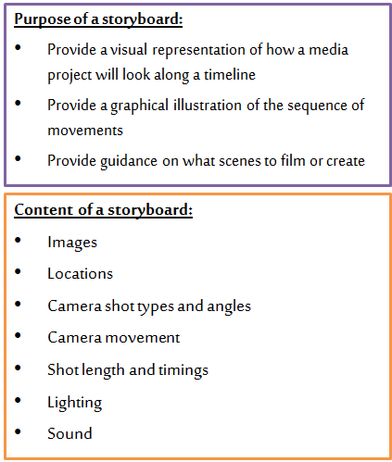
Name: Group: Teacher:

Pre-Production Documents
MoodBoard

Mind Map

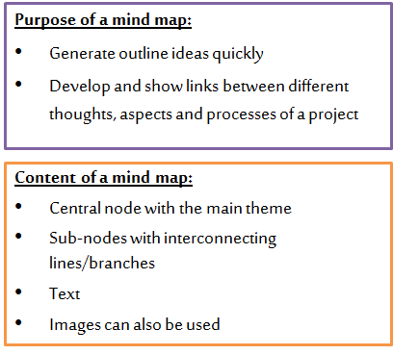
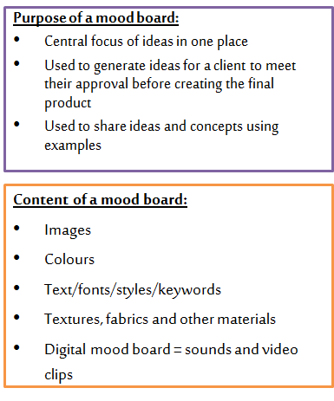
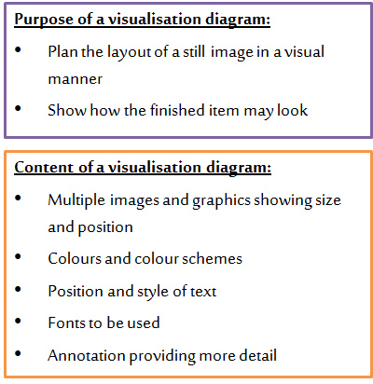
Script
Visualisation Diagram

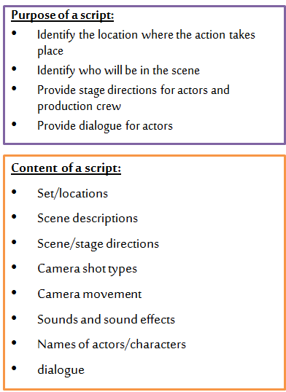

Name: Group: Teacher:

Client Requirements

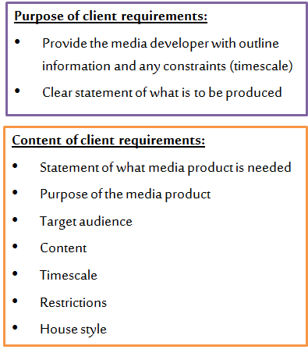
Target Audience

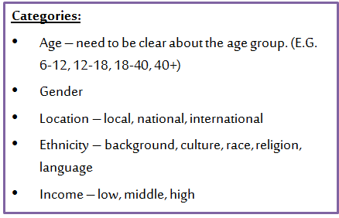

Primary and Secondary Resources

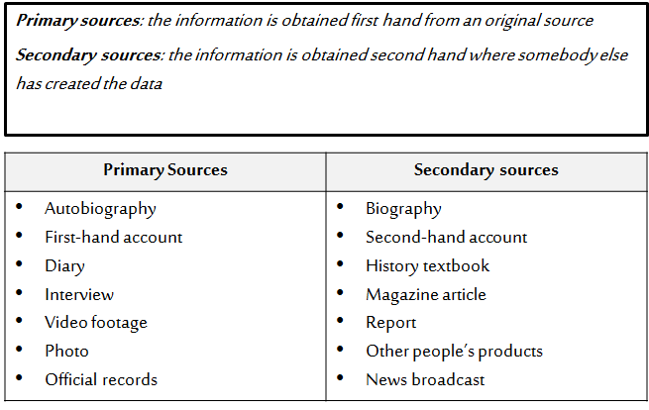

Name: Group: Teacher:
Name: Group: Teacher:

Name: Group: Teacher:

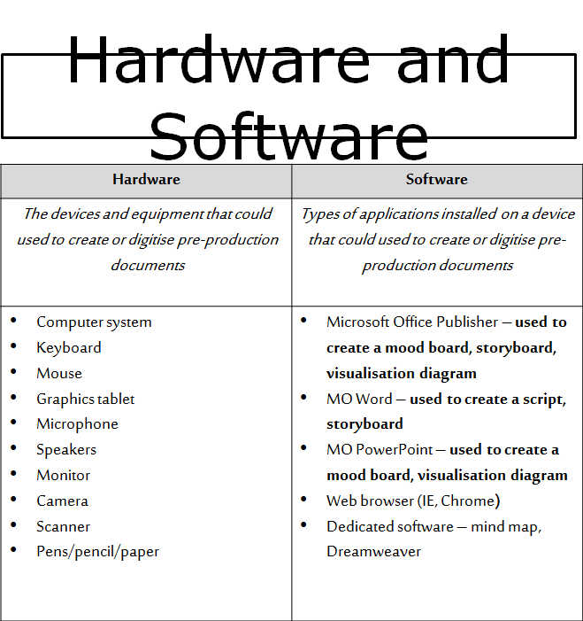
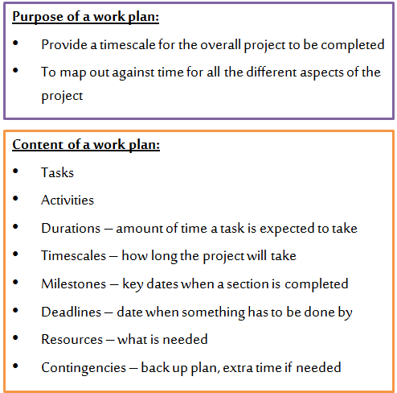
Hardware and Software

Work Plan

Name: Group: Teacher:

Health and Safety

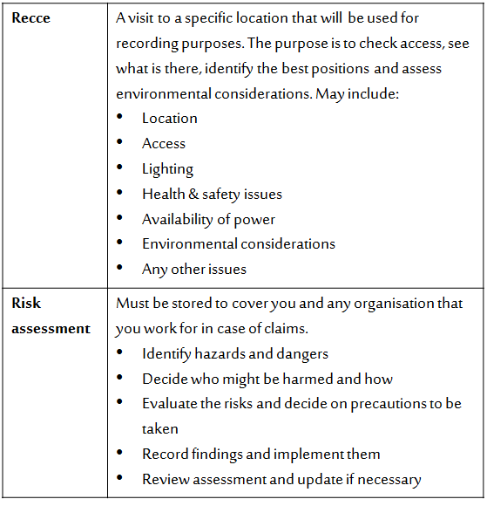

Key Documents

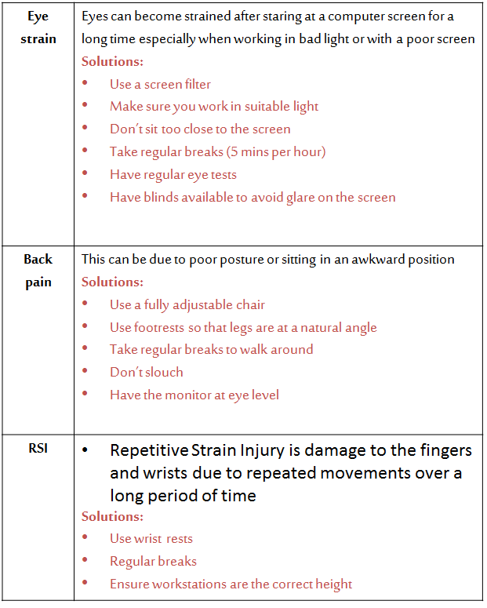

Health and Safety – using Computers

Name: Group: Teacher:

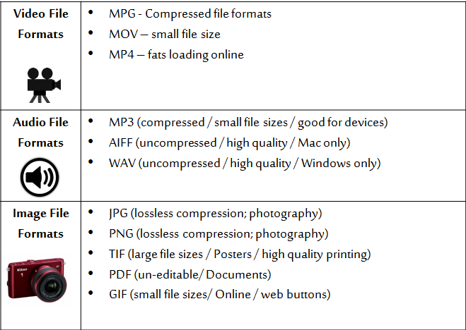
File Formats

Legislation

