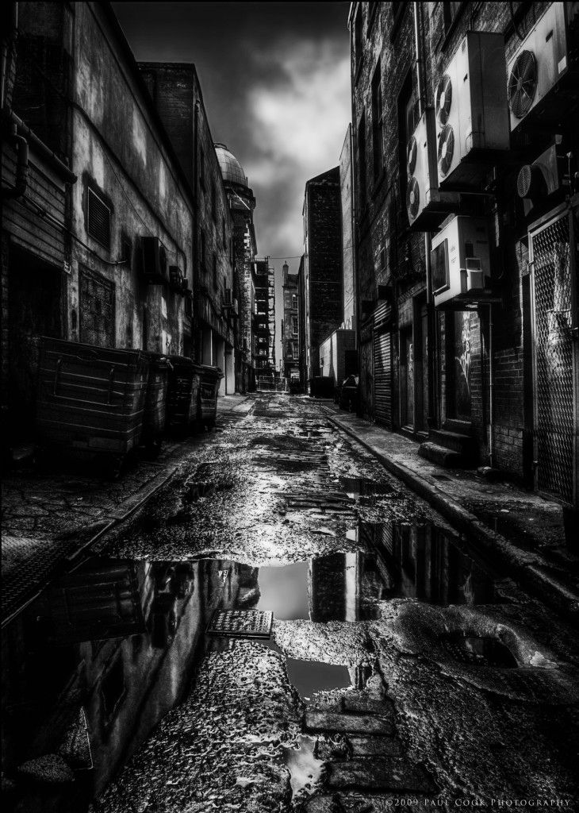

English

Home Learning Book – Learning Cycle 2
Year 8 Dystopia
English Language and Literature

Name: _______________________________Tutor Group: 8___
English Teacher(s): ___________________________________

Learning Cycle 2
November | 25 | 26 | 27 | 28 | 29 | Teaching week 1
December | 2 | 3 | 4 | 5 | 6 | Teaching week 2
 | 9 | 10 | 11 | 12 | 13 | Teaching week 3
 | 16 | 17 | 18 | 19 | 20 | Teaching week 4
 | 23 | 24 | 25 | 26 | 27 | Christmas Break
 | 30 | 31 | 1 | 2 | 3 | Christmas Break
January | 6 | 7 | 8 | 9 | 10 | Teaching week 5
 | 13 | 14 | 15 | 16 | 17 | Teaching week 6
 | 20 | 21 | 22 | 23 | 24 | Teaching week 7
 | 27 | 28 | 29 | 30 | 31 | Assessment Week
February | 3 | 4 | 5 | 6 | 7 | Super Teach Week

- Cycle 2 in English will focus on dystopian fiction. You will be developing your creative writing whilst learning how to create the appropriate atmosphere, setting and tone. The aim of your homework is to develop those descriptive and narrative skills, along with your ability to focus on a text and comprehend meaning.
- The knowledge organiser sets out the most important facts and information that you need to know to study this topic.
- Everything you need to answer the tasks is either in the knowledge organiser, or will have been covered in lessons.

Useful Websites
http://literary-devices.com/
https://en.oxforddictionaries.com/grammar/word-classes-or-parts-of-speech
http://www.thesaurus.com/
https://www.shortlist.com/news/20-best-dystopian-novels/43969 (For an extra homework challenge, choose a dystopian novel to read!)

Knowledge organiser

Week 1 - Key Words
To understand the ideas of Dystopia properly, you need to appreciate the meaning of some key vocabulary.
Task: Can you match the correct term with its definition from the table below?

Utopia | Dystopia | Society | Propaganda | Antagonist
Protagonist | Theme | Allusion | Synonym | Omniscient
Futuristic | Genre | Setting | Fiction | Convention

1) | The subject of a story or piece of writing or an idea that recurs in or pervades a work of art or literature.
2) | A particular style or category or literature, art etc.
3) | A collection of people living together in a more or less ordered community.
4) | Something that describes imaginary events and people.
5) | An expression designed to call something to mind without mentioning it explicitly; an indirect or passing reference.
6) | A way in which something is usually done.
7) | Knowing everything.
8) | An imagined place or state of things in which everything is perfect.
9) | Information, especially of a biased or misleading nature, used to promote a political cause or point of view.
10) | An imagined state or society in which there is great suffering or injustice, typically one that is totalitarian or post-apocalyptic.
11) | Having or involving very modern technology or design.
12) | The place or type of surroundings where something is positioned or where an event takes place.
13) | A person who actively opposes or is hostile to someone or something; an adversary.
14) | The leading character or one of the major characters in a play, film, novel, etc.
15) | A word or phrase that means exactly or nearly the same as another word or phrase in the same language.

Parent/carer comments:

Week 2 – Synonyms (periodic table of emotions)
Task
In order to excel in the Dystopian unit, you will need to learn an abundance of new words. Using your own knowledge, along with the periodic table of emotions on pg.3, suggest at least five synonyms for each of these lazy lexical choices. (Not sure what a synonym is? – Re-read your homework definition from last week!)
Dark:
.............................................................................................................................................................................................................................................................................................................................................................................................................................................................................................

Light:
.............................................................................................................................................................................................................................................................................................................................................................................................................................................................................................

Sadness:
.............................................................................................................................................................................................................................................................................................................................................................................................................................................................................................

Anger:
.............................................................................................................................................................................................................................................................................................................................................................................................................................................................................................

Big:
.............................................................................................................................................................................................................................................................................................................................................................................................................................................................................................

Little:
.............................................................................................................................................................................................................................................................................................................................................................................................................................................................................................
Parent/carer comments:
Week 3 – Exploring Dystopian Literature
Read the extract from George Orwell’s dystopian novel ‘1984’ and complete the tasks that follow on the next page.
It was a bright cold day in April, and the clocks were striking thirteen. Winston Smith, his chin nuzzled into his breast in an effort to escape the vile wind, slipped quickly through the glass doors of Victory Mansions, though not quickly enough to prevent a swirl of gritty dust from entering along with him.
The hallway smelt of boiled cabbage and old rag mats. At one end of it a coloured poster, too large for indoor display, had been tacked to the wall. It depicted simply an enormous face, more than a metre wide: the face of a man of about forty-five, with a heavy black moustache and ruggedly handsome features. Winston made for the stairs. It was no use trying the lift. Even at the best of times it was seldom working, and at present the electric current was cut off during daylight hours. It was part of the economy drive in preparation for Hate Week. The flat was seven flights up, and Winston, who was thirty-nine and had a varicose ulcer above his right ankle, went slowly, resting several times on the way. On each landing, opposite the lift-shaft, the poster with the enormous face gazed from the wall. It was one of those pictures which are so contrived that the eyes follow you about when you move. BIG BROTHER IS WATCHING YOU, the caption beneath it ran.
Inside the flat a fruity voice was reading out a list of figures which had something to do with the production of pig-iron. The voice came from an oblong metal plaque like a dulled mirror which formed part of the surface of the right-hand wall. Winston turned a switch and the voice sank somewhat, though the words were still distinguishable. The instrument (the telescreen, it was called) could be dimmed, but there was no way of shutting it off completely. He moved over to the window: a smallish, frail figure, the meagreness of his body merely emphasised by the blue overalls which were the uniform of the party. His hair was very fair, his face naturally sanguine, his skin roughened by coarse soap and blunt razor blades and the cold of the winter that had just ended.
Outside, even through the shut window-pane, the world looked cold. Down in the street little eddies of wind were whirling dust and torn paper into spirals, and though the sun was shining and the sky a harsh blue, there seemed to be no colour in anything, except the posters that were plastered everywhere. The black moustachio'd face gazed down from every commanding corner. There was one on the house-front immediately opposite. BIG BROTHER IS WATCHING YOU, the caption said, while the dark eyes looked deep into Winston's own. Down at street level another poster, torn at one corner, flapped fitfully in the wind, alternately covering and uncovering the single word INGSOC. In the far distance a helicopter skimmed down between the roofs, hovered for an instant like a bluebottle, and darted away again with a curving flight. It was the police patrol, snooping into people's windows. The patrols did not matter, however. Only the Thought Police mattered.

Tasks on ‘1984’ (Week 3)
- Read paragraph 1 carefully.
List four things that readers are told about the setting.
1 - ______________________________________________________________________
2 - ______________________________________________________________________
3 - ______________________________________________________________________
4 - ______________________________________________________________________
[4]

- Read paragraph 2 carefully. Choose the four true answers from the list below:
- Winston was forty-five years old.
- Winston’s job was putting up advertising posters.
- Winston lived on the seventh floor of the building.
- Winston lived in flat number thirty-nine.
- Winston was in pain because of his ankle while walking up stairs.
- The lift wasn’t working because of an economy drive.
- Winston’s favourite TV show was Big Brother.
- The eyes of the posters followed people as they moved.

- Find a quotation to explain why Winston doesn’t turn off the telescreen? ________________________________________________________________________________________________________________________________________________

- Explain how the idea of the ‘Thought Police’ fits in with your understanding of dystopian fiction (think about the connotations created by the phrase.) ________________________________________________________________________________________________________________________________________________________________________________________________________________________________________________________________________________________________________________________________________________________________________
Parent/carer comments:

Week 4 – Exploring Dystopian Literature

Read the extract from the opening of Ray Bradbury’s dystopian novel ‘Fahrenheit 941’. It is 2053 and Guy Montag is on the way home from work. His job – to burn books.
Following reading the extract, complete the tasks on the next page.
It was a pleasure to burn.

It was a special pleasure to see things eaten, to see things blackened and changed. With the brass nozzle in his fists, with this great python spitting its venomous kerosene upon the world, the blood pounded in his head, and his hands were the hands of some amazing conductor playing all the symphonies of blazing and burning to bring down the tatters and charcoal ruins of history. With his symbolic helmet numbered 451 on his solid head, and his eyes all orange flame with the thought of what came next, he flicked the igniter and the house jumped up in a gorging fire that burned the evening sky red and yellow and black. He strode in a swarm of fireflies. He wanted above all, like the old joke, to shove a marshmallow on a stick in the furnace, while the flapping pigeon-winged books died on the porch and lawn of the house. While the books went up in sparkling whirls and blew away on a wind turned dark with burning.

Montag grinned the fierce grin of all men singed and driven back by flame.

He knew that when he returned to the firehouse, he might wink at himself, a minstrel man, burnt-corked, in the mirror. Later, going to sleep, he would feel the fiery smile gripped by his face muscles, in the dark. It never went away, that smile, it never went away, as long as he remembered.

He hung up his black-beetle coloured helmet and shined it, he hung his flameproof jacket neatly; he showered luxuriously, and then, whistling, hands in pockets, walked across the upper floor of the fire station and fell down the hole. At the last minute, when disaster seemed positive, he pulled his hands from his pockets and broke his fall by grasping the golden pole. He slid to a squeaking halt, the heels one inch from the concrete floor downstairs.

Technique | Key Colour
Metaphor
Adjectives
Alliteration
Verbs

- Using the key, choose a different colour for each technique and complete the following tasks.
- Highlight at least three metaphors in the passage.
- Highlight at least three adjectives
- Highlight at least two examples of alliteration
- Highlight at least four verbs

- List four things from the text which describe what Montag did when he returned to the firehouse
- _______________________________________________________________
- _______________________________________________________________
- _______________________________________________________________
- _______________________________________________________________

- Using the start of the extract, how is the fire being described? Think about the technique being used, along with words and phrases.
________________________________________________________________________________________________________________________________________________________________________________________________________________________________________________________________________________________________________________________________________________________________________________________________________________________________________________________________________________________________________________________

Parent/carer comments:

Week 5 – Exploring Dystopian Literature

Read the extract from Suzanne Collins’ dystopian novel ‘The Hunger Games’. Here, the protagonist, Katniss, describes the lottery system (the reaping) for deciding how children are chosen to fight to the death in the Hunger Games. Read the extract and complete the tasks that follow.
The reaping system is unfair, with the poor getting the worst of it. You become eligible for the reaping the day you turn twelve. That year, your name is entered once. At thirteen, twice. And so on and so on until you reach the age of eighteen, the final year of eligibility, when your name goes into the pool seven times. That’s true for every citizen in all twelve districts in the entire country of Panem.
But here’s the catch. Say you are poor and starving as we were. You can opt to add your name more times in exchange for tesserae. Each tessera is worth a meagre year’s supply of grain and oil for one person. You may do this for each of your family members as well. So, at the age of twelve, I had my name entered four times. Once, because I had to, and three times for tesserae for grain and oil for myself, Prim, and my mother. In fact, every year I have needed to do this. And the entries are cumulative. So now, at the age of sixteen, my name will be in the reaping twenty times. Gale, who is eighteen and has been either helping or single-handedly feeding a family of five for seven years, will have his name in forty-two times.

- Choose the four true answers:
- Your name is entered once for every year of your age.
- Only minors (people under the age of 18) are safe from the reaping.
- You become eligible for the reaping when you are twelve years old.
- At eighteen, your name can be entered only seven times.
- You can buy extra food by putting your name in for the reaping more times.
- The poor are usually entered more times than the rich, due to tesserae.
- Katniss’ name will be entered forty-two times this year.
- There are three people in the narrator’s family.

- In your own words, summarise how the reaping system is unfair to the poor.
________________________________________________________________________________________________________________________________________________________________________________________________________________________________________________________________________________________________________________________
Parent/carer comments:

Week 6 – Exploring Dystopian Literature

Read the extract from Aldous Huxley’s novel ‘A Brave New World’. Here, the director of a baby making laboratory is demonstrating how worker babies are made. Following reading the extract, complete the task on the next page.
“Now bring in the children.”
They hurried out of the room and returned in a minute or two, each pushing a kind of tall dumb-waiter laden, on all its four wire-netted shelves, with eight month-old babies, all exactly alike and all dressed in khaki.
“Put them down on the floor.”
The infants were unloaded.
“Now turn them so that they can see the flowers and books.”
Turned, the babies at once fell silent, then began to crawl towards those clusters of sleek colours, those shapes so gay and brilliant on the white pages. From the ranks of the crawling babies came little squeals of excitement, gurgles and twitterings of pleasure.
The Director rubbed his hands. “Excellent!” he said. “It might almost have been done on purpose.”
The swiftest crawlers were already at their goal. Small hands reached out uncertainly, touched, grasped, unpetaling the transfigured roses, crumpling the illuminated pages of the books. The Director waited until all were happily busy.
Then, “Watch carefully,” he said. And, lifting his hand, he gave the signal.
The Head Nurse, who was standing by a switchboard at the other end of the room, pressed down a little lever.
There was a violent explosion. Shriller and ever shriller, a siren shrieked. Alarm bells maddeningly sounded.
The children started, screamed; their faces were distorted with terror.
“And now,” the Director shouted (for the noise was deafening), “now we proceed to rub in the lesson with a mild electric shock.”
He waved his hand again, and the Head Nurse pressed a second lever. The screaming of the babies suddenly changed its tone. There was something desperate, almost insane, about the sharp spasmodic yelps to which they now gave utterance. Their little bodies twitched and stiffened; their limbs moved jerkily as if to the tug of unseen wires.
“We can electrify that whole strip of floor,” bawled the Director in explanation.
“But that’s enough,” he signalled to the nurse.
The explosions ceased, the bells stopped ringing, the shriek of the siren died down from tone to tone into silence. The stiffly twitching bodies relaxed, and what had become the sob and yelp of infant maniacs broadened out once more into a normal howl of ordinary terror.
“Offer them the flowers and the books again.”
The nurses obeyed; but at the approach of the roses, at the mere sight of those coloured images of cock-a-doodle-doo and baa-baa black sheep, the infants shrank away in horror, the volume of their howling suddenly increased.
“Observe,” said the Director triumphantly, “observe.”

Tasks on ‘A Brave New World’ (Week 6)
- What were the babies all wearing?
………………………………………………………………………………………………………………………………………………………………………………………………………………………………………………………………………………………………………………………………………………………………………………………………………………

- What were the babies all shown and allowed to play with?
………………………………………………………………………………………………………………………………………………………………………………………………………………………………………………………………………………………………………………………………………………………………………………………………………………

- What happened when the Head Nurse pressed down the first little lever?
………………………………………………………………………………………………………………………………………………………………………………………………………………………………………………………………………………………………………………………………………………………………………………………………………………

- What happened when the Head Nurse pressed down the second little lever?
………………………………………………………………………………………………………………………………………………………………………………………………………………………………………………………………………………………………………………………………………………………………………………………………………………

- What was the purpose of this experiment?
……………………………………………………………………………………………………………………………………………………………………………………………………………………………………………………………………………………………………………………………………………………………………………………………………………………………………………………………………………………………………………………………………………………

- Why would it be in a society’s interests to do this? (Think about when they grow up.)
……………………………………………………………………………………………………………………………………………………………………………………………………………………………………………………………………………………………………………………………………………………………………………………………………………………………………………………………………………………………………………………………………………………
Parent/carer comments:

Week 7 – Dystopian Convention

Task 1.
Spot the difference! How many ways has the second image been changed to turn Buckingham Palace into a more dystopian setting. Label the second image with as many differences as you can find. You should use vocabulary from lessons as well as previous homework or extracts, along with the periodic table of emotions on pg. 3.

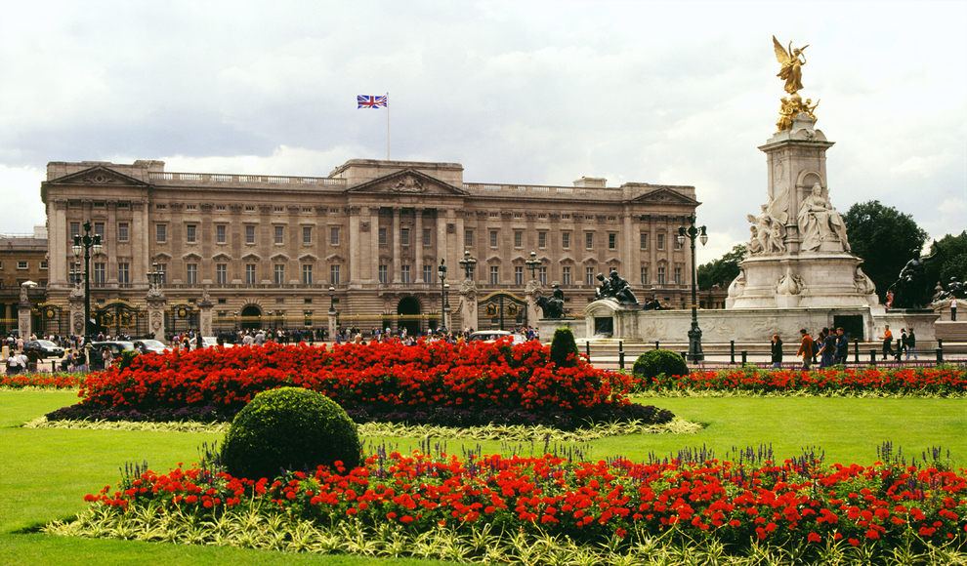

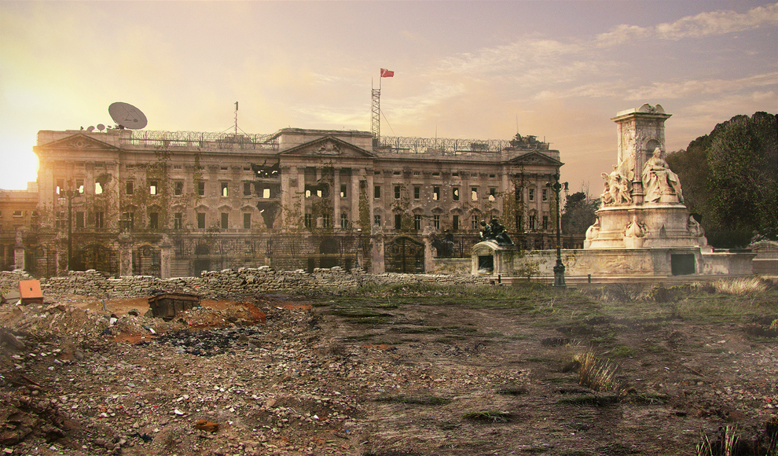

Task 2 (Week 7).
Now write a paragraph describing the dystopian Buckingham Palace, using at least 5 of the methods listed below.
Metaphor | Simile | Personification | Alliteration | Pathetic Fallacy
Onomatopoeia | Dystopian lexis | Hyperbole | Repetition | Symbolism

___________________________________________________________________________________________________________________________________________________________________________________________________________________________________________________________________________________________________________________________________________________________________________________________________________________________________________________________________________________________________________________________________________________________________________________________________________________________________________________________________________________________________________________________________________________________________________________________________________________________________________________________________________________________________________________________________________________________________________________________________________________________________________________________________________________________________________________________
Task 3 (Week 7).
Annotate your description above, identifying the methods used and explaining how ideas created link to dystopian literature.
Parent/carer comments:

Extension tasks
Basic | Challenging | Ultra challenging
Dystopian collage  Clip pictures and words from magazines and newspapers to create a multi-layered collage. It should include the elements of a dystopian land including: setting, characters, conflicts, themes etc. | Dystopian board game  Develop a board game based on life in a dystopia. Include all game pieces and directions. The game should be enjoyable and educational. Include and instruction booklet so we can play! | Dystopian model  Build a miniature model of a dystopian land. This will include destruction, decay and appropriate colors.
Character Sketch Book  Draw a portrait of five dystopian characters, illustrating each portrait with text descriptions. | Dismal dystopian song  Write a song about life in a dystopian land. Display the words of the song on a poster and/or record a version of the song. | Group film.  Film and edit a version of a dystopian land. Consider costumes, props, make-up and setting. Save it as a Quick Time file so that the class can watch it.
Design a comic book  Craft your own comic book story based in a dystopian land. | Reading challenge  Read one of the ‘Divergent’ trilogy books and write a book review. | Reading challenge  Read George Orwell’s novel ‘1984’ and write a book review.
Reading challenge  Read one of ‘The Hunger Games’ trilogy and write a book review. | Reading challenge  Read one of ‘The Maze Runner’ books and write a book review. | Reading challenge  Read George Orwell’s ‘Animal Farm’ and write a book review.

