WCSA

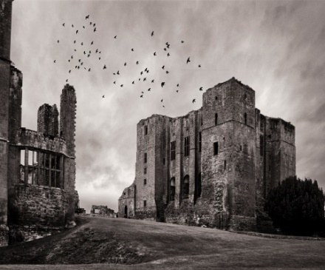
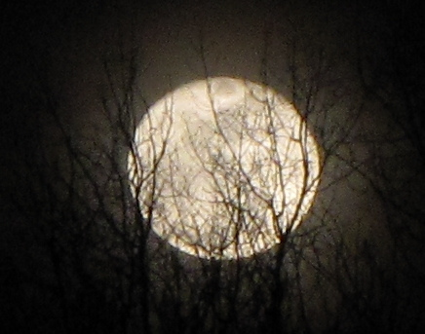
English

Home Learning Book –
Learning Cycle 2

Year 9
Gothic Literature

English Language and Literature

Name: __________________________Tutor Group: 9___

English Teacher(s): ______________________________

Learning Cycle 2
November | 25 | 26 | 27 | 28 | 29 | Teaching week 1
December | 2 | 3 | 4 | 5 | 6 | Teaching week 2
 | 9 | 10 | 11 | 12 | 13 | Teaching week 3
 | 16 | 17 | 18 | 19 | 20 | Teaching week 4
 | 23 | 24 | 25 | 26 | 27 | Christmas Break
 | 30 | 31 | 1 | 2 | 3 | Christmas Break
January | 6 | 7 | 8 | 9 | 10 | Teaching week 5
 | 13 | 14 | 15 | 16 | 17 | Teaching week 6
 | 20 | 21 | 22 | 23 | 24 | Teaching week 7
 | 27 | 28 | 29 | 30 | 31 | Assessment Week
February | 3 | 4 | 5 | 6 | 7 | Super Teach Week
- The aim of the homework throughout Year 9 is to develop independent revision and analytical skills, along with developing students’ core subject knowledge in English, in preparation for embarking upon their GCSE courses properly in Year 10.
Useful Websites to help you with your research
https://en.oxforddictionaries.com/grammar/word-classes-or-parts-of-speech
http://www.thesaurus.com/
http://literary-devices.com/
https://www.thoughtco.com/what-is-gothic-literature-739030
https://www.bl.uk/romantics-and-victorians/themes/the-gothic

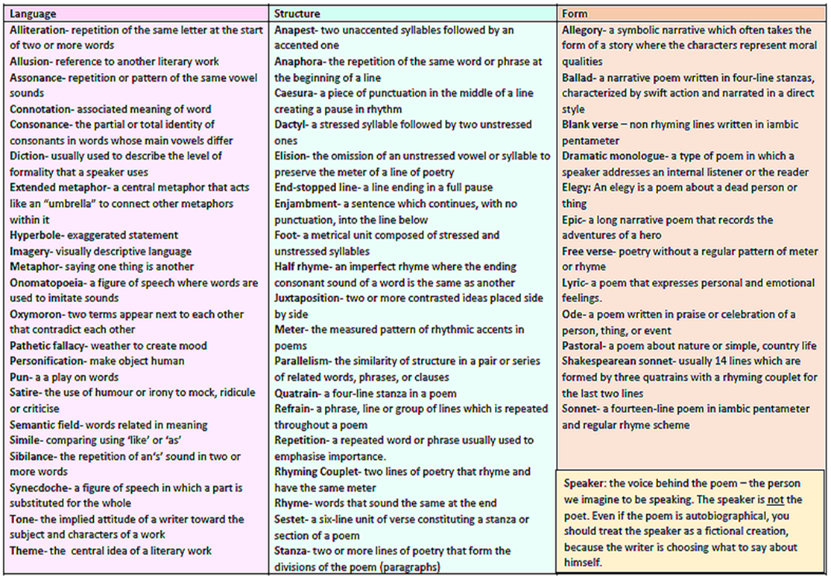

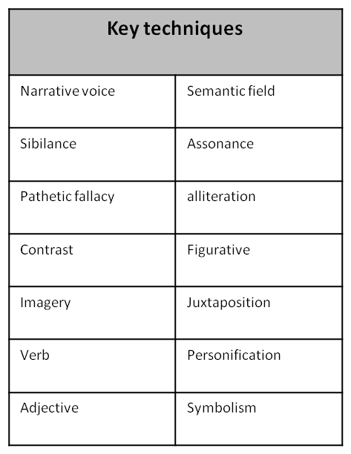
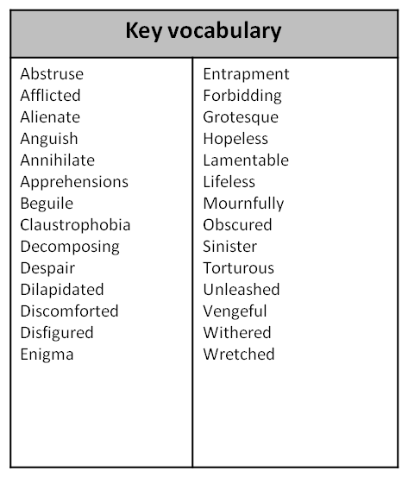

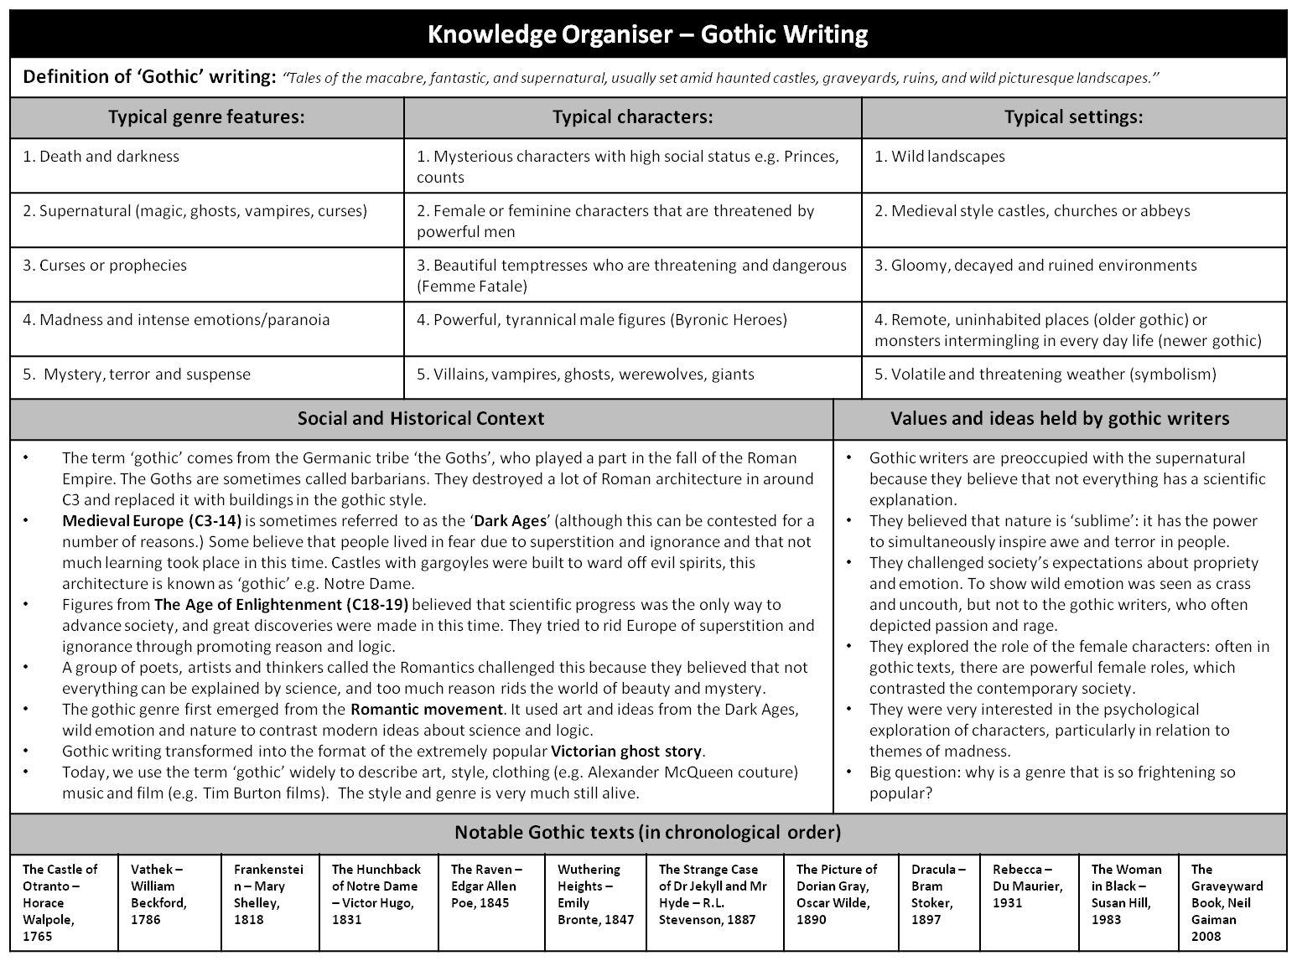

Week 1 – Key vocabulary – p4

When discussing literary texts it is vital to use the appropriate vocabulary.

Task: Can you match the correct term with its definition from the table below? Some key ideas are discussed on the knowledge organiser on p3 – check this if you need help.

atmosphere | pathetic fallacy | genre | Byronic Hero | climax
entrapment | Femme fatale | tension | sublime | sinister
Gothic | uncanny | supernatural | grotesque | suspense

1) | A style or category of art, music, or literature.
2) | The most intense, exciting, or important point of something; the main point of action within a text.
3) | An attractive and seductive woman, especially one who will ultimately cause distress to a man who becomes involved with her.
4) | A style of writing that is characterized by elements of fear, horror, death, and gloom, as well as romantic elements, such as nature, individuality, and very high emotion.
5) | The overriding tone or mood of a place, situation, or creative work.
6) | Linked to forces beyond scientific understanding or the laws of nature.
7) | An antihero of the highest order; typically rebellious, arrogant, anti-social or in exile, and darkly, enticingly romantic.
8) | A state or feeling of excited or anxious uncertainty about what may happen.
9) | Giving the impression that something harmful or evil is happening or will happen.
10) | A very ugly or comically distorted figure or image.
11) | The state of being caught in or as in a trap.
12) | In Gothic, using terror to create extreme emotions such as delight and confusion.
13) | Being both familiar and strange or mysterious, especially in an unsettling way.
14) | When writers use elements of nature, especially the weather, to reflect the mood of a person, place or situation.
15) | An element in a novel that evokes emotions such as worry, anxiety, fear and stress on the part of both the reader and the characters in a novel.

Parent/ carer comments:

Week 2 –Varying vocabulary using synonyms – p5
Task 1:
Synonyms are words which have very similar meanings to others, e.g. hot = warm, boiling, sweltering, burning.
Below are a number of synonyms for the words cold, dark, sad and old. Can you sort them into the appropriate boxes?
Challenge: Can you identify the few synonyms which could be used for more than one of the identified words?
decrepit | intense | antique | crisp | overcast | brisk | venerable
piercing | aged | heartbroken | exhausted | despondent | elderly | sombre
lightless | raw | shadowy | unlit | seasoned | dusky | dingy
inky | distressed | wasted | ancient | icy | veteran | sorrowful
fossil | arctic | frigid | biting | chilled | dismal | mature
numbing | senior | despairing | bleak | tired | dim | miserable
bitter | wintry | foggy | frosty | glacial | mournful | wistful
gloomy | murky | melancholy | experienced | black | bereaved | dull

Cold | Dark | Sad | Old

Positive | Negative
Task 2: Can you now sort the synonyms you’ve identified for the word old into positive and negative adjectives when applied to describing people?
Parent/ carer comments:

Week 3 –Language Skills – p6&7

Read the extract from the opening chapters of ‘The Canterville Ghost’ by Oscar Wilde and complete the tasks that follow:

Chapter I

When the American, Mr Otis, bought Canterville Castle, everyone told him that this was very foolish, as the place was haunted. But Mr Otis answered, “I come from a modern country, where we have everything that money can buy. And if there were such a thing as a ghost in Europe, we would have it at home in one of our museums.”
A few weeks later, on a lovely July evening, Mr Otis, his wife and their children, Washington, Virginia and the twins, went down to their new home. When they entered the avenue of Canterville Castle, the sky suddenly became dark and a spooky stillness was in the air.
Mrs Umney, the housekeeper, led them into the library of the castle, where they sat down and began to look around. Suddenly, Mrs Otis saw a red stain on the floor just by the fireplace and said to Mrs Umney, “I am afraid something has been spilt there.”
“Yes, madam,” said the old housekeeper in a low voice, “blood has been spilt on that spot.”
“How terrible,” said Mrs Otis; “I don't want any blood-stains in my sitting-room. It must be removed at once.”
The old woman smiled and answered, “It is the blood of Lady Eleanore de Canterville, who was murdered on that spot by her husband, Sir Simon de Canterville, in 1575. Sir Simon disappeared seven years later. His body has never been found, but his ghost still haunts the Castle. The blood-stain is a tourist attraction now and it cannot be removed.”
“That is all nonsense,” said Washington, the eldest son of the Otis family, “stain remover will clean it up in no time,” and he took a bottle of stain remover out of his pocket and cleaned the spot. But as soon as the blood-stain had disappeared, a terrible flash of lightning lit up the room and a fearful peal of thunder made the whole building shake.

Chapter II

There was a horrible storm that night, but apart from that nothing scary happened. The next morning, however, when the family came down to breakfast, they found the terrible stain of blood once again on the floor. Washington cleaned it a second time, but the second morning it appeared again. The third morning it was there, too, although the library had been locked up at night by Mr Otis himself.
The following night, all doubts about the existence of the ghost were finally removed forever. At eleven o'clock the family went to bed and sometime after, Mr Otis was awakened by a strange noise in the corridor, outside his room. It sounded like the clank of metal, and it came nearer every moment. Mr Otis got up and looked at the time. It was exactly one o'clock. So Mr Otis put on his slippers, went to the door and opened it. There, right in front of him, stood the ghost - his eyes were as red as burning coals; long grey hair fell over his shoulders and from his wrists and ankles hung heavy chains.
“My dear Sir,” said Mr Otis, “you must oil those chains. It's impossible to sleep with such a noise going on outside the bedrooms. I have therefore brought you this bottle of lubricator, and I will be happy to supply you with more if you require it.” With these words Mr Otis laid the bottle down, closed his door and went back to bed.
Shocked, the Canterville ghost stood quite motionless for a moment, but then he growled angrily. Just at this moment, the twins appeared on the corridor and threw a large pillow at him! The ghost hastily escaped through the wall, and the house became quiet again.
When the ghost reached his small secret chamber, he took a deep breath. No ghosts in history had ever been treated in this manner!

Task 1.
Read through the following statements and identify the FOUR correct ones.

1 – Mr Otis is not frightened by the ghost. He’s an American and doesn’t believe in them.
2 – The blood stain disappears after being cleaned.
3 – Mrs Umney owns the house.
4 – Washington is the eldest son in the Otis family.
5 – The house was destroyed in the storm.
6 – The Canterville ghost cannot believe how he is being treated by the family.
7 –Around his wrists and ankles, the Canterville ghost wears chains.
8 – Sir Simon de Canterville was murdered by his wife.

Task 2. – Highlight all words and phrases which make this story part of the Gothic tradition.

Parent/ carer comments:

Week 4 –Text Analysis and Comprehension – p8&9

Read the opening of ‘The Monkey’s Paw’ by W. W. Jacobs and answer the questions that follow.
Without, the night was cold and wet, but in the small parlour of Laburnum villa the blinds were drawn and the fire burned brightly. Father and son were at chess; the former, who possessed ideas about the game involving radical chances, putting his king into such sharp and unnecessary perils that it even provoked comment from the white-haired old lady knitting placidly by the fire.
"Hark at the wind," said Mr. White, who, having seen a fatal mistake after it was too late, was amiably desirous of preventing his son from seeing it.
"I'm listening," said the latter grimly surveying the board as he stretched out his hand. "Check."
"I should hardly think that he's come tonight,” said his father, with his hand poised over the board. "Mate," replied the son.
"That's the worst of living so far out," balled Mr. White with sudden and unlooked-for violence; "Of all the beastly, slushy, out of the way places to live in, this is the worst. Path's a bog, and the road's a torrent. I don't know what people are thinking about. I suppose because only two houses in the road are let, they think it doesn't matter."
"Never mind, dear," said his wife soothingly; "perhaps you'll win the next one."
Mr. White looked up sharply, just in time to intercept a knowing glance between mother and son. The words died away on his lips, and he hid a guilty grin in his thin grey beard.
"There he is," said Herbert White as the gate banged to loudly and heavy footsteps came toward the door.
The old man rose with hospitable haste and opening the door, was heard condoling with the new arrival. The new arrival also condoled with himself, so that Mrs. White said, "Tut, tut!" and coughed gently as her husband entered the room followed by a tall, burly man, beady of eye and rubicund of visage.
"Sergeant-Major Morris,” he said, introducing him.
The Sergeant-Major took hands and taking the proffered seat by the fire, watched contentedly as his host got out whiskey and tumblers and stood a small copper kettle on the fire.
At the third glass his eyes got brighter, and he began to talk, the little family circle regarding with eager interest this visitor from distant parts, as he squared his broad shoulders in the chair and spoke of wild scenes and doughty deeds; of wars and plagues and strange peoples.
"Twenty-one years of it," said Mr. White, nodding at his wife and son. "When he went away he was a slip of a youth in the warehouse. Now look at him."
"He don't look to have taken much harm." said Mrs. White politely.
"I'd like to go to India myself," said the old man, just to look around a bit, you know."
"Better where you are," said the Sergeant-Major, shaking his head. He put down the empty glass and sighing softly, shook it again.
"I should like to see those old temples and fakirs and jugglers," said the old man. "what was that that you started telling me the other day about a monkey's paw or something, Morris?"
"Nothing." said the soldier hastily. "Leastways, nothing worth hearing."

- List four things that we learn about the parlour and its inhabitants from the opening paragraph:
- _____________________________________________________________________
- _____________________________________________________________________
- _____________________________________________________________________
- _____________________________________________________________________

- List four things that we learn about the outside setting of the story.
- _____________________________________________________________________
- _____________________________________________________________________
- _____________________________________________________________________
- _____________________________________________________________________

- Look at the second half of the text. List four things that we learn about the “new arrival”.
- _____________________________________________________________________
- _____________________________________________________________________
- _____________________________________________________________________
- _____________________________________________________________________

- List four features from the extract which conform to the Gothic tradition.
- _____________________________________________________________________
- _____________________________________________________________________
- _____________________________________________________________________
- _____________________________________________________________________

Parent/ carer comments:

Week 5 –Comprehending Texts and Vocabulary– p10&11
Read the following opening of the story called ‘The Chamber’ then answer the questions that follow.
Emily looked around her room, they certainly had made this old Victorian house into a beautiful hotel; she particularly liked the large, crimson, four poster bed that dominated the room. Hopefully, she would be warmer once in bed as she felt decidedly cold- somewhat irritating when she considered how much she had paid for the room. She looked around the room trying to decide where to place her jewellery. She saw a small, old-fashioned dressing table and placed her pearl choker carefully on the top, she didn't want it to get scratched as it was her most precious item- it belonged to her great, great grandmother and was a family heirloom. She fingered the pearls delicately; she loved the way the bulbous pearls always caught the light and always felt blood-warm to the touch. Tonight, however, she noticed that in fact the pearls felt cold and they had lost their lustre. 'How odd,' she whispered and, for some reason, she looked nervously around the room.
She heard in the distance the clock tower announce that midnight had arrived and she realised that she ached for sleep. She had a busy day tomorrow as she would be meeting her fiancé’s parents for the first time. As Emily approached the bed she glanced at the ornate, gold-leaf mirror. What she saw reflected in the mirror made her blood freeze. She caught her breath. Her eyes widened. Her hand went instinctively to her throat.....

- Using the context of the word ‘heirloom’ in the story, which of the following do you think is the correct meaning?
- A piece of lace used for curling and putting up hair.
- A valuable object that has belonged to a family for several generations.
- A piece of fabric filled with air, used for levitation.
- A weaving machine for making fine cloth.

- Using the context of the word ‘lustre’ in the story, which of the following do you think is the correct meaning?
- Warmth.
- Velvety soft fur.
- A hard rough touch.
- A gentle sheen or soft glow.

- Using the context of the word ‘bulbous’ in the story, which of the following do you think is the correct meaning?
- Fat, round, or bulging.
- Ugly.
- Shaped link a light bulb.
- Grown from a bulb.

- Using the context of the word ‘ornate’ in the story, which of the following do you think is the correct meaning?
- Excessively large.
- Broken.
- Square.
- Elaborately or highly decorated.

- Using the context of the word ‘crimson’ in the story, which of the following do you think is the correct meaning?
- Excessively large.
- Crumpled and unmade.
- Deep rich red.
- Elaborately or highly decorated.

- What time was it?
___________________________________________________________________________

- Why is Emily staying in the hotel?
________________________________________________________________________________________________________________________________________________________________________________________________________________________________________________________________________________________________________________________________

- The pearls are described as blood-warm to the touch. Why is the word blood so effective here?
________________________________________________________________________________________________________________________________________________________________________________________________________________________________________________________________________________________________________________________________

- Write down all the words associated with temperature.
________________________________________________________________________________________________________________________________________________________________________________________________________________________________________________________________________________________________________________________________

- Read paragraph two carefully. How does the author create dramatic tension?
________________________________________________________________________________________________________________________________________________________________________________________________________________________________________________________________________________________________________________________________
Parent/ carer comments:

Week 6 –Comprehending Texts and Vocabulary– p12&13
Read the following extract from ‘New Moon’ by Stephanie Meyer then answer the questions that follow.
The stone antechamber was not large. It opened quickly into a brighter, cavernous room, perfectly round like a huge castle turret …which was probably exactly what it was. Two stories up, long window slits threw thin rectangles of bright sunlight onto the stone floor below. There were no artificial lights. The only furniture in the room were several massive wooden chairs, like thrones, that were spaced unevenly, flush with the curving stone walls. In the very centre of the circle, in a slight depression, was another drain. I wondered if they used it as an exit, like the hole in the street.
The room was not empty. A handful of people were convened in seemingly relaxed conversation. The murmur of low, smooth voices was a gentle hum in the air. As I watched, a pair of pale women in summer dresses paused in a patch of light, and, like prisms, their skin threw the light in rainbow sparkles against the sienna walls.
The exquisite faces all turned toward our party as we entered the room. Most of the immortals were dressed in inconspicuous pants and shirts - things that wouldn’t stick out in the streets below. But the man who spoke first wore one of the long robes. It was pitch-black, and brushed against the floor. For a moment, I thought his long, jet-black hair was the hood of his cloak.
“Jane, dear one, you’ve returned!” he cried in evident delight. His voice was just a soft sighing.
He drifted forward, and the movement flowed with such surreal grace that I gawked, my mouth hanging open. Even Alice, whose every motion looked like dancing, could not compare.
I was only more astonished as he floated closer and I could see his face. It was not like the unnaturally attractive faces that surrounded him (for he did not approach us alone; the entire group converged around him, some following, and some walking ahead of him with the alert manner of bodyguards). I couldn’t decide if his face was beautiful or not. I suppose the features were perfect. But he was as different from the vampires beside him as they were from me. His skin was translucently white, like onionskin, and it looked just as delicate-it stood in shocking contrast to the long black hair that framed his face. I felt a strange, horrifying urge to touch his cheek, to see if it was softer than Edward’s or Alice’s, or if it was powdery like chalk. His eyes were red, the same as the others around him, but the colour was clouded, milky; I wondered if his vision was affected by the haze.
He glided to Jane, took her face in his papery hands, kissed her lightly on her full lips, and then floated back a step.

- Using the context of the word ‘antechamber’ in the story, which of the following do you think is the correct meaning?
- A tiny room.
- A walled garden.
- A small room leading to a main one.
- A maze lie passage.

- Using the context of the word ‘convened’ in the story, which of the following do you think is the correct meaning?
- Fitting in with the needs of people.
- A religious place
- A party.
- To come together; to assemble.

- Using the context of the word ‘inconspicuous’ in the story, which of the following do you think is the correct meaning?
- Very bright and attention grabbing; standing out.
- Plotting together in a secretive way.
- Not attracting attention; trying to blend in.
- Thoughtful and quiet.

- Using the context of the word ‘surreal’ in the story, which of the following do you think is the correct meaning?
- Awkward
- Robotic
- Bizarre
- Invisible

- Using the context of the word ‘converged’ in the story, which of the following do you think is the correct meaning?
- Coming together to meet at a point.
- Having a conversation.
- Curving outwards.
- Showing their understanding of.

- Using the context of the word ‘translucently’ in the story, which of the following do you think is the correct meaning?
- Almost see through but with a frosting effect.
- Brilliantly.
- Standing out very brightly in contrast.
- Hardly.

- Choose the correct three synonyms for the word ‘cavernous’ from the list below:

- spacious
- dingy
- roomy
- dismal
- frosty
- colossal
- threatening
- sinister
- eerie

- A simile is used to describe the man’s skin. Can you identify the simile and say why you think it was chosen?
_________________________________________________________________________________________________________________________________________________________________________________________________________________________________________________________

- Identify two metaphors used within the text.
- ________________________________________________________________________________
- ________________________________________________________________________________

- How does the description of ‘the man’ compare to your typical description of a vampire?
____________________________________________________________________________________________________________________________________________________________________________________________________________________________________________________________________________________________________________________________________________
Parent/ carer comments:

Week 7 – Exploring implied meaning – p14&15
Read the following extract from ‘Dracula’ by Bram Stoker and then complete the tasks that follow.
8 May.--I began to fear as I wrote in this book that I was getting too diffuse. But now I am glad that I went into detail from the first, for there is something so strange about this place and all in it that I cannot but feel uneasy. I wish I were safe out of it, or that I had never come. It may be that this strange night existence is telling on me, but would that that were all! If there were any one to talk to I could bear it, but there is no one. I have only the Count to speak with, and he-- I fear I am myself the only living soul within the place. Let me be prosaic so far as facts can be. It will help me to bear up, and imagination must not run riot with me. If it does I am lost. Let me say at once how I stand, or seem to.
I only slept a few hours when I went to bed, and feeling that I could not sleep any more, got up. I had hung my shaving glass by the window, and was just beginning to shave. Suddenly I felt a hand on my shoulder, and heard the Count's voice saying to me, "Good morning." I started, for it amazed me that I had not seen him, since the reflection of the glass covered the whole room behind me. In starting I had cut myself slightly, but did not notice it at the moment. Having answered the Count's salutation, I turned to the glass again to see how I had been mistaken. This time there could be no error, for the man was close to me, and I could see him over my shoulder. But there was no reflection of him in the mirror! The whole room behind me was displayed, but there was no sign of a man in it, except myself.
This was startling, and coming on the top of so many strange things, was beginning to increase that vague feeling of uneasiness which I always have when the Count is near. But at the instant I saw that the cut had bled a little, and the blood was trickling over my chin. I laid down the razor, turning as I did so half round to look for some sticking plaster. When the Count saw my face, his eyes blazed with a sort of demoniac fury, and he suddenly made a grab at my throat. I drew away and his hand touched the string of beads which held the crucifix. It made an instant change in him, for the fury passed so quickly that I could hardly believe that it was ever there.
"Take care," he said, "take care how you cut yourself. It is more dangerous than you think in this country." Then seizing the shaving glass, he went on, "And this is the wretched thing that has done the mischief. It is a foul bauble of man's vanity. Away with it!" And opening the window with one wrench of his terrible hand, he flung out the glass, which was shattered into a thousand pieces on the stones of the courtyard far below. Then he withdrew without a word. It is very annoying, for I do not see how I am to shave, unless in my watch-case or the bottom of the shaving pot, which is fortunately of metal.
When I went into the dining room, breakfast was prepared, but I could not find the Count anywhere. So I breakfasted alone. It is strange that as yet I have not seen the Count eat or drink. He must be a very peculiar man! After breakfast I did a little exploring in the castle. I went out on the stairs, and found a room looking towards the South.
The view was magnificent, and from where I stood there was every opportunity of seeing it. The castle is on the very edge of a terrific precipice. A stone falling from the window would fall a thousand feet without touching anything! As far as the eye can reach is a sea of green tree tops, with occasionally a deep rift where there is a chasm. Here and there are silver threads where the rivers wind in deep gorges through the forests.
But I am not in heart to describe beauty, for when I had seen the view I explored further. Doors, doors, doors everywhere, and all locked and bolted. In no place save from the windows in the castle walls is there an available exit. The castle is a veritable prison, and I am a prisoner!
Task 1: Using the context of the text to help you, figure out which definition matches which word.
prosaic | demoniac | salutation | precipice
chasm | veritable | crucifix | vanity

- excessive pride in or admiration of one's own appearance or achievements.
- a gesture or utterance of greeting.

- a deep, long crack in the earth’s surface.

- a representation of a cross with a figure of Christ on it.

- a person supposedly possessed by an evil spirit; relating to the devil.
- a word used for emphasis.

- lacking imagination; basic narrative.

- a very steep rock face or cliff, especially a tall one.

Task 2: Make a list of all the clues you can find that the Count might be a vampire.
Clues
Parent/ carer comments:

