PLT
English

Home Learning Book – Learning Cycle 2

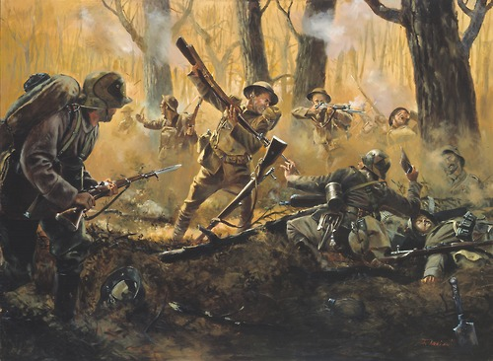
Year 7 WAR POETRY
Name: _______________________________Tutor Group: 7___

English Teacher(s): ___________________________________

Learning Cycle 2

November | 25 | 26 | 27 | 28 | 29 | Teaching week 1
December | 2 | 3 | 4 | 5 | 6 | Teaching week 2
 | 9 | 10 | 11 | 12 | 13 | Teaching week 3
 | 16 | 17 | 18 | 19 | 20 | Teaching week 4
 | 23 | 24 | 25 | 26 | 27 | Christmas Break
 | 30 | 31 | 1 | 2 | 3 | Christmas Break
January | 6 | 7 | 8 | 9 | 10 | Teaching week 5
 | 13 | 14 | 15 | 16 | 17 | Teaching week 6
 | 20 | 21 | 22 | 23 | 24 | Teaching week 7
 | 27 | 28 | 29 | 30 | 31 | Assessment Week
February | 3 | 4 | 5 | 6 | 7 | Super Teach Week

- Cycle 2 in English will focus on analysing war poetry as well as creating your own descriptive pieces.
- The knowledge organiser sets out the most important facts and information that you need to know to study this topic.
- Everything you need to answer the tasks is either in the knowledge organiser, or will have been covered in lessons.

USEFUL WEBSITES
http://www.dictionary.com/
https://en.wikipedia.org/wiki/Main_Page
http://www.bbc.co.uk/schools/0/ww1/25407948
https://www.dkfindout.com/uk/history/world-war-i/allies-world-war-i/
https://www.britishlegion.org.uk
http://noglory.org/index.php/poetry-spoken-word/43-when-siegfried-sassoon-met-wilfred-owen

Week 1: A profile of a poet.

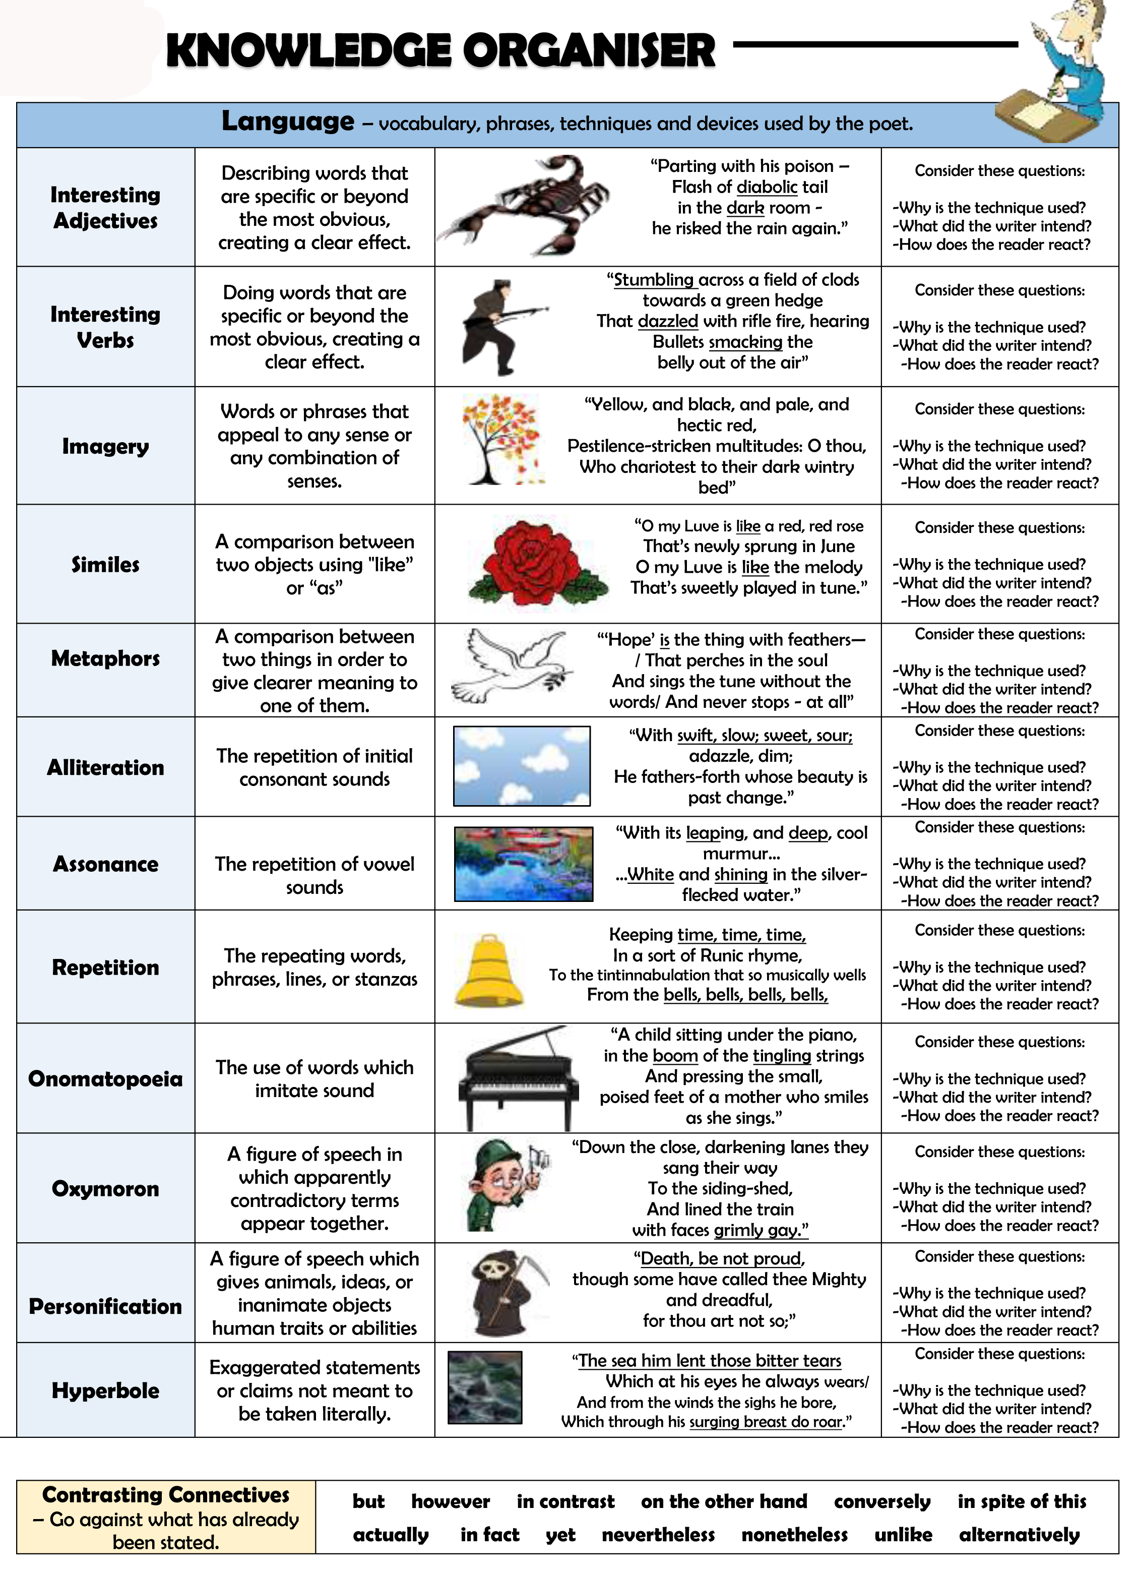

Wilfred Owen
Wilfred Owen (18 March 1893 – 4 November 1918) is best known as one of the most powerful war poets, who depicted the reality and horrors of the First World War.
- He was born in Oswestry, Shropshire, England - where there is now a memorial to him.
- Owen was influenced by the great romantic poets of Keats, Byron, Shelly, Coleridge and Wordsworth.
- When war broke out, Owen was teaching in France. He even considered joining the French army but joined the British army in 1915.
- Owen's first experience of the war was in hospitals treating the wounded soldiers - often without anaesthetic.
- Wilfred Owen was invalided out of the army in 1916 suffering from shell shock.
- Recuperating in an Edinburgh hospital, Wilfred Owen became close friends with poet Siegfried Sassoon. Sassoon played a key role in encouraging the young war poet.
- When Owen returned to the front in 1918, he hid the fact from his friend Siegfried Sassoon, who didn't want him to return.
- Wilfred Owen was killed in battle during the last month of the war - November 1918. He died exactly one week (almost to the hour) before the signing of the Armistice which ended the war. He was only 25 when he died.
- His parents received a telegram on Armistice day 1918, as the bells were ringing in celebration at the end of the war.
- After his death, he was awarded the Military Cross. Owen wanted this medal to make his anti-war poetry appear even stronger.

Siegfried Sassoon
Siegfried Loraine Sassoon, CBE, MC (8 September 1886 – 1 September 1967) was an English poet, writer, and soldier. Decorated for bravery on the Western Front, he became one of the leading poets of the First World War.
- Siegfried Sassoon was born on 8 September 1886 in Kent.
- Sassoon studied at Cambridge University but left without a degree. He then lived the life of a country gentleman, hunting and playing cricket while also publishing sall volumes of poetry.
- In May 1915, Sassoon was commissioned into the Royal Welsh Fusiliers and went to France.
- He impressed many with his bravery in the front line and was given the nickname 'Mad Jack' for his near-suicidal exploits. He was decorated twice.
- In the summer of 1916, Sassoon was sent to England to recover from fever. He went back to the front, but was wounded in April 1917 and returned home.
- Meetings with several prominent pacifists, including Bertrand Russell, had reinforced his growing disillusionment with the war and in June 1917 he wrote a letter that was published in the Times in which he said that the war was being deliberately and unnecessarily prolonged by the government. As a decorated war hero and published poet, this caused public outrage.
- It was only his friend and fellow poet, Robert Graves, who prevented him from being court-martialled by convincing the authorities that Sassoon had shell-shock.
- He was sent to Craiglockhart War Hospital in Edinburgh for treatment. Here he met, and greatly influenced, Wilfred Owen. Both men returned to the front where Owen was killed in 1918. Sassoon was posted to Palestine and then returned to France, where he was again wounded, spending the remainder of the war in England. Many of his war poems were published in 'The Old Huntsman' (1917) and 'Counter-Attack' (1918).
- He died on 1 September 1967.

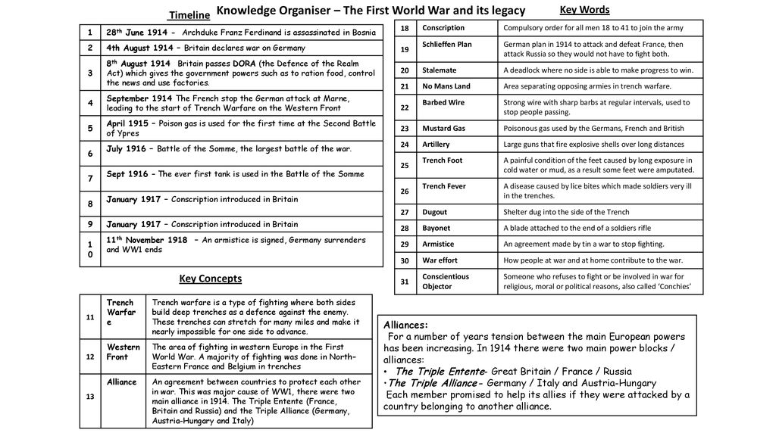
Week 1
Use page 5 of your Knowledge Organiser to answer the following questions. You need this knowledge in order to fully understand the poems we will be studying in class.

- When did Britain declare war on Germany? ________________________________

- When did WW1 end? __________________________________________________

- What does the word ‘conscription’ mean? __________________________________________________________________________________________________________________________________________

- When was conscription introduced in Britain?
__________________________________________________________________________________________________________________________________________

- What does the word alliance mean? __________________________________________________________________________________________________________________________________________

- In 1914, which alliance was Great Britain part of? __________________________________________________________________________________________________________________________________________

- The war lasted for years due to a ‘stalemate’. What does this word mean? _______________________________________________________________________________________________________________________________________________________________________________________________________________

- What was a ‘Conscientious Objector’? _______________________________________________________________________________________________________________________________________________________________________________________________________________

Parent/carer comments:
Week 2
Use page 4 of your Knowledge Organiser to answer the following questions. You need this knowledge in order to fully understand the poems we will be studying in class.
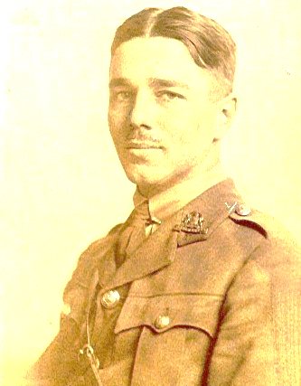
- When was he born?
________________________
- What job did Owen have
when the war first started?
________________________
- In what way was Owen injured in
1915?
________________________
- How old was he when he died?
------------------------------------------
- Sadly, Wilfred Owen died a short time before Armstice Day was declared. How many weeks before the end of the war was this?
_________________________________________________________________
- Before his death Wilfred Owen was injured and returned to Great Britain
to recover. Where was he sent?
_________________________________________________________________
- Which influential poet did Wilfred Owen meet when he was recovering from his injuries?________________________

Parent/carer comments:
Week 3
For each of the techniques listed, you need to write down a definition. Then try to find an example in the extract from the poem below. Use page 3 of your Knowledge Organiser to help.
What passing-bells for these who die as cattle?
- Only the monstrous anger of the guns.
Only the stuttering rifles’ rapid rattle
Can patter out their hasty orisons.
No mockeries now for them; no prayers nor bells;
Nor any voice of mourning save the choirs, -
The shrill, demented choirs of wailing shells;
And bugles calling for them from sad shires.

ALLITERATION
Definition___________________________________________________________________
Example____________________________________________________________________

PERSONIFICATION
Definition___________________________________________________________________
Example: ___________________________________________________________________

METAPHOR
Definition___________________________________________________________________
Example____________________________________________________________________

SIMILE
Definition___________________________________________________________________
Example____________________________________________________________________

Parent/carer comments:
Week 4
Look at the extract of descriptive writing below. You will need three colours to do this task. Use page 3 of your Knowledge Organiser if you need a reminder of key terms.
- In paragraph 1, highlight or underline all of the adjectives.
- In paragraph 2, highlight or underline all of the verbs.
- In paragraph 3, highlight or underline the metaphor.

As he trudged through the squalid and muddy passageways, cold water seeped through his boots. Thin materials of socks did little to protect his damp and wrinkly feet, and the infestation of sores that had only grown in size since finding their homes among his calloused skin. As if lifting one foot after the other was not painful enough, his back was continually assaulted with the poking and prodding of items in his rucksack; his head, constantly hit by the ill-fitting helmet that loosely tilted to one side.
Entering deeper into the trenches and dodging barbed wires along the way, he could already begin to smell – among smoke and fire – the awful stench and odour that reeked of half buried bodies. As Mother Nature’s ominous clouds loomed closer towards his group, he and his mates lengthened their strides as much as possible. It seemed however, that someone had angered Mother Nature that particular evening, and like an animal waiting to pounce on its prey, drops of water that started small quickly turned large and threatening. It wasn’t long before he was waist deep in water, soaked with brown and murky soil that had been picked up by the rain and washed along in the waters. As tears continued to pelt down and drown him in mud, he knew that this was now the place where his body would be forever; yet he was content.
For the first time in a long time, a sense of peace and comfort washed over him. He clung onto the knowledge that he would leave this world at the same time as his mates, never having to live one more day without them, never having to live with the guilt that it should have been him and not them. With that last thought in mind, he closed his eyes, feeling no longer afraid of death….. feeling that death could finally conquer him.

Parent/carer comments:
Week 5
You need to annotate the PETER paragraph below looking for the different elements of analysis. Ideally you would highlight the P.E.T.E.R in different colours.
How does Wilfred Owen use language and structure to present the horrors of life in the trenches?
In his poem ‘Dulce et Decorum Est’ Wilfred Owen suggests that the horrors of war can be haunting and will not leave you alone. Owen writes: “In all my dreams, before my helpless sight/ He plunges at me, guttering, choking, drowning.” This is the only couplet within the four stanza poem suggesting that the poet has used his structural choices to draw particular attention to the images within the couplet. The reader cannot miss the repetition of ‘drowning’ which creates the effect of an echo in our minds from the last word of the second stanza, especially since it also ends the power of three technique used by Owen when he writes the three violent verbs ‘guttering, choking, drowning’. This savage image of death is what haunts the narrator ‘in all my dreams’. Owen is describing perhaps the effects of shell shock, common amongst soldiers during the First World War. Today we would know this haunting sensation as a symptom of post-traumatic stress disorder (P.T.S.D). Ultimately, it is the narrator’s inability to help the man he saw drowning in gas that perhaps leaves him with a sense that he is ‘helpless’ and leaves him with such horrible images of the war.
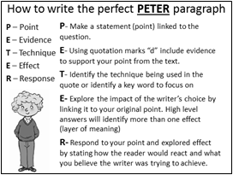

Parent/carer comments:
Week 6
Read the information below about Wilfred Owen and Siegfried Sassoon. Answer the comprehension questions that follow. They go on to the next page.
Two great British war poets, Wilfred Owen and Siegfried Sassoon, both served as army officers during World War I, experiencing first-hand the horrors of trench warfare at the front and, in the case of Owen, gas attacks. Sassoon and Owen met when hospitalised for shell shock (now called post-traumatic stress disorder) in Craiglockhart War Hospital near Edinburgh.
Owen was a brilliant young officer who had been hospitalised after surviving numerous horrendous combat experiences, including being trapped in a trench under heavy fire for several days with the remains of a fellow officer.
Nicknamed “Mad Jack” by his men for the boldness of his exploits under fire, Sassoon came to believe that the war was wrong and that it must be stopped. In 1917, while back in England recovering from a shoulder wound, Sassoon, already a decorated war hero and published poet, wrote a letter of protest to his commander, ‘Finished with the War: A Soldier’s Declaration’.
With the support of prominent pacifists, including philosopher Bertrand Russell who would later go to prison for anti-war activities, Sassoon had the declaration read out in the British House of Commons and printed in the London Times. The result was a political firestorm. Sassoon was threatened with court-martial and military execution until his friend, writer-soldier Robert Graves, successfully argued that Sassoon was mentally unfit due to shell shock, or “war neurosis,” and should instead be sent for treatment to Craiglockhart.
Owen was a great admirer of Sassoon’s poetry and the two became friends. Both men felt a tremendous sense of responsibility to the soldiers they had left at the front, a feeling expressed by many soldiers today when they leave a combat unit. Although both Sassoon and Owen could have avoided being sent back to action, each insisted on returning to the front. Sassoon, wounded a second time and sent home, tried fiercely to prevent Owen from returning to battle.

- What rank in the army did both Owen and Sassoon have?
__________________________________________________________
- What did Owen experience that Sassoon did not?
__________________________________________________________
- What is the modern term for ‘shell shock’?
__________________________________________________________
- What was the name of the hospital where the two poets met?
____________________________________________________________

- How did Sassoon receive the name “Mad Jack”?
____________________________________________________________
- In what year did Sassoon write a letter of protest claiming that the war was wrong?
____________________________________________________________
- Who went to prison for anti-war activities?
____________________________________________________________
- Who did Sassoon and Owen feel responsible for after their return from war?
____________________________________________________________

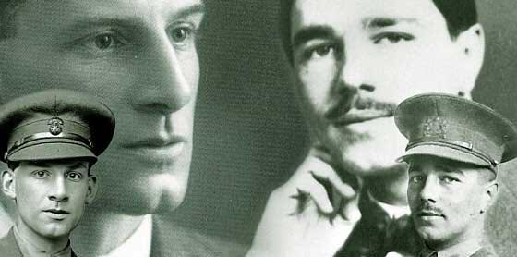

Parent/carer comments:
Week 6
The First World War inspired some of British poetry's most poignant and emotionally charged poetic writing.
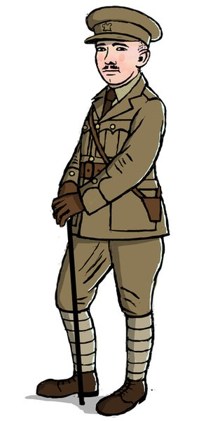
Use your knowledge to be inspired and WRITE A WAR POEM of your own.
You should use the Success Criteria to help guide you.

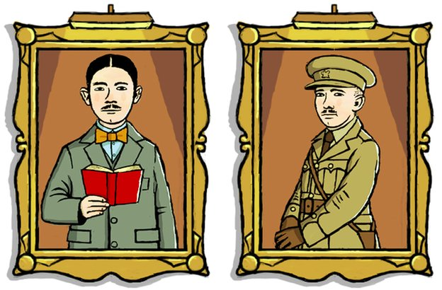
Success Criteria
- Plan your poem before you begin to write it – mind maps can be helpful.
- Include the theme of war/conflict. (Does NOT have to be the first world war)
- Include a range of linguistic devices – metaphor, simile, personification, alliteration, onomatopoeia
- Use the senses
- It should be structured like a poem (not a paragraph!)
- It doesn’t have to rhyme (use free verse if you wish)
_________________________________________________________________________________________________________________________________________________________________________________________________________________________________________________________________________________________________________________________________________________________________________________________________________________________________________________________________________________________________________________________________________________________________________________________________________________________________________________________________________________________________________________________________________________________________________________________________________________________________________________________________________________________________________________________________________________________________________________________________________________________________________________________________________________________________________________________________________________________________________________________________________________________________________________________________________________________________________________________________________________________________________________________________________________________________________________________________________________________________________________________________________________________________________________________________________________________________________________________________________________________________________________________________________________________________________________________________________________________________________________________________________________________________________________________________________________________________________________________________________________________________________________________________________________________________________________________________________________________________________________________________________________________________________________________________________________________________________________________________________________________________________________________________________________________________________________________________________________________________________________________________________________________________________________________________________________________________________________________________________________________________________________________________________________________________________________________________________________________________________________________
Parent/carer comments:

