Worle Community School Academy

Geography
Yr 9 Learning Cycle 4 Homework Book
Name: _______________________________________________
Class: _______________
Teacher(s)_______________________________________________
Learning cycle 4

May 2019 | 6 | 7 | 8 | 9 | 10 | Teaching week 1
 | 13 | 14 | 15 | 16 | 17 | Teaching week 2
 | 20 | 21 | 22 | 23 | 24 | Teaching week 3
 | 27 | 28 | 29 | 30 | 31 | Half Term
June 2019 | 3 | 4 | 5 | 6 | 7 | Teaching week 4
 | 10 | 11 | 12 | 13 | 14 | Teaching week 5
 | 17 | 18 | 19 | 20 | 21 | Teaching week 6
 | 24 | 25 | 26 | 27 | 28 | Assessment week
July 2019 | 1 | 2 | 3 | 4 | 5 | Super Teach week

- During the Assessment Week, students will be assessed on the material that they have covered the previous 6 weeks.

- Following this, the teacher will re-teach areas of underachievement, as identified during the assessment week, during the Super Teaching week.
- The tasks labelled as “consolidation tasks” mean that students should be able to complete them using their knowledge from lessons.

- There are also tasks labelled, “research tasks”, where we are asking students to spend 15-20 minutes doing some research.
Useful Websites to help you with your research
BBC bitesize

Each week we will mark homework in class. Write in the score you got and

Week | Date due | Task | Red/Amber/Green
1 |  | Water Resources
2 |  | Energy Resources
3 |  | Energy Resources
4 |  | How do you use resources?
5 |  | Food security
6 |  | Food security
7 |  | Indus River Basin System

Parent comments:

Teacher checked:
Date due:

Week 1 – Consolidation task Water Resources
- What do we use water for – produce a mindmap

Uses of water

- The map in fig2 (next page) shows water stress across the UK.
- Define water stress __________________________________________
- Identify an area suffering from water stress _________________________

C. Using your own knowledge and help from figure 1 why do you think the South East of England suffers from water stress?
_______________________________________________________________________
_______________________________________________________________________
_______________________________________________________________________
_______________________________________________________________________
_______________________________________________________________________
_______________________________________________________________________
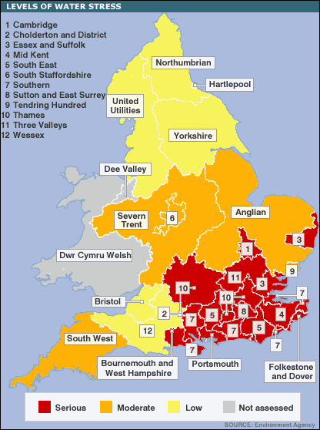
Fig 1. Map showing levels of water stress within the UK.

What is a water transfer scheme?
______________________________________________________________________________________________________________________________________________________________________________________

- With help from figure 1 how might a water transfer scheme be beneficial in the England? How could it work?
______________________________________________________________________________________________________________________________________________________________________________________________________________________________________________________________________________________________________________________________________________________________________________________________________________________________________________________________________________________________________________________________________________________________________________

Teacher checked:
Date due:

Week 2 – consolidation task Energy in the UK

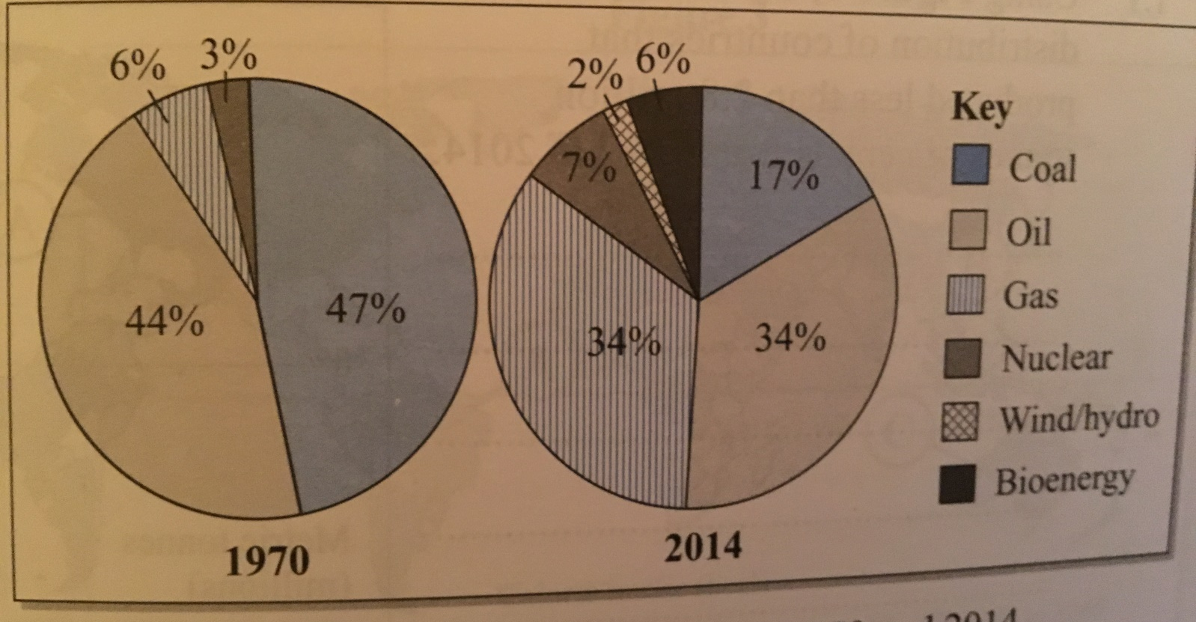

The pie charts above show sources of UK energy. Coal for 1970 is 47% and 17% in 2014 (key works clockwise on the pie chart from coal)

1. Which energy source did the UK most rely in 1970?____________

- By how much has the demand for oil changed between 1970 and 2014?
____________________________________________________

- Which sources of energy being used in 2014 were not being used in 1970? ________________________________________________

- Which energy source increased the most between 1970 and 2014?
__________________________________________________

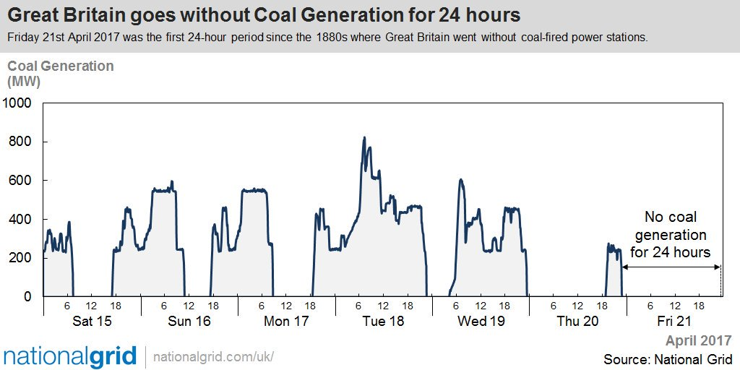

- What was the highest figure for coal generation between Saturday and Friday? _______________________________________

- Suggest why Britain was able to survive without any coal generated electricity for 24hours.
_________________________________________________
__________________________________________________
______________________________________________________________________________________________________________________________________________________
______________________________________________________________________________________________________________________________________________________

Teacher checked:
Date due:

Week 3 Consolidation task Energy use in the UK

- How has our demand for energy in the UK changed? Explain your ideas
____________________________________________________________________________________________________________________________________________________________________________________________________________________________________________________________________________________________________________

- Why has our demand for coal fallen in the UK?
__________________________________________________________________________________________________________________________________________________________________________________________________________________________________________________________

3. Coal, oil and natural gas are collectively known as ____________________________________________________

- What do we mean by renewable sources of energy? Give 3 examples
________________________________________________________________________________________________________________________________________________________________________________________________________

- Outline one economic issue caused by exploiting renewable energy sources
________________________________________________________________________________________________________________________________________________________________________________________________________

- Explain a range of ways that exploiting energy sources can cause environmental issues
_____________________________________________________________________________________________________________________________________________________________________________________________________________________________________________________________________________________________________________________________________________________________________________________________________________________________________________________________________________________________________________________________________________________________________________________________________________________________________________________________________

Teacher checked:
Date due:
Week 4 Eco Friendly Quiz!
Are you Eco-friendly?
Unless you’ve been living in a cave – or on the dark side of the Moon – for the last few years, you know what you ought to be doing when it comes to saving energy, helping wildlife and supporting ethical projects. Work your way through these quick 12 questions and see just how green you really are. The answers are at the bottom – so enjoy finding out! Once completed write a short paragraph explaining how you could improve your environmental footprint.
1. Do you switch off your TV/computer/sound system at the wall?  a) Always.  b) Mostly.  c) Sometimes. | 7. How did you travel to your last holiday?  a) By boat or train.  b) On foot or by bicycle.  c) By air.
2. When you clean your teeth, do you let the water run?  a) Yes.  b) No!  c) Sometimes. | 8. How do you get to school?  a) Walk or cycle.  b) School bus.  c) Car.
3. Do you grow your own food at home?  a) Yes – loads.  b) Yes, some.  c) No, not really. | 9. Shower or bath?  a) Bath.  b) Shower.  c) Don’t care.
4. How many of your home’s light bulbs are low energy ones?  a) None / one or two.  b) About half.  c) All of them. | 10. If you’re buying a present, which matters MOST to you?  a) Price.  b) Was it made locally?  c) Will the person I’m giving it to like it?
5. How much of your household waste do you recycle?  a) We put our bottles in the bottle bank.  b) As much as we can.  c) Most of what we can. | 11. How do you think of wasps?  a) If they avoid me, I’ll avoid them.  b) A nuisance.  c) An important part of the natural world.
6. Do you have a wildlife friendly garden?  a) We’ve got a bit of a wildlife corner, but it’s nothing special.  b) I think we’ve got a bird box.  c) We’ve got bird boxes, a wildlife area, a pond and loads of plants for bees and butterflies. | 12. How many times do you re-use the plastic bags shops give you?  a) Once, maybe.  b) Several times.  c) I never take them; I always use my own bag.

RESULTS  1. (a) 3 points (b) 2 points (c) 1 point  2. (a) 1 point (b) 3 points (c) 2 points  3. (a) 3 points (b) 2 points (c) 1 point  4. (a) 1 point (b) 2 points (c) 3 points  5. (a) 1 point (b) 3 points (c) 2 points  6. (a) 2 points (b) 1 point (c) 3 points  7. (a) 2 points (b) 3 points (c) 1 point  8. (a) 3 points (b) 2 points (c) 1 point  9. (a) 2 points (b) 3 points (c) 1 point | 10. (a) 1 point (b) 3 points (c) 2 points  11. (a) 2 points (b) 1 point (c) 3 points  12. (a) 1 point (b) 2 points (c) 3 points  How Did You Do?  29 to 36 – Deep Green! Well done Eco-warrior!  19 to 28 – Emerald Green! Pretty good.  12 to 18 – Light Green! Hmmmm – maybe be a little greener?

- What three changes could you (or someone else) make to their life style – after taking this quiz- to get a higher score. Explain how it would help our environment.
- ____________________________________________________________________________________________________________________________________________________________________________________________________________________
__________________________________________________________________________________________________________

- ____________________________________________________________________________________________________________________________________________________________________________________________________________________
____________________________________________________________________________________________________________________________________________________________________________________________________________________

- ______________________________________________________________________________________________________________________________________________________________________________________________________________________________________________________________________________________________________________________________

Teacher checked:
Date due:

Week 5 – Consolidation Food Security
Mind map factors that affect food security, explain how they impact it by developing points. Can you add location examples by completing further research?
Farmers are unable to tend to crops so no food is grown.

War/Conflict

Imported food may not make it to the country because…
Food security

Date due:
Teacher checked:
Week 6 – Consolidation Food insecurity

- Define Malnutrition _______________________________________________________

- Define food insecurity
______________________________________________________________________________________________________________________

- Identify three impacts of food insecurity on a country.
___________________________________________________________________________________________________________________________________________________________________________
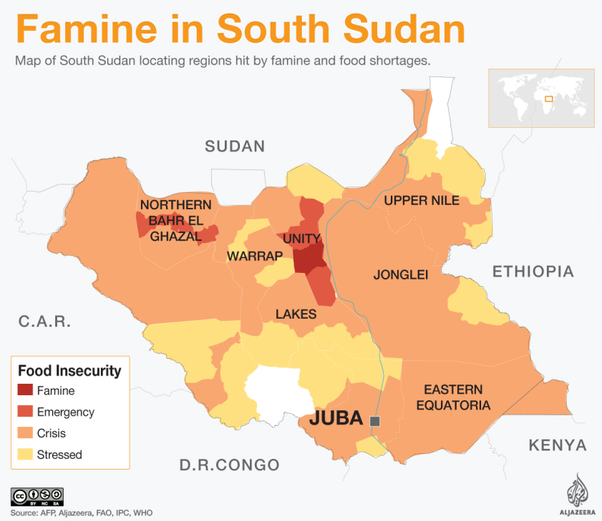
- This figure shows a map of South Sudan
The United Nations (UN) has declared a famine in South Sudan, the world's youngest country.
The severe food shortage is the result of a civil war that has been going on since 2013. Tens of thousands of people have been killed in the conflict, which has also displaced millions.
According to the UN, the famine affects more than 100,000 people in two counties of Unity state. There are fears it will spread as an additional one million South Sudanese are on the brink of starvation. Officials have contested that hunger in South Sudan is even more shocking because of the country's fertile land conditions.

- Using the information above identify two pieces of evidence to show South Sudan suffers from food insecurity.
______________________________________________________________________________________________________________

- Using the information explain why South Sudan may suffer from food insecurity (P.E.E.L)
______________________________________________________________________________________________________________________________________________________________________________________________________________________________________________________________________________________________________________________________________________________
___________________________________________________________________________________________________________________________________________________________________________
___________________________________________________________________________________________________________________________________________________________________________
___________________________________________________________________________________________________________________________________________________________________________
___________________________________________________________________________________________________________________________________________________________________________

Date due:
Week 7 –
Teacher checked:
Indus River Basin System.
Where is the Indus River?
___________________________________________________________
___________________________________________________________
___________________________________________________________

How does the project work?
___________________________________________________________
___________________________________________________________
___________________________________________________________
___________________________________________________________
___________________________________________________________

Advantages of scheme | Disadvantages of scheme

