Worle Community School Academy
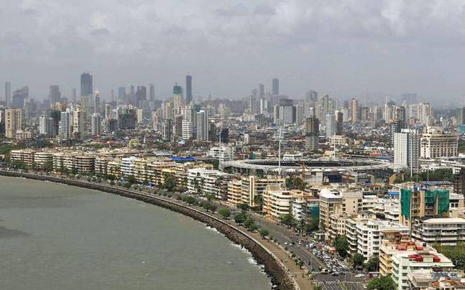
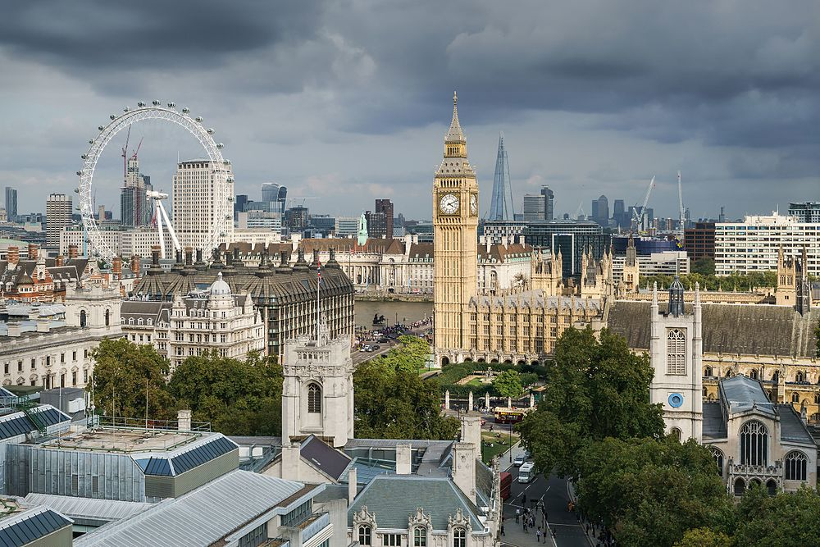
Yr 7 Learning Cycle 4
Homework Booklet
Geography
Name: ________________________
Class: _______________
Teacher(s): ______________________________________
Week | Homework task | Red | Amber |  |  | Green
1
 | Parent /carer comments
2
 | Parent /carer comments
3
 | Parent /carer comments
4
 | Parent /carer comments
5
 | Parent/carer comments
6
 | Parent/carer comments
7
 | Parent/carer comments
Each week we will mark homework in class. Write in the score you got and how easy you found the homework (RED = really tough, Amber= OK, Green =Easy).
There is a space below each task in the table for parents/carers to make a comment if they need to.

May 2019 | 6 | 7 | 8 | 9 | 10 | Teaching week 1
 | 13 | 14 | 15 | 16 | 17 | Teaching week 2
 | 20 | 21 | 22 | 23 | 24 | Teaching week 3
 | 27 | 28 | 29 | 30 | 31 | Half Term
June 2019 | 3 | 4 | 5 | 6 | 7 | Teaching week 4
 | 10 | 11 | 12 | 13 | 14 | Teaching week 5
 | 17 | 18 | 19 | 20 | 21 | Teaching week 6
 | 24 | 25 | 26 | 27 | 28 | Assessment week
July 2019 | 1 | 2 | 3 | 4 | 5 | Super Teach week
Learning cycle 4

During the Assessment Week, students will be assessed on the material that they have covered the previous 3-4 weeks.

- Following this, the teacher will re-teach areas of underachievement, as identified during the assessment week, during the Super Teaching week.

- The tasks labelled as “consolidation tasks” mean that students should be able to complete them using their knowledge from lessons.

- There are also tasks labelled, “research tasks”, where we are asking students to spend 15-20 minutes doing some research.
Useful Websites to help you with your research
BBC bitesize

Each week we will mark homework in class. Write in the score you got and how

Date due:
Week 1- Urban and Rural- Consolidation
Task 1:
Label if these pictures are showing you an urban area or a rural one
Marked By:

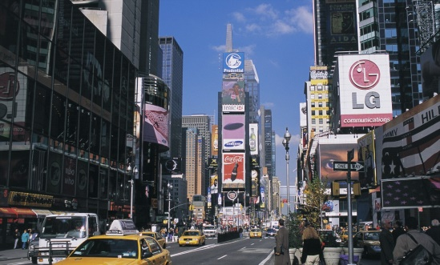

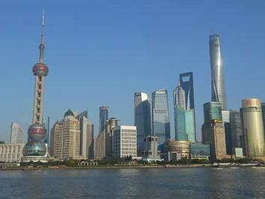
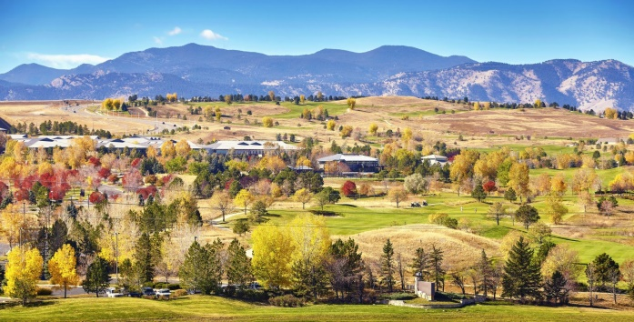

Task 2:
Why might some people decide to move from rural areas to urban ones?

………………………………………………………………………………………………………………………………………………………………………………………………………………………………………………………………………………………………………………………………………………………………………………………………………………………………………………………………………………………………………………………………………………………………………………………………………………………………………………………………………………………………

v
Task 3:
How many cities of the world can you name? (Challenge, can you name the city and the country it’s found in?)

………………………………………………………………………………………………………………………………………………………………
…………………………………………………………………………………………………………………………………………………………………………………………………………………………………………………………………………………………………………………………………………………………………………………………………………………………………………………………………………………………………………………………………………………………………………………………………………………………………………………………………………………………………………………………………………………………………………………………………………………………………………………………………………………………………………………………………………………………………………………………………………….

Week 2- Megacities- Research
Marked By:
Date due:

Task 2:
Using the world map below, label at least 10 megacities (google terms such as ‘world megacity list’ or ‘megacity world map’ to help you.
Task 1:
What is a megacity?
________________________________________________________________________________________________________________________________________________________________________________________________________________________________________________________________________________

Challenge:
- Which continent has the most megacities?
- Describe the distribution of megacities (use continents, countries, and compass points to describe where in the world we can find them)
____________________________________________________________________________________________________________________________________________________________________________________________________________________________________________________________________________

Date due:
Marked By:
Week 3- Introducing London- Consolidation
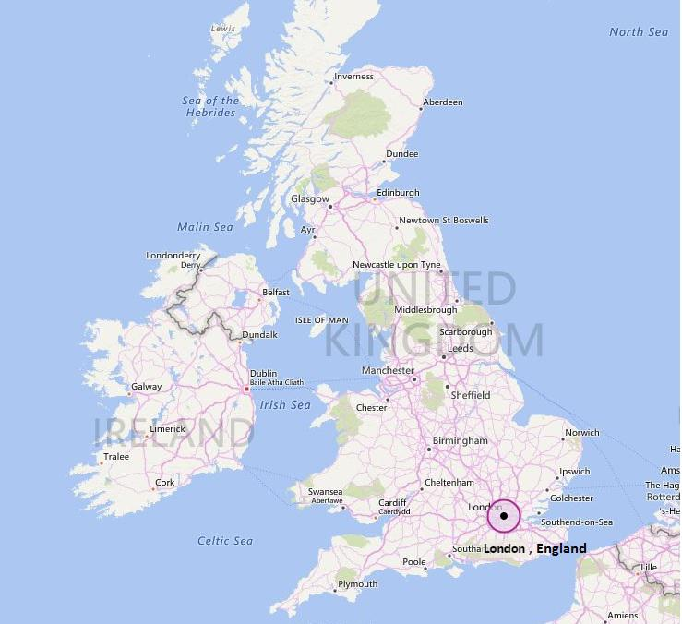

Task 1: Describe the location of London within the United Kingdom
………………………………………………………….………………………………………………………….………………………………………………………….………………………………………………………….………………………………………………………….………………………………………………………….………………………………………………………….………………………………………………………….………………………………………………………….………………………………………………………….

Task 3: What makes London an important city nationally (in the UK) and internationally (the rest of the world) today?

Nationally
………………………………………………………….………………………………………………………….………………………………………………………….………………………………………………………….………………………………………………………….………………………………………………………….………………………………………………………….………………………………………………………….………………………………………………………….………………………………………………………….……………………………………………………….………………………………………………………….……………………………………………………….……………………………
Internationally
………………………………………………………….………………………………………………………….………………………………………………………….………………………………………………………….………………………………………………………….………………………………………………………….………………………………………………………….………………………………………………………….………………………………………………………….………………………………………………………….……………………………………………………….………………………………………………………….……………………………………………………….……………………………

Task 2: What famous events in London’s history do you know? Pick 2 (either that you know about or you can research) and explain them here:

Event 1: ………………………………………………………….………………………………………………………….………………………………………………………….………………………………………………………….………………………………………………………….………………………………………………………….………………………………………………………….………………………………………………………….………………………………………………………….………………………………………………………….……………………………………………………….………………………………………………………….……………………………………………………….……………………………
Event 2
………………………………………………………….………………………………………………………….………………………………………………………….………………………………………………………….………………………………………………………….………………………………………………………….………………………………………………………….………………………………………………………….………………………………………………………….………………………………………………………….……………………………………………………….………………………………………………………….……………………………………………………….……………………………

Week 4- Social opportunities in London- Research
Marked By:
Date due:
Your task:
Imagine someone you know is going to spend 3 days in London, your task is to design an itinerary (a plan of activities for them to do/places for them to see) for those 3 days. The internet will help you, or you could use your own knowledge.

Challenge:
At the bottom of the table, add up how much all the activities/museums/sightseeing will cost
Challenge task space

Monday Morning | Monday Afternoon
Tuesday Morning | Tuesday Afternoon
Wednesday Morning | Wednesday Afternoon

Week 5- Mumbai Consolidation
Marked By:
Date due:
Task 1: Describe the location of Mumbai
………………………………………………………….………………………………………………………….………………………………………………………….………………………………………………………….………………………………………………………….………………………………………………………….………………………………………………………….………………………………………………………….………………………………………………………….………………………………………………………….

Task 2: Describe why someone may want to move to Mumbai
………………………………………………………….………………………………………………………….………………………………………………………….………………………………………………………….………………………………………………………….………………………………………………………….………………………………………………………….………………………………………………………….………………………………………………………….………………………………………………………….

Task 3: Read through this newspaper article, then answer the questions below

Tens of thousands of people are fighting to leave Mahul, a heavily industrialised neighbourhood in the western Indian city of Mumbai, saying the toxic pollution there is adversely impacting their health. BBC Marathi's Mayuresh Konnur and Janhavee Moole report on the residents' battle to be relocated.

Anita Dhole, 38, was forced to move to a "transit camp" set up by the civic authorities in Mahul in May 2017 after the illegal slum she was living in was demolished. Since then, she says, she has been suffering.

"I have breathing trouble and high blood pressure, and the pollution has also affected my eyesight," she says.

Hers was one of more than 5,000 families - estimated to be between 30,000 and 50,000 people - that lost their homes in the demolition drive and were offered temporary housing in Mahul. They were told they would be given homes in another Mumbai suburb later but, residents say, Mahul is not fit for living, even for a short time. A former fishing village, it's now close to oil and petroleum refineries, chemical factories and fertiliser plants.

A report in 2013 by the King Edward Memorial Hospital said that around 67% of people living in Mahul complained of breathlessness several times a month and around 84% of them complained of eye-irritation. In 2015, India's environment court National Green Tribunal said there was "a perceptible threat to [the] health of residents" in Mahul because of the poor quality air in the area, known as air pollution, caused partly by factories and exhaust fumes.

Besides pollution, residents say they have no access to clean water and sewage facilities and that electricity supply is far from regular. There are also no hospitals or schools nearby. The area is poorly connected with other parts of the city and, as a result, many women have been forced to quit their jobs and stay home.

- Why did Anita Dhole have to move to a ‘transit camp’?
- What problems with her health has she had since leaving?
- What percentage of people living in Mahul complained of breathlessness several times a month?

- What are two causes of the air pollution?

- What else in Mahul do people not have access to?

Challenge:
What could be done to improve life in slums (Shanty towns?

Date due:
Marked By:

Week 6- Keywords
Your task- define the key word (or work out what the key word is) and create a diagram to help you
Keyword | Meaning | Diagram
Congestion | Too much traffic on the roads
 | A city with 10 million people or more
Migration
 | How many people live in a town or city (or country, or even the world)
Rural
Slum
 | Built up areas (towns and cities)

Use at least 3 of these words to create a paragraph about something we have learnt so far.
_________________________________________________________________________________________________________________________________________________________________________________________________________________________________________________________________________________________________________________________________________________________________________________________________________________________________________________________________________________________________________________________________________________________________________________________________________________________________________________________________________

Week 7- Revision
Marked By:
Date due:

Create a mindmap on what we have learnt ready for your assessment.

London

Mumbai

