Faculty: Modern Foreign Languages
Head of Faculty: Mrs K Webb-Jones
Staff: Miss M Vila, Miss J Garnet, Mrs D Bainbridge, Mrs A Khole, Mrs A Venn, Mrs N Muir.
Introduction and ethos of our Modern Foreign Languages Department are:
“Learning another language is not only learning different words for the same things but learning another way to think about things.” Flora Lewis.
The MFL Department at WCSA aims to inspire pupils to embark on a life-long enjoyment of languages and develop an understanding, interest, respect and empathy for other nationalities and cultures. We have high expectations of students’ achievement and behaviour and hope to ensure that students achieve their full academic potential in the subject.
KS3
At Key Stage 3, students learn either French or Spanish for three lessons of 60 minutes each week. The four main skills are listening, speaking, reading and writing, which are taught in engaging lessons and are regularly assessed. A good understanding of grammar is an important factor in language learning and throughout KS3 we build students knowledge so they can manipulate the language as necessary.
KS4
Students carry on with either French or Spanish at GCSE level in Years 10 and 11. They build on the existing foundations gained in KS3 and improve their skills. The AQA GCSE specification is followed for accreditation in both languages. In French the Studio textbook and in Spanish the Viva textbook are successfully used as core texts.
Examinations in different skills for these GCSEs are all taken at the end of year 11.
Paper 1: Listening Foundation or Higher (25%)
Paper 2: Speaking Test conducted by teachers (25%)
Paper 3: Reading Foundation or Higher (25%)
Paper 4: Writing Foundation or Higher (25%)

Enrichment opportunities:
Our students are encouraged to take part in our trips to Paris for French students or Granada for Spanish student where they experience the culture first hand and are encouraged to practice their language skills. They are immersed in the culture of the countries and have the opportunity to sample local food and visit local landmarks.
Home Learning
Home Learning is set weekly for all students as regular practice secures the knowledge needed to succeed and make good progress. Homework is presented in booklet form and consists of two parts – the first in the form of vocabulary learning which is tested weekly, the second part consolidates knowledge that has been learnt during lessons. We encourage students to experiment with different ways of learning vocabulary and even for parents to get involved! KS4 students are also issued with a speaking booklet which helps them prepare and practise for their speaking exams.
Career Links
Jobs directly related to a degree in MFL include (but are not limited to):
• Interpreter
• Secondary school teacher
• Translator Jobs where a degree in MFL would be useful include:
• Broadcast journalist
• Diplomatic service officer
• English as a foreign language teacher
• International aid/development worker
• Logistics and distribution manager
• Marketing executive
• Patent examiner
• Private tutor
• Sales executive
• Tour manager
To learn more about careers relating to this specific subject, please click the link below: https://www.careerpilot.org.uk/job-sectors/subjects
“If you talk to a man in a language he understands, that goes to his head. If you talk to him in his language, that goes to his heart”. Nelson Mandela
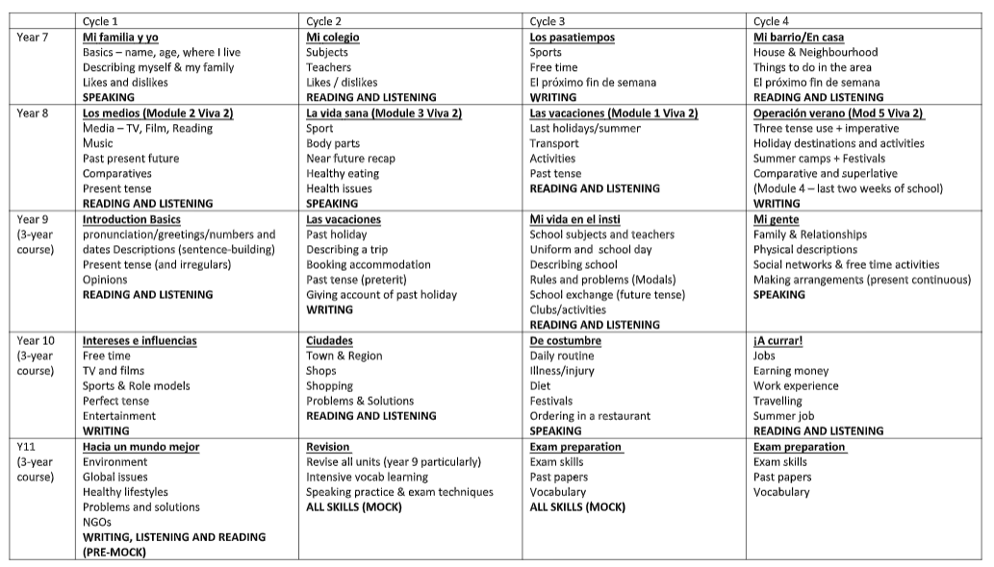
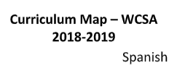

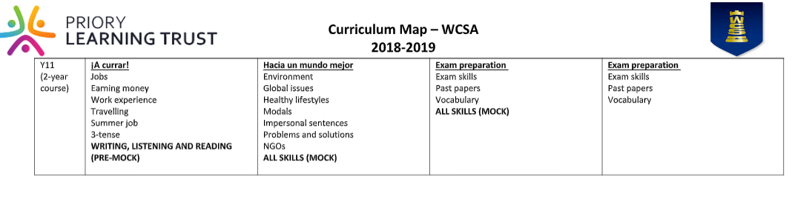
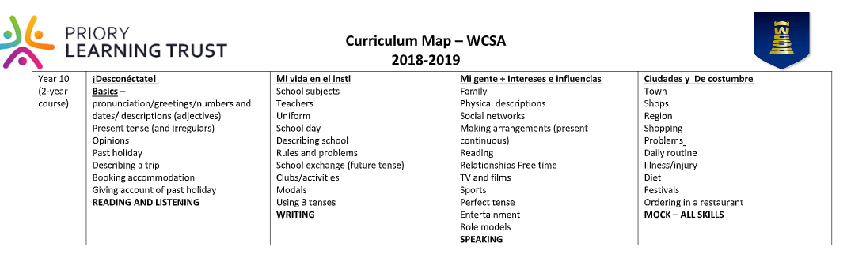

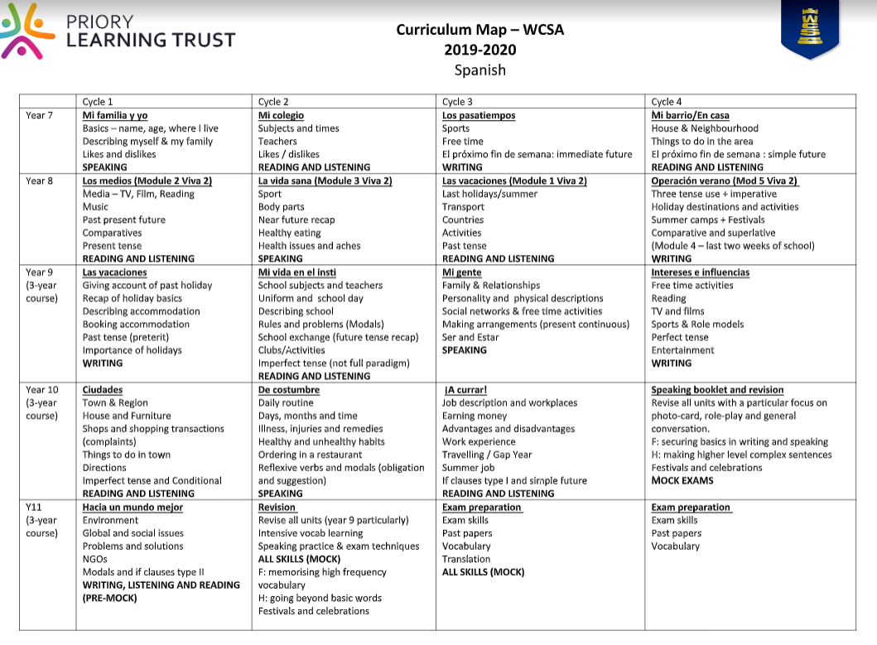

ALLIGNMENT SOL –MCA – ECA - SPANISH
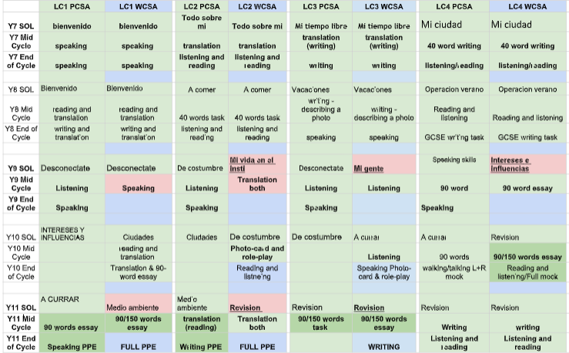

Spanish
 | Cycle 1 | Cycle 2 | Cycle 3 | Cycle 4
Year 7 | Mi familia y yo  Basics – name, age, where I live  Describing myself & my family  Likes and dislikes  SPEAKING | Mi colegio  Subjects  Teachers  Likes / dislikes  READING AND LISTENING | Los pasatiempos  Sports  Free time  El próximo fin de semana  WRITING | Mi barrio/En casa  House & Neighbourhood  Things to do in the area  El próximo fin de semana  READING AND LISTENING
Year 8 | Los medios (Module 2 Viva 2)  Media – TV, Film, Reading  Music  Past present future  Comparatives  Present tense  READING AND LISTENING | La vida sana (Module 3 Viva 2)  Sport  Body parts  Near future recap  Healthy eating  SPEAKING | Las vacaciones (Module 1 Viva 2)  Last holidays/summer  Transport  Activities  Past tense  READING AND LISTENING | Operación verano (Mod 5 Viva 2)  Three tense use + imperative  Holiday destinations and activities  Summer camps  (Module 4 – last two weeks of school)  WRITING
Year 9  (3-year course) | Introduction Basics pronunciation/greetings/numbers and dates Descriptions (sentence-building)  Present tense (and irregulars)  Opinions  READING AND LISTENING | Las vacaciones  Past holiday  Describing a trip  Booking accommodation  Past tense (preterit)  Giving account of past holiday  WRITING | Mi vida en el insti  School subjects and teachers  Uniform and school day  Describing school  Rules and problems (Modals)  School exchange (future tense)  Clubs/activities  READING AND LISTENING | Mi gente  Family & Relationships  Physical descriptions  Social networks & free time activities  Making arrangements (present continuous)  SPEAKING
Year 10  (3-year course) | Intereses e influencias  Free time  TV and films  Sports & Role models  Perfect tense  Entertainment  WRITING | Ciudades  Town & Region  Shops  Shopping  Problems & Solutions  READING AND LISTENING | De costumbre  Daily routine  Illness/injury  Diet  Festivals  Ordering in a restaurant  SPEAKING | ¡A currar!  Jobs  Earning money  Work experience  Travelling  Summer job  READING AND LISTENING
Y11  (3-year course) | Hacia un mundo mejor  Environment  Global issues  Healthy lifestyles  Problems and solutions  NGOs  WRITING, LISTENING AND READING (PRE-MOCK) | Revision  Revise all units (year 9 particularly)  Intensive vocab learning  Speaking practice & exam techniques  ALL SKILLS (MOCK) | Exam preparation  Exam skills  Past papers  Vocabulary  ALL SKILLS (MOCK) | Exam preparation  Exam skills  Past papers  Vocabulary

Year 10  (2-year course) | ¡Desconéctate!  Basics – pronunciation/greetings/numbers and dates/ descriptions (adjectives)  Present tense (and irregulars)  Opinions  Past holiday  Describing a trip  Booking accommodation  Giving account of past holiday  READING AND LISTENING | Mi vida en el insti  School subjects  Teachers  Uniform  School day  Describing school  Rules and problems  School exchange (future tense)  Clubs/activities  Modals  Using 3 tenses  WRITING | Mi gente + Intereses e influencias  Family  Physical descriptions  Social networks  Making arrangements (present continuous)  Reading  Relationships Free time  TV and films  Sports  Perfect tense  Entertainment  Role models  SPEAKING | Ciudades y De costumbre  Town  Shops  Region  Shopping  Problems  Daily routine  Illness/injury  Diet  Festivals  Ordering in a restaurant  MOCK – ALL SKILLS
Y11  (2-year course) | ¡A currar!  Jobs  Earning money  Work experience  Travelling  Summer job  3-tense  WRITING, LISTENING AND READING (PRE-MOCK) | Hacia un mundo mejor  Environment  Global issues  Healthy lifestyles  Modals  Impersonal sentences  Problems and solutions  NGOs  ALL SKILLS (MOCK) | Exam preparation  Exam skills  Past papers  Vocabulary  ALL SKILLS (MOCK) | Exam preparation  Exam skills  Past papers  Vocabulary

WCSA
CURRICULUM MAP 2018-2019 DEPARTMENT: FRENCH
 | Cycle 1 | Cycle 2 | Cycle 3 | Cycle 4
Year 7  KS3 | MA FAMILLE ET MOI  Basics – name, age, where I live  Describing myself & my family. Likes and dislikes  Assessment: Speaking | MON COLLEGE  Subjects  Teachers  Likes / dislikes  Assessment:Read. & List. | MES PASSETEMPS  Sports  Free time  Le weekend prochain  Assessment: Writing | MA ZONE/CHEZ MOI ET CHEZ TOI  House & Area  Things to do in the area  Le weekend dernier  Assessment:Read. & List.
Year 8  KS3 | MES TEMPS LIBRES  Media – TV, Film, Reading  Music, Internet  Past present future  Assessment: Writing | LA VIE SAINE  Sport  Body parts  Healthy eating  Assessment:Read. & List. | LES VACANCES  Holiday destinations  Transport  Activities  Weather  Assessment: Speaking | A L’HORIZON / MOI DANS LE MONDE  Future ambitions  Jobs  Rights as a teenager  Assessment:Read. & List.
Year 9  KS4 | QUI SUIS-JE  Family & Friends  Role models  Marriage  Assessment:Read. & List. | QUI SUIS-JE ET LE TEMPS DES LOISIRS  Going out / a day out  Sports. Media – TV, Film, Music  Night out with friends  Assessment: Writing | LE TEMPS DES LOISIRS  Technology  Clothes  Revision of Night out with friends  Assessment:Read. & List. | JOUR ORDINAIRES, JOURS DE FETES  Daily life  Festivals & Traditions  Special meal & family celebrations  Assessment: Speaking
Year 10  KS4 | DE LA VILLE A LA CAMPAGNE  House  Town  Region  Assessment: Writing | LE GRAND LARGE  Holidays. Weather. Disasters.  Travelling  Tourist Information  Accommodation  Assessment: Read. & List. | AU COLLÈGE  Subjects  Facilities & Teachers  Rules & Clubs  Comparisons  Assessment: Speaking | Bon travail  Future study  Work  Part time-jobs  Work experience (fits in to start of yr11)  Assessment: Read. & List.
Year 11  KS4 | Un oeil sur le monde  Environment  Volunteering & Ethical Shopping  Big Events  PPE Exams: Writing, Listing & Reading | REVISION  Exam skills  Past papers  Intensive vocab learning  Speaking practice  MOCKS: ALL SKILLS | REVISION  Exam skills  Past papers  Intensive vocab learning  Speaking practice  MOCKS: ALL SKILLS

