WCSA
Citizenship GCSE
Yr 9
Home learning book
Learning Cycle 3

Name……………………………………………………………….

Teacher……………………………………………………………

Class…………………………………………………………………

Week 1
01. State two core values of the civil service.
……………………………………………………………………………………………………………………………………………………………………………………………………………………………………………………………………………………………………………… [2]
02. Identify one way in which the Parliament holds the Government to account.
……………………………………………………………………………………………………………………………………………………………………………………………………………………………………………………………………………………………………………… [1]
03. Why is it important for the judiciary to be independent from any government?
……………………………………………………………………………………………………………………………………………………………………………………………………………………………………………………………………………………………………………… [1]
04. Identify the three different branches. (Think about the separation of powers)
i………………………………………………………………………………………………………………………………………………………….
ii…………………………………………………………………………………………………………………………………………………………
iii…………………………………………………………………………………………………………………………………………………… [3]
05. What does the term parliamentary sovereignty mean?
……………………………………………………………………………………………………………………………………………………………………………………………………………………………………………………………………………………………………………… [1]
06. What type of constitution does the UK have?
……………………………………………………………………………………………………………………………………………………………………………………………………………………………………………………………………………………………………………… [1]
07. Describe one important occasion that happens during parliament
……………………………………………………………………………………………………………………………………………………………………………………………………………………………………………………………………………………………………………… [1]

Week 2
British Constitution Vs American constitution
In the USA they have a written constitution which is a set of documents called the Declaration of Independence. In the UK we haven't got a set of clear written rules in one place like the USA. People often refer to the UK as having an unwritten constitution but that’s not strictly true. Some parts of it are written down in statute laws passed by parliament. Therefore the UK constitution is often described as Uncodified (no single written document). This means the UK can be flexible as parts of the constitution can be changed to allow things like same sex marriage.
Source: Adapted from American Article

1 Identify two decision making bodies that help to run the UK.
……………………………………………………………………………………………………………………………………………………………………………………………………………………………………………………………………………………………………………… [2]
2 What type of constitution does the USA have? Name the document that sets out the American constitution.
……………………………………………………………………………………………………………………………………………………………………………………………………………………………………………………………………………………………………………… [2]
3 Identify two organisations/ bodies / institution / groups that hold the Government to account.
i…………………………………………………………………………………………………………………………………………………………
ii…………………………………………………………………………………………………………………………………………………… [2]
4 With reference to Source A Explain why it is useful for Britain to keep its constitution in its current format. ……………………………………………………………………………………………………………………………………………………………………………………………………………………………………………………………………………………………………………………………………………………………………………………………………………………………………………………………………………………………………………………………………………………………………………………………………………………………………………………………………………………………………………………………………………………………………………………………………………………………………………………………………………………………………………………………………………………………………………………………………………………………………………………………………………………………………………………… [4]

Week 3
“The process of passing a bill through parliament is too long and complicated”
Considering a range of evidence, to what extent do you agree or disagree with the statement?
In your answer you should consider:
The process of how a bill becomes a law
Impact laws have on society [8 Marks]
------------------------------------------------------------------------------------------------------------------------------------------------------------------------------------------------------------------------------------------------------------------------------------------------------------------------------------------------------------------------------------------------------------------------------------------------------------------------------------------------------------------------------------------------------------------------------------------------------------------------------------------------------------------------------------------------------------------------------------------------------------------------------------------------------------------------------------------------------------------------------------------------------------------------------------------------------------------------------------------------------------------------------------------------------------------------------------------------------------------------------------------------------------------------------------------------------------------------------------------------------------------------------------------------------------------------------------------------------------------------------------------------------------------------------------------------------------------------------------------------------------------------------------------------------------------------------------------------------------------------------------------------------------------------------------------------------------------------------------------------------------------------------------------------------------------------------------------------------------------------------------------------------------------------------------------------------------------------------------------------------------------------------------------------------------------------------------------------------------------------------------------------------------------------------------------------------------------------------------------------------------------------------------------------------------------------------------------------------------------------------------------------------------------------------------------------------------------------------------------------------------------------------------------------------------------------------------------------------------------------------------------------------------------------------------------------------------------------------------------------------------------------------------------------------------------------------------------------------------------------------------------------------------------------------------------------------------------------------------------------------------------------------------------------------------------------------------------------------------------------------------------------------------------------------------------------------------------------------------------------------------------------------------------------------------------------------------------------------------------------------------------------------------------------------------------------------------------------------------------------------------------------------------------------------------------------------------------------------------------------------------------------------------------------------------------------------------------------------------------------------------------------------------------------------------------------------------------------------------------------------------------------------------------------------------------------------------------------------------------------------------------------------------------------------------------------------------------------------------------------------------------------------------------------------------------------------------------------------------------------------------------------------------------------------------------------------------------------------------------------------------------------------------------------------------------------------------------------------------------------------------------------------------------------------------------------------------------------------------------------------------------------------------------------------------------------------------------------------------------------------------------------------------------------------------------------------------------------------------------------------------------------------------------------------------------------------------------------------------------------------------------------------------------------------------------------------------------------------------------------------------------------------------------------------------------------------------------------------------------------------------------------------------------------------------------------------------------------------------------------------------------------------------------------------------------------------------------------------------------------------------------------------------------------------------------------------------------------------------------------------------------------------------------------------------------------------------------------------------------------------------------------------------------------------------------------------------------------------------------------------------------------------------------------------------------------------------------------------------------------------------------------------------------------------------------------------------------------------------------------------------------------------------------------------------------------------------------------------------------------------------------------------------------------------------------------------------------------------------------------------------------------------------------------------------------------------------------------------------------------------------------------------------------------------------------------------------------------------------------------------------------------------------------------------------------------------------------------------------------------------------------------------------------------------------------------------------------------------------------------------------------------------------------------------------------------------------------------------------------------------------------------------------------------------------------------------------------------------------------------------------------------------------------------------------------------------------------------------------------------------------------------------------------------------------------------------------------------------------------------------------------------------------------------------------------------------------------------------------------------------------------------------------------------------------------------------------------------------------------------------------------------------------------------------------------------------------------------------------------------------------------------------------------------------------------------------------------------------------------------------------------------------------------------------------------------------------------------------------------------------------------------------------------------------------------------------------------------------------------------------------------------------------------------------------------------------------------------------------------------------------------------------------------------------------------------------------------------------------------------------------------------------------------------------------------------------------------------------------------------------------------------------------------------------------------------------------------------------------------------------------------------------------------------------------------------------------------------------------------------------------------------------------------------------------------------------------------------------------------------------------------------------------------------------------------------------------------------------------------------------------------------------------------------------------------------------------------------------------------------------------------------------------------------------------------------------------------------------------------------------------------------------------------------------------------------------------------------------------------------------------------------------------------------------------------------------------------------------------------------------------------------------------------------------------------------------------------------------------------------------------------------------------------------------------------------------------------------------------------------------------------------------------------------------------------------------------------------------------------------------------------------------------------------------------------------------------------------------------------------------------------------------------------------------------------------------------------------------------------------------------------------------------------------------------------------------------------------------------------------------------------------------------------------------------------------------------------------------------------------------------------------------------------------------------------------------------------------------------------------------------------------------------------------------------------------------------------------------------------------------------------------------------------------------------------------------------------------------------------------------------------------------------------------------------------------------------------------------------------------------------
Week 4
01. State two devolved powers / responsibilities that Scotland now has.
……………………………………………………………………………………………………………………………………………………………………………………………………………………………………………………………………………………………………………… [2]
02. What is the name given to those who are elected at local government in local elections?
……………………………………………………………………………………………………………………………………………………………………………………………………………………………………………………………………………………………………………… [1]
03. Give one example of what local government is responsible for.
……………………………………………………………………………………………………………………………………………………………………………………………………………………………………………………………………………………………………………… [1]
04. Identify three devolved bodies in the United Kingdom.
i………………………………………………………………………………………………………………………………………………………
ii……………………………………………………………………………………………………………………………………………………
iii…………………………………………………………………………………………………………………………………………………… [3]
05. Identify one situation when a referendum has been held.
……………………………………………………………………………………………………………………………………………………………………………………………………………………………………………………………………………………………………………… [1]
06. Identify one reserved power held by Westminster for the entire of the UK.
……………………………………………………………………………………………………………………………………………………………………………………………………………………………………………………………………………………………………………… [1]
07. Identify one argument in favour of a referendum.
……………………………………………………………………………………………………………………………………………………………………………………………………………………………………………………………………………………………………………… [1]

Week 5
Source A
Source B
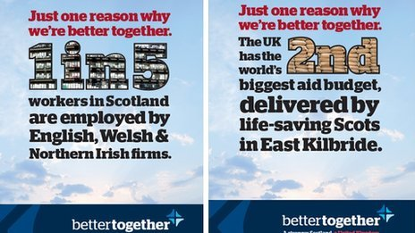
Source C
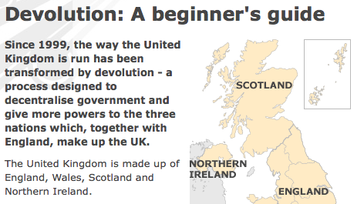
1 Using source A which political party is Alisha most likely to support and why.
……………………………………………………………………………………………………………………………………………………………………………………………………………………………………………………………………………………………………………… [2]
2 Using Source B identify two reasons why Scotland should remain in the UK.
……………………………………………………………………………………………………………………………………………………………………………………………………………………………………………………………………………………………………………… [2]
3 State two actions Alisha could undertake to support the political party she has joined.
i…………………………………………………………………………………………………………………………………………………………
ii…………………………………………………………………………………………………………………………………………………… [2]
4 With reference to Source B why might referendums not always be the best way to make an important decision?
……………………………………………………………………………………………………………………………………………………………………………………………………………………………………………………………………………………………………………………………………………………………………………………………………………………………………………………………………………………………………………………………………………………………………………………………………………………………………………………………………………………………………………………………………………………………………………………………………………………………………………………………………………………………………………………………………………………………………………………………………………………………………………………………………………………………………………………………………………………………………………………………………………………………………………………………………………………………………………………………………………………………………………………………………………………………………………………………………………………………………………………………………………………………………………………………………………………………………………………………………………………………………………………………………………………………………………………………………………………………………………………………………………………………………………………………………………………………………………………………………………………………………………………………………… [4]

Week 6
01. State the names of two political parties that put up candidates in the UK General election.
……………………………………………………………………………………………………………………………………………………………………………………………………………………………………………………………………………………………………………… [2]
02. Identify one category of people in the UK who are unable to vote in General elections.
……………………………………………………………………………………………………………………………………………………………………………………………………………………………………………………………………………………………………………… [1]
03. Describe the electoral system used for General elections in the UK.
……………………………………………………………………………………………………………………………………………………………………………………………………………………………………………………………………………………………………………… [1]
04. Identify three factors that may influence a person’s decision on which party to vote for.
i………………………………………………………………………………………………………………………………………………………….
ii…………………………………………………………………………………………………………………………………………………………
iii…………………………………………………………………………………………………………………………………………………… [3]
05. State one advantage of Proportional Representation. ……………………………………………………………………………………………………………………………………………………………………………………………………………………………………………………………………………………………………………… [1]
06. Identify one type of democracy.
……………………………………………………………………………………………………………………………………………………………………………………………………………………………………………………………………………………………………………… [1]
07. Identify one situation when a referendum has happened in recent history.
…………………………………………………………………………………………………………………………………………………………………………………………………………………………………………………………………………………………………

Week 7
Source A
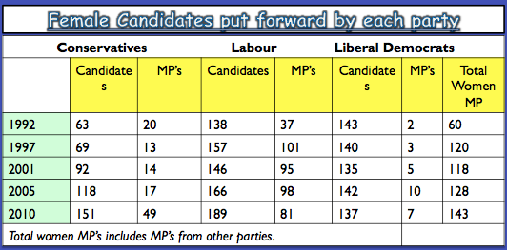
Source B
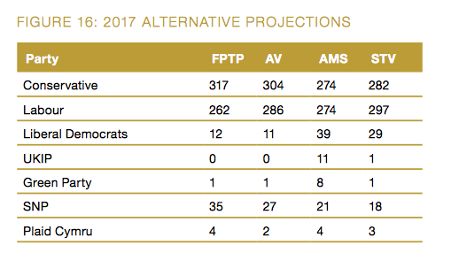

1 Using source A identify two trends you notice about female candidates and female MP’s between 1992 – 2010 ……………………………………………………………………………………………………………………………………………………………………………………………………………………………………………………………………………………………………………… [2]
2 In 2010 which political party fielded the most female candidates and how many did they field?
……………………………………………………………………………………………………………………………………………………………………………………………………………………………………………………………………………………………………………… [2]
3 In Source B under the Additional Member System which two political parties benefit the most?
i…………………………………………………………………………………………………………………………………………………………
ii…………………………………………………………………………………………………………………………………………………… [2]
4 With reference to Source B. Explain why people might argue that FPTP is not the most democratic voting system. ……………………………………………………………………………………………………………………………………………………………………………………………………………………………………………………………………………………………………………………………………………………………………………………………………………………………………………………………………………………………………………………………………………………………………………………………………………………………………………………………………………………………………………………………………………………………………………………………………………………………………………………………………………………………………………………………………………………………………………………………………………………………………………………………………………………………………………………… [4]

