ICT - Doddle homework
Year you started year 7
Name: ___________________
Class: ___________________
Username: JoeBloggs14
Use capitals for the first letter of your first and last name
Your first name and last name

Password: worle
Learning cycle 1
Week | Homework title | Final % score | Due date | Home signature
1 | Representation of data 1
2 | Representation of data 2
3 | Binary and hexadecimal
4 | Representing Characters
5 | Producing a one-bit depth image
6 | Graphics mini quiz
7 | Representing images and sound
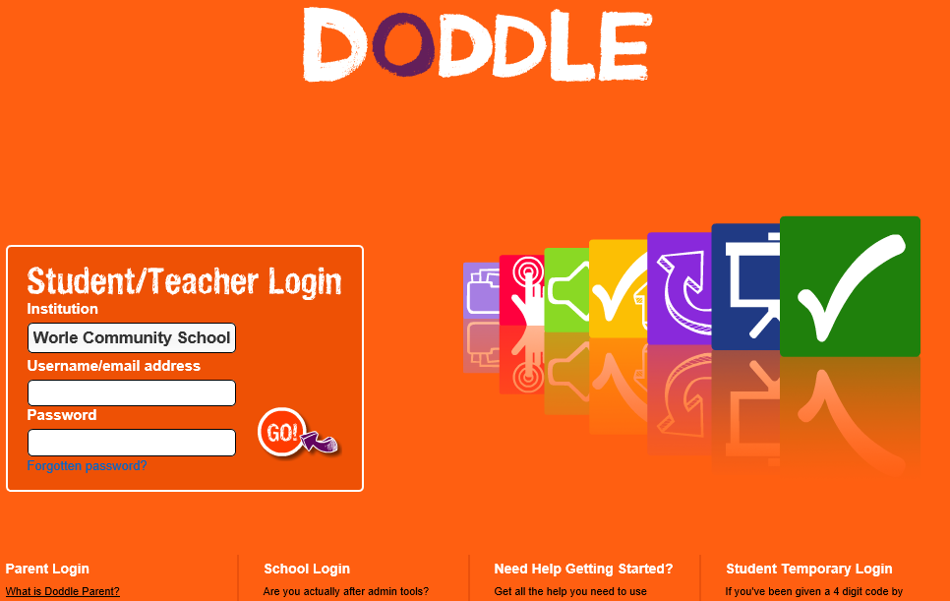
www.doddlelearn.co.uk

Institution = worle community school

