ICT - Doddle homework
Year you started year 7
Name: ___________________
Class: ___________________
Username: JoeBloggs14
Use capitals for the first letter of your first and last name
Your first name and last name

Password: worle
Learning cycle 1
Week | Homework title | Final % score | Due date | Home signature
1 | Introduction to Networks mini quiz
2 | Wired and wireless networks
3 | Topologies, Wi-Fi and Ethernet
4 | Protocols and layers
5 | The Internet
6 | Networks and Communications super quiz
7 | Introduction to Networks revision
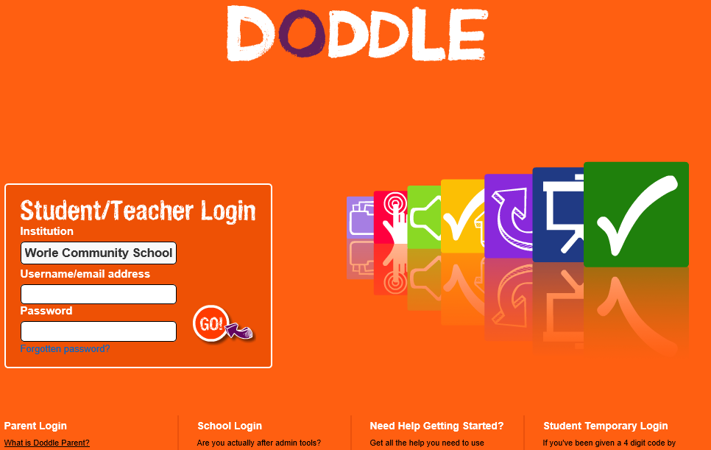
www.doddlelearn.co.uk

Institution = worle community school

