WCSA

English

Home Learning Book – Learning Cycle 1

Year 10

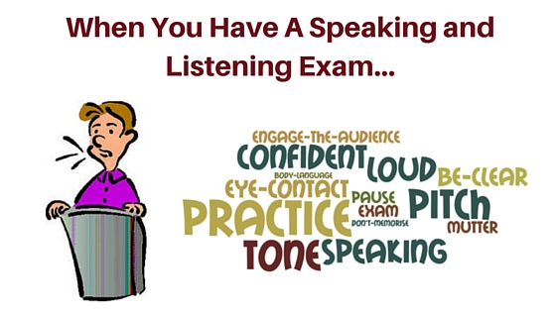

English

Name: ________________________Tutor Group: 10______

Teacher: ________________________________________

Learning Cycle 1
September 2018 | 9 | 10 | 11 | 12 | 13 | Week 1
September 2018 | 16 | 17 | 18 | 19 | 20 | Week 2
September 2018 | 23 | 24 | 25 | 26 | 27 | Week 3
October 2018 | 31 | 1 | 2 | 3 | 4 | Week 4
October 2018 | 7 | 8 | 9 | 10 | 11 | Week 5
October 2018 | 14 | 15 | 16 | 17 | 18 | Week 6
October 2018 | 21 | 22 | 23 | 24 | 25 | Extended Half Term
October 2018 | 28 | 29 | 30 | 31 | 1 | Extended Half Term
November 2018 | 4 | 5 | 6 | 7 | 8 | Week 7
November 2018 | 11 | 12 | 13 | 14 | 15 | Assessment Week
November 2018 | 18 | 19 | 20 | 21 | 22 | Super-Teach Week

- The first unit of your English Language course will be centred around your ‘Speaking and Listening’ endorsement which makes up part of the AQA GCSE syllabus.

- At the end of this unit, you will be expected to deliver a formal presentation to your class, lasting 3-5 minutes. You MUST answer questions as part of this assessment.

- Preparation is a key factor with this assessment and you will be expected to provide proof of planning – this homework booklet is geared towards providing AQA with evidence of this part of the course requirement. Each task in this booklet will contribute to the final awarding of a grade, and will be used alongside your presentation to award you with your GCSE Speaking and Listening grade.
Useful Websites

http://literary-devices.com/

https://dictionary.cambridge.org/ (online dictionary)

https://www.ted.com/talks - website which provides examples of some brilliant speeches

http://examples.yourdictionary.com/examples-of-rhetorical-devices.html - shows examples of rhetorical devices (persuasive language)


Week 1 – Page 3 - Key Words
Research

Research and write the definitions for the following key terms.

Tricolon __________________________________________________________________________________________________________________________________________________________________

Emotive Language –
__________________________________________________________________________________________________________________________________________________________________

Hyperbole –
__________________________________________________________________________________________________________________________________________________________________

Metaphor –
__________________________________________________________________________________________________________________________________________________________________

Imagery –
__________________________________________________________________________________________________________________________________________________________________

Viewpoint - __________________________________________________________________________________________________________________________________________________________________

Anecdote –
__________________________________________________________________________________________________________________________________________________________________

Statistics –
__________________________________________________________________________________________________________________________________________________________________

Rhetoric –
__________________________________________________________________________________________________________________________________________________________________

Parent/ carer comments:

Week 2 – page 4 & 5 – Sophisticated topics
Research

To have any chance of achieving a Distinction in your Speaking and Listening endorsement, you will be required to choose a more complex topic. These will be topics where you express a particular viewpoint on your topic or have a specific angle that you will be exploring.
For example:

Basic (Pass) | Complex (Distinction
‘Why I think _________ is the greatest footballer of all time.’ | ‘Should footballers’ wages be capped to the same wage as soldiers?’
‘My pet dog.’ | ‘Should dog licenses be brought back in an attempt to deter animal cruelty and the breeding of aggressive animals?’
‘All about Cyprus’. | ‘Varosha – the ghost town created by war.’
‘The greatest invention ever created.’ | ‘Free will or fate?’

Task 1:

Look closely at the following pairs of topics. Decide which is Basic (B) and which is Complex (C). Be careful, as some pairs may be both Basic or both Complex. Label them accordingly.

All about bees. |  | Why the existence of bees is important for human life.
Has the internet changed society for better or worse? |  | The history of the internet.
The many theories about ‘Jack the Ripper’. |  | Are serial killers born or bred?
The top 10 Disney films of all time. |  | How Disney are promoting more positive female role models.
How the ‘Harry Potter’ series revived teen fiction. |  | Fan theories and plot holes of the Harry Potter series – myth or magically right?
The importance of travel to a healthy and open mindset. |  | Why France is the best country to visit on holiday.
Is it ethical to eat meat? |  | Are vegetarians healthier than carnivores?
Why dogs make the perfect pet. |  | How dogs can help to improve mental health.

Task 2:

Choose 3-5 possible topics for your speaking presentation and try to craft a few potential complex presentation titles.

Remember, for a complex presentation, you should:
- Choose a topic that you are interested in researching or know a lot about
- Have a particular viewpoint or angle on your topic that you would like to present

Suggested Topics: | Possible presentation titles:

Self/ peer assessment:
The best choice of topic and title is______________________________________________ because ____________________________________________________________________
___________________________________________________________________________
Parent/ carer comments:

Week 3 – page 6 & 7 – Developing Research
Research

One of the key requirements for success in the Speaking and Listening endorsement is to know your topic. Use the next two pages of your homework booklet to develop research notes on your topic.

You could include:
- Facts and statistics
- Expert quotations / viewpoints on chosen topic
- Arguments for being for and against your chosen topic
- Useful websites for future reference

______________________________________________________________________________________________________________________________________________________________________________________________________________________________________________________________________________________________________________________________________________________________________________________________________________________________________________________________________________________________________
______________________________________________________________________________________________________________________________________________________________________________________________________________________________________________________________________________________________________________________________________________________________________________________________________________________________________________________________________________________________________
______________________________________________________________________________________________________________________________________________________________________________________________________________________________________________________________________________________________________________________________________________________________________________________________________________________________________________________________________________________________________
______________________________________________________________________________________________________________________________________________________________________________________________________________________________________________________________________________________________________________________________________________________________________________________________________________________________________________________________________________________________________
______________________________________________________________________________________________________________________________________________________________________________________________________________________________________________________________________________________________________________________________________________________________________________________________________________________________________________________________________________________________________
______________________________________________________________________________________________________________________________________________________________________________________________________________________________________________________________________________________________________________________________________________________________________________________________________________________________________________________________________________________________________

Parent/ carer comments:


Week 4 – page 8 & 9 – Crafting PERSUADE
Consolidation

For an engaging and effective speech, you will have to craft using rhetorical (persuasive) devices.

Choose at least 8 rhetorical devices from the options below and craft at least one example of these devices about your chosen topic. You will be able to use these in your presentations as a way of making your speech more engaging for your audience.
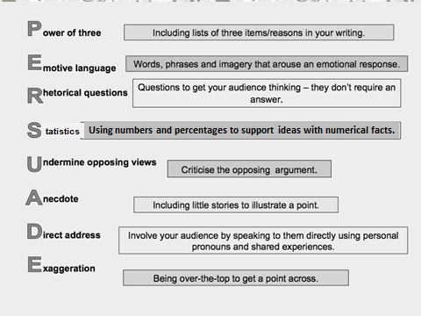
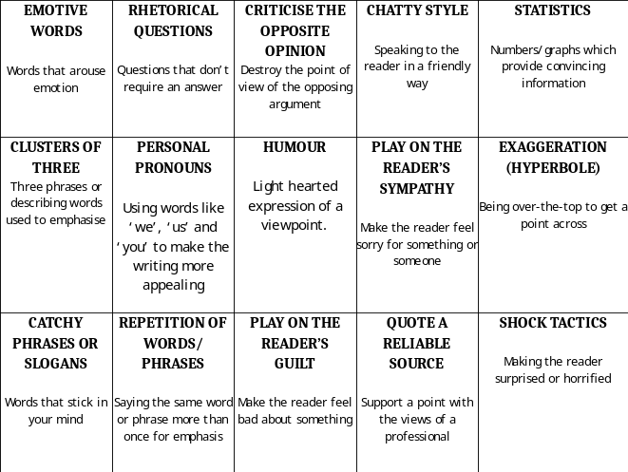

Method : ____________
Example:_____________________________________________________________________________________________________________________________________________________________________________________________________________________________________________________

Method : ____________
Example:_____________________________________________________________________________________________________________________________________________________________________________________________________________________________________________________

Method : ____________
Example:_____________________________________________________________________________________________________________________________________________________________________________________________________________________________________________________

Method : ____________
Example:_____________________________________________________________________________________________________________________________________________________________________________________________________________________________________________________

Method : ____________
Example:_____________________________________________________________________________________________________________________________________________________________________________________________________________________________________________________

Method : ____________
Example:_____________________________________________________________________________________________________________________________________________________________________________________________________________________________________________________

Method : ____________
Example:_____________________________________________________________________________________________________________________________________________________________________________________________________________________________________________________

Method : ____________
Example:_____________________________________________________________________________________________________________________________________________________________________________________________________________________________________________________

Method : ____________
Example:_____________________________________________________________________________________________________________________________________________________________________________________________________________________________________________________

Method : ____________
Example:_____________________________________________________________________________________________________________________________________________________________________________________________________________________________________________________

Method : ____________
Example:_____________________________________________________________________________________________________________________________________________________________________________________________________________________________________________________

Parent/ carer comments:

Week 5 – pages 10 & 11 – Crafting your introductions
Consolidation

Having done your research about your topic, and having planned some examples of rhetorical devices, you should now be ready to craft an effective introduction to your presentation.

It is really important to engage your readers from the very start of your speech, and so your opening minute should be well organized, well researched and well crafted.

Use the space provided to develop an effective introduction to your presentation. Remember to include some of the rhetorical devices from last week’s homework to make it engaging!

______________________________________________________________________________________________________________________________________________________________________________________________________________________________________________________________________________________________________________________________________________________________________________________________________________________________________________________________________________________________________
______________________________________________________________________________________________________________________________________________________________________________________________________________________________________________________________________________________________________________________________________________________________________________________________________________________________________________________________________________________________________
______________________________________________________________________________________________________________________________________________________________________________________________________________________________________________________________________________________________________________________________________________________________________________________________________________________________________________________________________________________________________
______________________________________________________________________________________________________________________________________________________________________________________________________________________________________________________________________________________________________________________________________________________________________________________________________________________________________________________________________________________________________
______________________________________________________________________________________________________________________________________________________________________________________________________________________________________________________________________________________________________________________________________________________________________________________________________________________________________________________________________________________________________
______________________________________________________________________________________________________________________________________________________________________________________________________________________________________________________________________________________________________________________________________________________________________________________________________________________________________________________________________________________________________

Parent/ carer comments:

Week 6 – page 12 & 13 – Developing Questions
Research

It is a requirement of the Speaking and Listening endorsement that all candidates answer questions on their chosen topic (minimum of 3).

Good questions to ask are open questions – these allow the recipient to give extended answers, whereas closed questions tend to be limited in the information that can be given.

Task 1.
Look at the examples given and then decide whether the following are open or closed questions.

 | Open or closed? |  | Open or closed?
Who was the inventor of the first automobile? | Closed | How do you think the invention of the first automobile has influenced today’s society? | Open
In what ways do you think that Turkey is the ideal holiday destination? |  | Have you ever been on holiday to Turkey?
What lessons do you think have been learnt about safety at sea following the Titanic disaster? |  | How many people lost their lives in the Titantic sea disaster?
Do you think that soldiers should be paid a higher wage than footballers? |  | How do you think the wage gap between soldiers and footballers can most realistically be closed?
Do you think society will ever be totally equal and why do you think this? |  | Who do you think has had the biggest influence on gender equality and why?

Task 2.

In the provided space below, write down six questions on your chosen topic. Aim to make them open questions. Following this, write down a small answer for each of them; some of these can be used for the question session of your Speaking and Listening presentation.

1._________________________________________________________________________________________________________________________________________Answer:______________________________________________________________________________________________________________________________________________________________________________________________________________________________________________________________________________
2._________________________________________________________________________________________________________________________________________Answer:______________________________________________________________________________________________________________________________________________________________________________________________________________________________________________________________________________
3._________________________________________________________________________________________________________________________________________Answer:______________________________________________________________________________________________________________________________________________________________________________________________________________________________________________________________________________
4._________________________________________________________________________________________________________________________________________Answer:______________________________________________________________________________________________________________________________________________________________________________________________________________________________________________________________________________
5._________________________________________________________________________________________________________________________________________Answer:______________________________________________________________________________________________________________________________________________________________________________________________________________________________________________________________________________
6._________________________________________________________________________________________________________________________________________Answer:______________________________________________________________________________________________________________________________________________________________________________________________________________________________________________________________________________
Parent/ carer comments:

Week 7 – page 14 – Preparing for delivery
Consolidation

So far, you have researched and planned all aspects of your Speaking and Listening presentation. Now it is time to deliver it.

However, before you do so, you must be well practiced, so that you can deliver your speech with fluency and with confidence. You should know your speech well enough that you are not reading from a script (you can use prompt cards with key information on them if these will help).

Your final homework task is to deliver your presentation to your parent/carer. When you have finished, ask them for their feedback. You will require a signature to confirm that this part of your homework has been completed.
Feedback

w.w.w.__________________________________________________________________________________________________________________________________________________________________________________________________________________________________________________________________________________________________________________________________________________________________________________________

e.b.i.- __________________________________________________________________________________________________________________________________________________________________________________________________________________________________________________________________________________________________________________________________________________________________________________________

Parent/Carer signature ________________ Date ____________

Remember to keep practising until your actual presentation so that you are as fluent, confident and comfortable as possible!
Parent/ carer comments:

Speaking and Listening Review

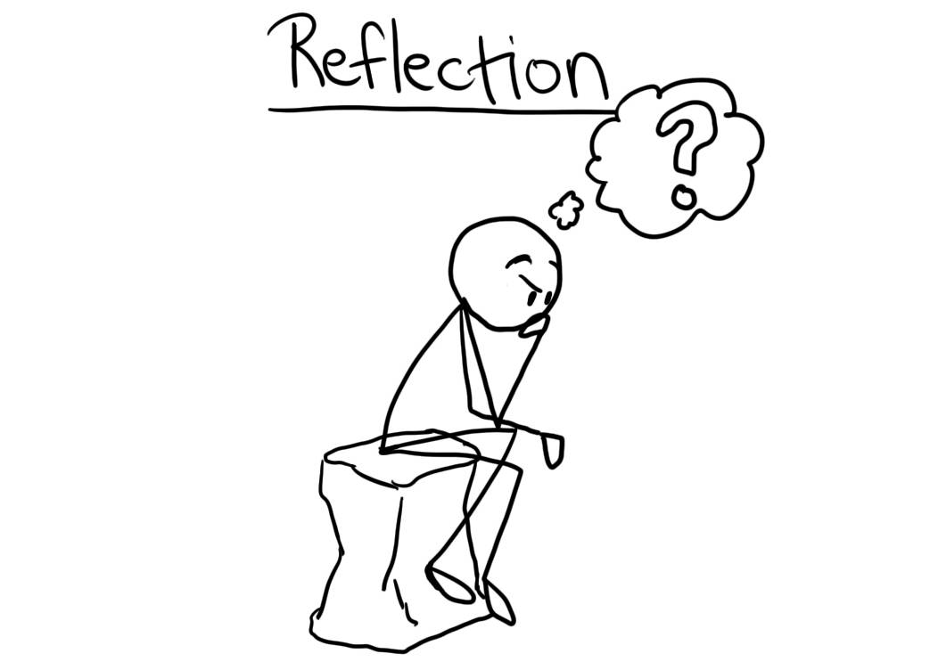
This is the time to reflect on the strengths and weaknesses of your presentation for your Speaking and Listening exam. Take some time and think of two to three areas of successes and improvements.

Remember, most probably you will have to speak in front of other people in your future, whether for a job interview or a presentation. It is vital to have the skills to do this successfully.

w.w.w.

______________________
______________________
______________________
______________________
______________________
______________________
______________________
______________________
______________________
______________________
______________________
______________________
______________________
______________________

e.b.i

______________________
______________________
______________________
______________________
______________________
______________________
______________________
______________________
______________________
______________________
______________________

